

Contracting Process

CCP USER GUIDE

Version 1.2  
June 27, 2021

|  |  |  |  |
| --- | --- | --- | --- |
| Date | Version | Changed By | Changes |
| June 10, 2021 | Version 0.1 | Maryna Nikolaienko | Original Version. |
| June 22, 2021 | Version 1.0 | Stephen Weiner | Edit for Format, English, and Grammar. |
| June 23, 2021 | Version 1.1 | Keith Brickey | Minor edits. |
| June 27, 2021 | Version 1.2 | Maryna Nikolaienko | - Added links to quickly navigate the document;  - Document converted to PDF file format. |

Table of Contents

User CCP Workflow 5

My Worklist 5

My Opportunities 6

My Projects 8

Additional role features 9

New Project Coordinator 9

New Project Manager 9

Filtering 10

Overview Tabs for Contracting Process 11

Form images and descriptions 11

Tab Opportunity 11

Tab Include/Exclude 19

Tab Q/A List 21

Tab Approval Notes 23

Tab Project 25

Tab Contract Review 26

Tab Contract Information 28

Tab Procore Project 29

Roles 30

Task form images and instructions 30

Sales 30

2-0 Upload Bid Setup and Customer Bid Documents 30

4-0 Sales Review and Approve Price Quotation 31

4-3 Send Quotation PDF to customer 32

5-0 Upload LOI/NTP or Revised Bid Setup 32

5-2 Agree to Move Forward Step 34

7-0 Review L Proposal 35

14-0 Upload and Review Contract 36

16-1 Request Contract Revision 38

19-0 Send Signed Contract to Customer Step 39

19-1 Upload Countersigned Contract from Customer Step 40

22-0 Procore Submittals Approved Step 41

56-0 Start Transition meeting Step 42

Estimating 43

3-0 Review Bid Setup and Upload Q Proposal 43

4-1 Review and Approve Price Quotation 44

4-2 Prepare Quotation PDF 45

6-0 Upload new or Revised L Proposal 46

14-1 Upload C Proposal and SOV 48

19-3 Upload CA Proposal Step 49

58-0 Upload OPS Proposal Step 51

23-2 RS Proposal Step 52

Sage admin 53

32-0 Create Job in Sage 53

Legal 55

16-0 Prepare Contract Addendum 55

17-0 Stakeholders Contract Review Meeting 56

18-1 Obtain All Signatures Step 57

19-2 Review Countersigned Contract Step 58

Operations Manager 60

1-0 Start PM Change Process Step 60

4-0 Hand off Meeting Step 61

PM 62

5-0 Complete Assigned PM Task Step 62

Project Coordination Manager 63

6-0 Start Project Coordinator Change Process Step 63

PC 64

21-0 Compile Submittal Package Step 64

19-4 Setup JE in RFMS Step 65

22-0 Procore Submittals Approved Step 65

23-0 Send Submittal Package to Customer Step 66

23-1 Confirm Submittal Items All Complete Step 67

58-2 Process OPS SOV for RFMS Step 68

Accounting 70

58-1 Process OPS SOV Step 70

Contracting Process General Schema 71

Designations on the diagram 72

# User CCP Workflow

This article provides a user guide for the CCP Process that uses the K2 Five application framework. The CCP application consists of two desktops:

• CCP workflow

• Configuration management

In the upper right corner of the header, there is a drop-down list for selecting a desktop. Left menu items and dropdown items are limited to restrict visibility to selected role members.

### My Worklist

In this section, we will look at working with the CCP Workflow.

The CCP Workflow menu for the user has four sections: CCP Workflow, CCP Dashboards, Helpdesk and Pydio.

*Screen shot - CCP Workflow – My Worklist*

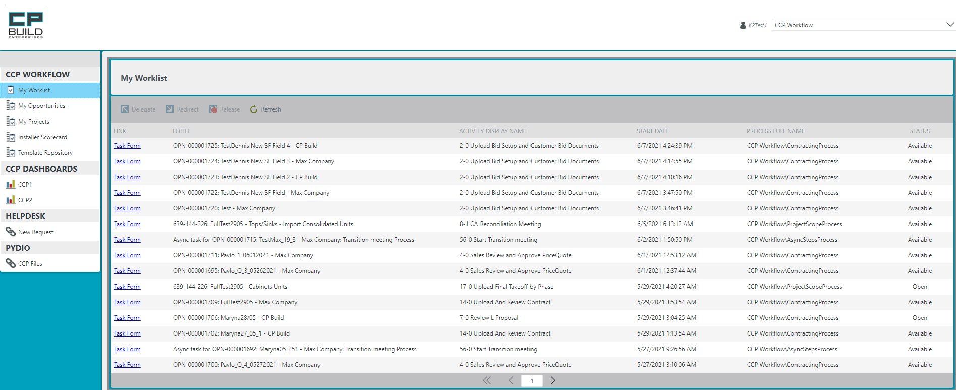

CCP Workflow

* The *My Worklist* contains Worklist Item records that each represent a task assigned to the user.
* On the *My Opportunities* item, there are eight tabs. Each tab is named as one of the opportunity status stages and shows existing tasks.
* The *My Projects* item has two tabs, which show task forms with Contract Negotiation or Closed Won contract status, respectively.

CCP Dashboards

* On the CCP 1 item, there is a form with dashboard, which shows short information about existing user tasks, sorted by opportunity status.
* The form on the CCP 2 item shows short information about tasks sorted by contract status.

Helpdesk

* New Request will redirect you to Bytezoom Help Center, where you can submit a request or report a problem.

Pydio

* You will be redirected to the Pydio page, where you can open your personal folder.

At the My Worklist tab, find the required task and click on Task Form LINK to open the form.

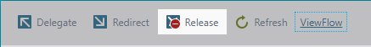

- To add another user to the execution of the current Task, select the Task you are interested in, click the *"Delegate"* button. In the window that opens, you need to enter the name of the desired user and click the "Select" button.

- To Redirect the task, select the task you interested in, click on the *“Redirect”* button, in the window that opens. You then need to enter a username and click the Select button.

- To Release the task, select the task you interested in and click on the *“Release”* button. Another user can then perform this Task.

- To Refresh the list, click *“Refresh”.*

- Select required Task and “*View Flow”* button will appear Clicking on this button User will see the All Workflow.

Allocated User is displayed here.

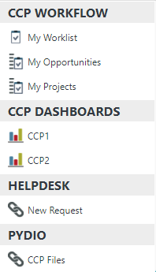

### My Opportunities

On the My Opportunities item, there are eight tabs: All, Qualification, Estimating, Proposal, LOI, Contract Negotiation, Closed Won, Dead and Closed Lost. On the All tab, we can see the following data: Opportunity name, Opportunity number, Activity, Recipient, Sales owner, FDD, Stage, Customer, Type, Created and Updated. All other tabs will display the tasks with the corresponding Title Stage.

*Screen shot - CCP Workflow – My Opportunities*

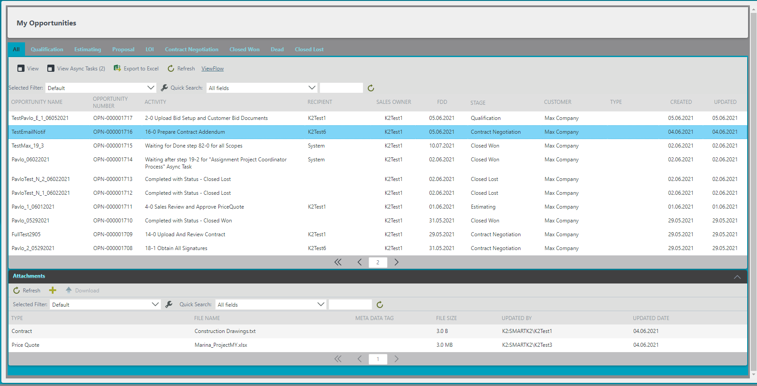

Each tab is named as one of the Opportunity status stages and shows existing tasks, which have the status as on the tab name.



To see the corresponding Task information, the user must select the Task line.

- To see the Opportunity Details, click on the *"View"* button.

- To view the Async Tasks for the current project, click the *"View Async Tasks"* button.

- The “*Kill”* button will offer to transfer the project to the Close-Lost or Dead-New status in the window that opens.

- You can also view the entire task list *Export to Excel,* by clicking the corresponding button.

- To refresh the list of tasks, click the *"Refresh"* button.

- When you click on the required task, the *View Flow* button appears, and the user can see the workflow of the task.

To quickly find the file you need, you can use the filter command line.



When the user clicks on the Task row, at the bottom of the page there appears a view with Attachments that have been added to the selected task. The Toolbar contains buttons for:

* *“Refresh”* the list of uploaded documents.
* *“Add”* a new document to Attachments.
* button for “*Download*” the required document.

View Async Task

While working with a Task, you will see similar messages - “Waiting after Step 19-2 “Create Job in Sage” Async Task” - in Activity on the My Opportunities and My Projects tabs. This means that a started asynchronous step blocks further progress of the Task and must be closed. *Screenshot - CCP Workflow – Button View Async Tasks*

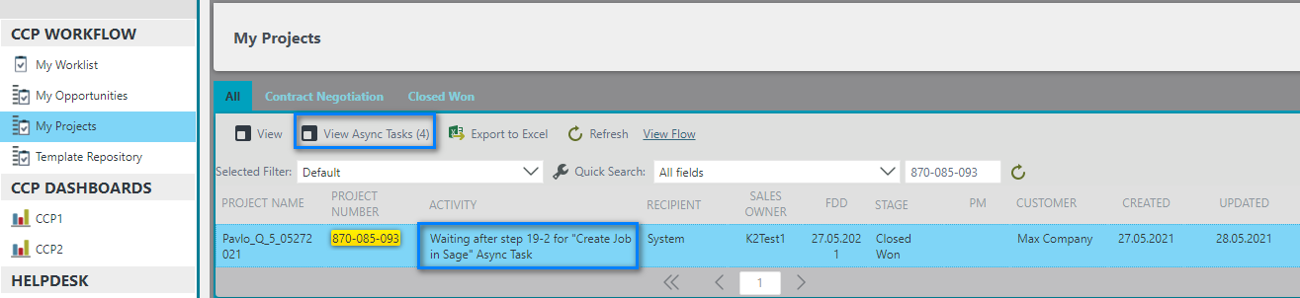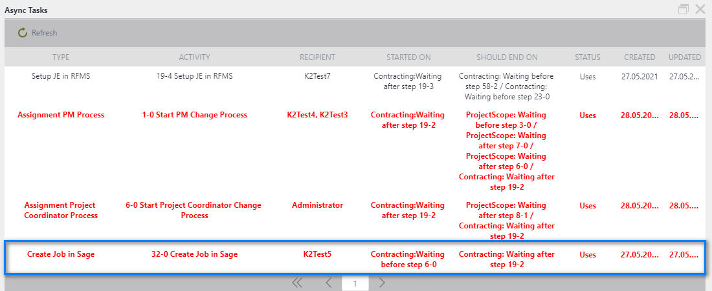

After closing one of the asynchronous tasks, you can click the Refresh button to refresh the page of both the pop-up window and the main one. You can then see the name of the next blocking step.

Blocking Async Tasks are highlighted in red. If several Async Tasks are selected in this way, priority will be indicated in the Activity of the main Task.

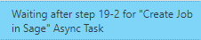

Upload file in the Attachment list

When adding a file using this method, an additional window opens.

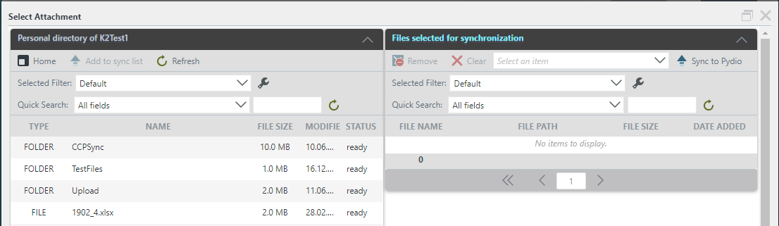

To return from a folder, click the *Home* button on the toolbar. To load the selected document, click the *Add to sync list* button (or double-click the left mouse button on the required file). Files in a personal folder can have two statuses: "Loading" and "Ready". With the first status, file synchronization is impossible. You must wait for the "Ready" status. To update the File Status, use the *Refresh.* button.

To remove the selected file from the synchronization sheet, click the *Remove* button on the toolbar. To completely clear the sync sheet, click the *Clear* button. To upload the file as an attachment, select the Type of Document (*Select an item*) from the dropdown list and click the *Sync to Pydio* button.

To quickly find the file you need, you can use the filter command. line.

***To add new attachment to Attachment’s view:***

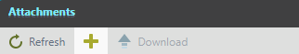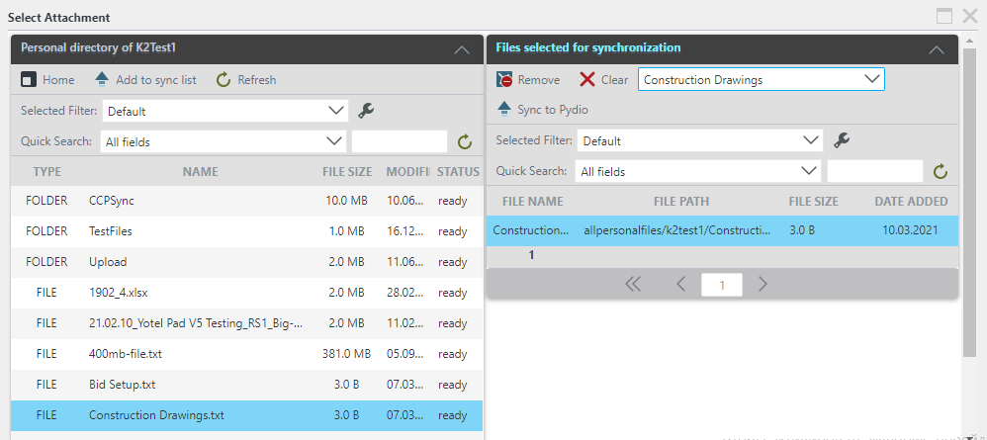

1. Select the required file or folder from the Personal directory and click on *Add to sync* list button.

3. Files will appear in the Files selected for the synchronization view.

4.On the Files for synchronization view, select from drop-down list file type.

5. Click on *Sync to Pydio*.

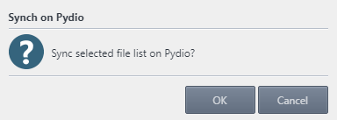

6. After clicking Sync to Pydio, click the *OK* button in the message box and new file will appear in the Attachments list.

1. Click the button in the toolbar and an auxiliary form will open.

### My Projects

The My Projects item has three tabs, which show task forms with All, Contract Negotiation or Closed Won contract status, respectively.

*Screenshot - CCP Workflow – My Projects*

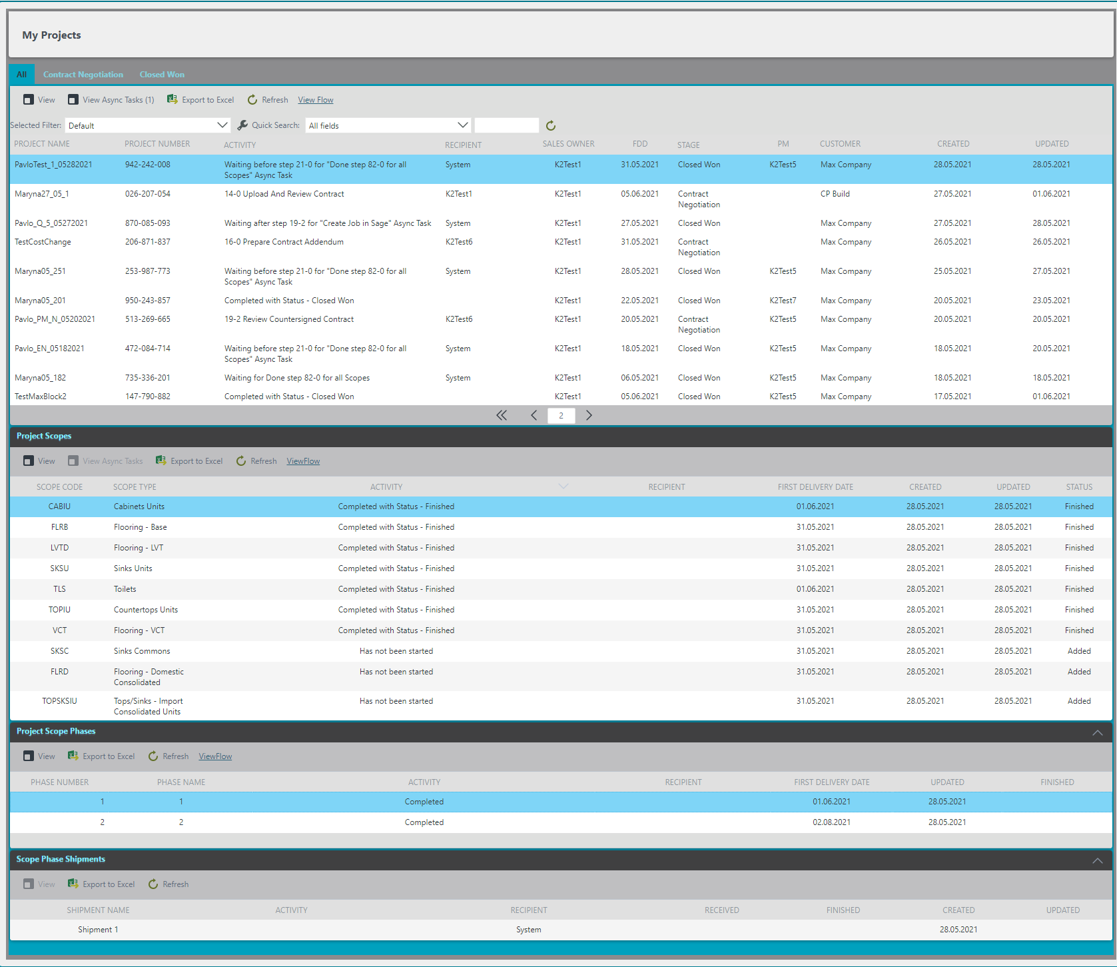



To see the corresponding Task information, the user must select the Task line

- To see the Project Details, click on the *"View"* button.

- To view the Async Tasks for the current project, click on the *"View Async Tasks"* button.

- You can also view the entire task list *Export to Excel,* by clicking the corresponding button.

- To refresh the list of tasks, click the *"Refresh"* button.

- When you click on the required task, the *View Flow* button appears, and the user can see the workflow of the task.

To quickly find the file you need, you can use the filter command line

When user clicks on the Phases task row, there appears Scopes Phases Shipments view, where user can see the Shipments.

After user clicks on the Scope task row, there appears Project Scopes Phases view, where user can see the Phases.

When the user Selects on the Task row appeared Project Scopes view, where user can see Scopes.

### Additional role features

#### New Project Coordinator

The Project Coordinator Manager can initiate the New Project Coordinator assignment process using the New Project Coordinator button on the My Project menu.

*Screenshot - CCP Workflow – My Projects- New Project Coordinator*

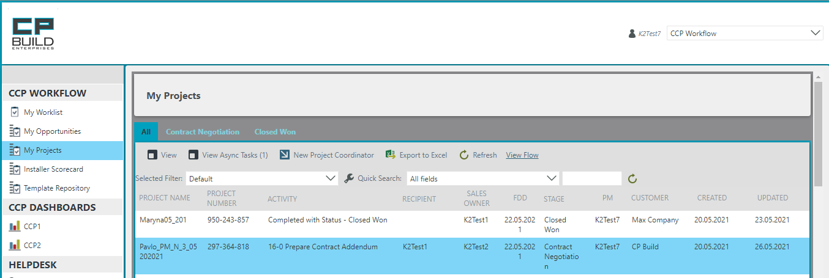

1. To do this, in your CCP Workflow, select the My Project menu and in the Tasks list, highlight the required Task.

2. After that, the New Project Coordinator button will become available in the Toolbar

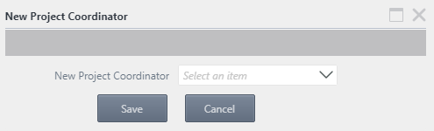

3. A dialog box will then appear in which the drop-down list New Project Coordinator will be offered.

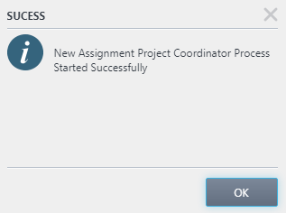

4. By clicking the Save button, a dialog box will appear confirming the successful completion of the action

#### New Project Manager

The Operations Manager can initiate the New Project Manager assignment process using the New Project Manager button on the My Project menu.

*Screenshot - CCP Workflow – My Projects- New Project Manager*

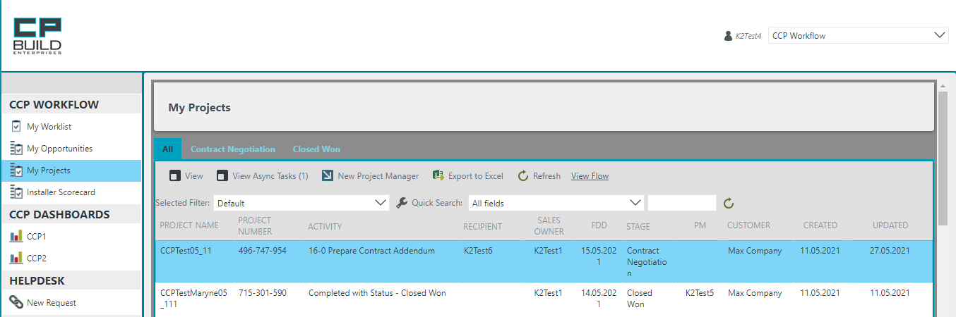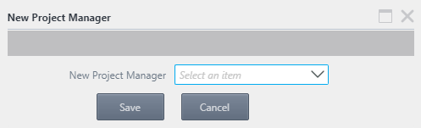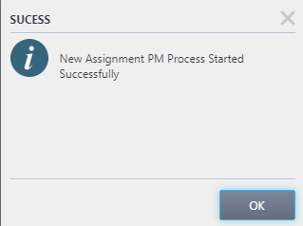

4. By clicking the Save button, a dialog box will appear confirming the successful completion of the action

1. To do this, in your CCP Workflow, select the My Project menu and in the Tasks list, highlight the required Task.

3. A dialog box will then appear in which the drop-down list New Project Manager will be offered.

2. After that, the New Project Manager button will become available in the Toolbar

#### Filtering

On the CCP Workflow, User can use different filtering and quickly search relevant tasks. The User can use filtering by default or configure their own filtering.

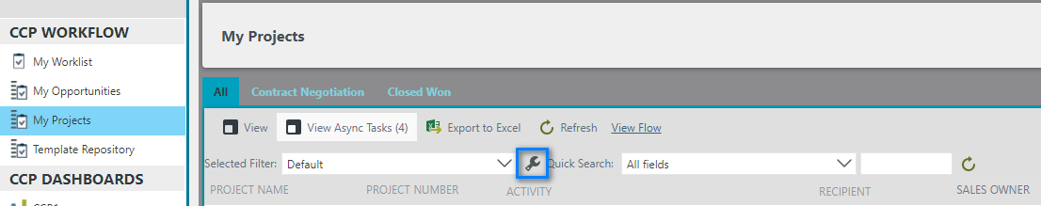

To customize the filter for yourself, press the “Configure” button, after which the subordinate form “Configure User Filters” will open.

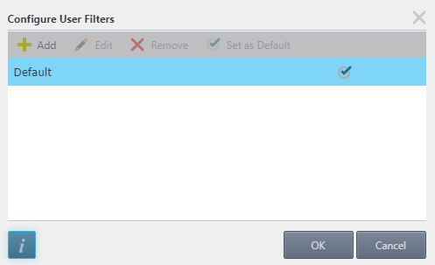



- To add a new filter, click the *“Add”* button.

- To edit a filter, select the one you need and click the *"Edit"* button.

- To remove a filter, click the *“Remove”* button.

- To use a filter every time, select the filter you want and click the *"Set as default"* button.



- The button will open the support page.

- If you want to save your changes, click the “*OK”* button in the subform.

- By clicking on the *"Cancel"* button, you will lose all settings.

*Screen shot - CCP Workflow – Configure User Filters*

After clicking on the Add button on the Configure User Filters subform, a new Configure User Filters subform will open. There are two tabs on the Configure User Filters sub-form: Filter and Sort.

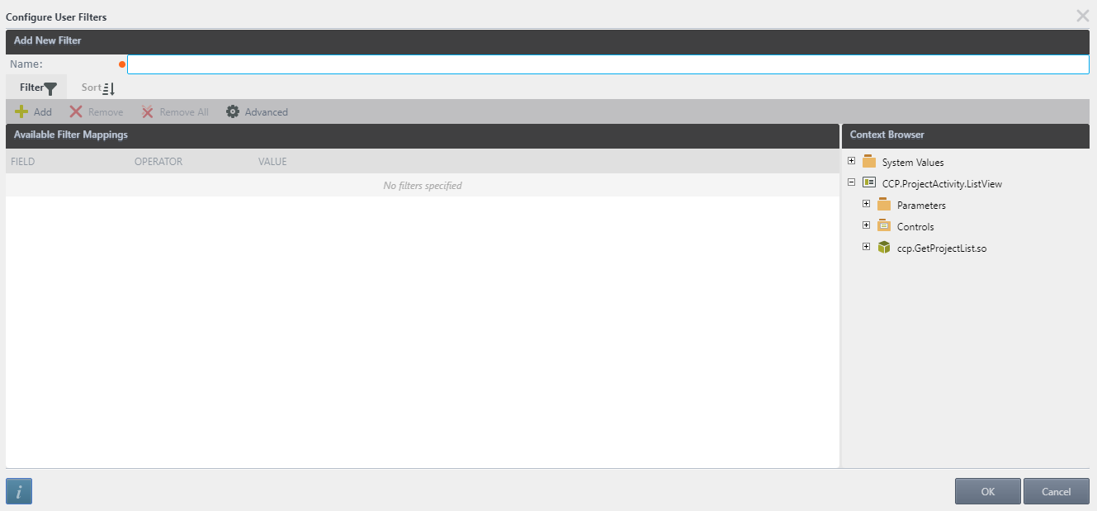

Enter the filter name and then configure filtering.

On the Filter tab



- *"Add"* button to create new rules

- *"Remove"* button to delete single selected rule

- "Remove All" button to delete all rules

- *"Advanced"* button to more difficult filter configures.

On the Sort tab



- Click on the *“Add”* button to add sort column, select required column from the drop-down list and select sort order.

- To delete single sort rule, choose one and click on the *“Remove”* button.

- To delete all sort rules, click on the *“Remove All”* button.

- User can choose the order of sorting using *“Move up”* button to lift up the rule or *“Move down”* button to let down the rule.

*Screenshot - CCP Workflow – Configure User Filters*

# Overview Tabs for Contracting Process

The Contracting Process is interconnected with Sales Force and transfers the following statuses, which are set at the appropriate steps:

* Qualification after Start Process
* Estimating after Step 2-0 Upload Bid Setup and Customer Bid Documents
* Proposal after Step 4-3 Send Quotation PDF to customer
* LOI after Step 5-0 Upload LOI\NTP or Revised Bid Setup
* Contact Negotiation after Step 5-2 Agree to Move Forward
* Closed Won after Step 19-2 Review Countersigned Contract



## Form images and descriptions

In the form for the Contracting Process, there are eight tabs (Opportunity, Include / Exclude, Q / A List, Approval Notes, Project, Contract Review, Contract Information and Procore Project) that are active at certain steps.

From the beginning of the start of the Contract Process, two tabs are available to us for work: Opportunity and Q / A List. Tab Include / Exclude becomes available after uploading the Quotation file in Step 3-0 Review Bid Setup and Upload Q Proposal Step. Tab Approval Notes becomes available in Step 4-0 Sales Review and Approve Price Quotation. At Step 14-0 Upload and Review Contract, the following tabs become available Project, Contract Review, Contract Information. Tab Procore Project becomes available in Step 22-0 Procore Submittals Approved.

### Tab Opportunity

On the Opportunity tab, some fields are already filled in automatically with information from Sales Force. All of the other fields will be filled in automatically after uploading documents, which will contain this information, or manually by the user.

*Screenshot - Sales – Step 2-0 Upload Bid Setup and Customer Bid Documents – Contracting Process*

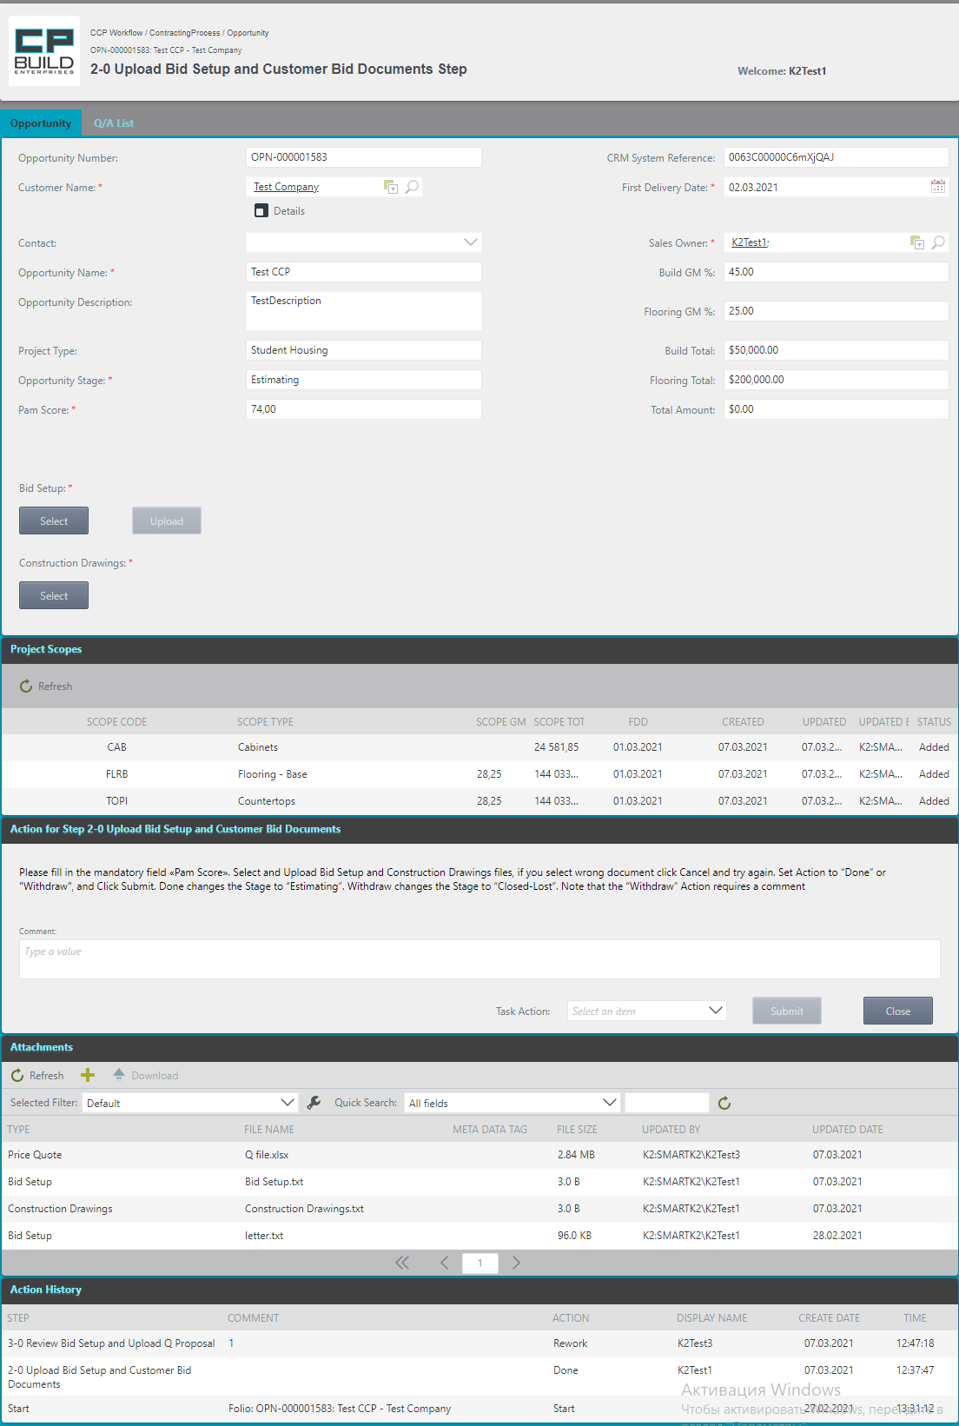

Header section, which displays current information about process name, project name and step number with its name and username.

This is the main user's work area in which tabs, fields with data information and a block for uploading the necessary documents for a specific step are available.

Action to represent a step. The user can enter a comment and select an action from the Task Action drop-down list. The user can also see a hint for the current step in the form of a description of the required actions and a link to a schematic representation of a step in the overall process.

On the Attachment view you may see added attachments, download them, or add a new one.

Action History view shows step name, comment, action, display name, date and time for activity in previous steps.

This part of the window displays the loaded Scopes from the Quotation Files.

*Header section*

This area is displayed at each step and is the same for all tabs. This area is informative and is not changed by anyone.

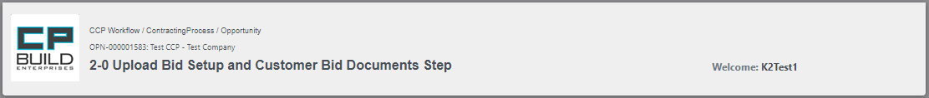

This part displays: Process Full Name, Folio and Activity Name

Allocated User is displayed here.

*Opportunity*

There are three active parts in this area: the upper part shows the available tabs to work with; in the middle part there are fields for viewing project data transferred from Sales Force, extracted from uploaded files, and manually entered by the user; and the third part is also available to upload the necessary documents for this contract. Some fields will be hidden or added for a specific step.

*Screenshot – Opportunity tab – Contracting Process*

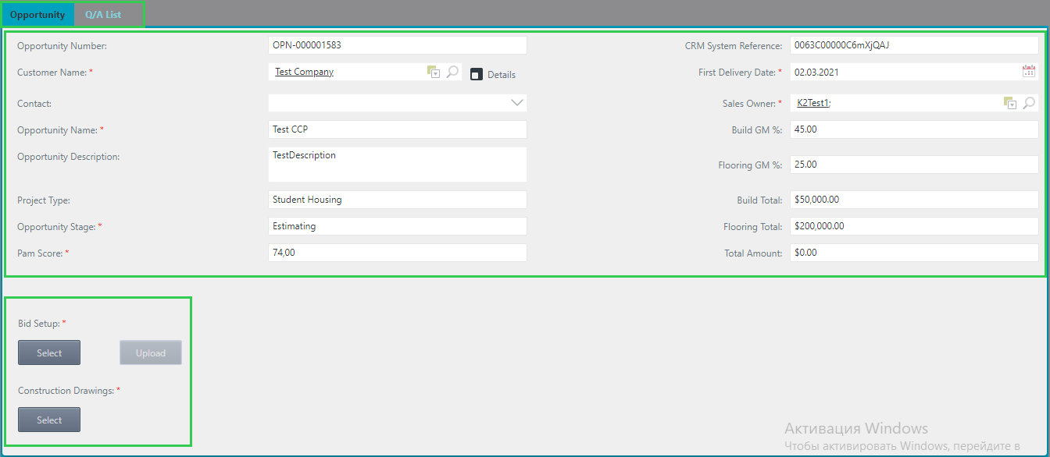

This block displays information about the current process. Fields that must be filled in before proceeding to the next step will be marked. *

Tabbed area to work with. Highlighted the currently active tab Opportunity.

Here you can upload files from a personal folder on Pydio. This part, * also means the obligatory Upload of this type of documents.

***To add attachments:***

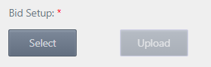

1. Click on the Select button and the view will open.
2. Choose the file user need and click on the Select button ad. This action will add the document to the form.

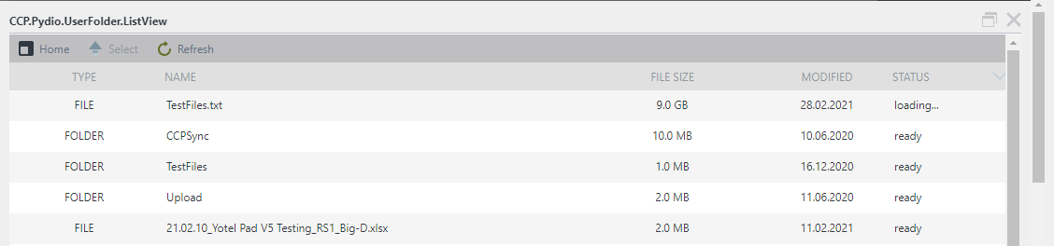

To return from a folder, click the *Home* button on the toolbar. To load the selected document, click the *Select* button (or double-click the left mouse button on the required file). To update the File Status, use the *Refresh* button.

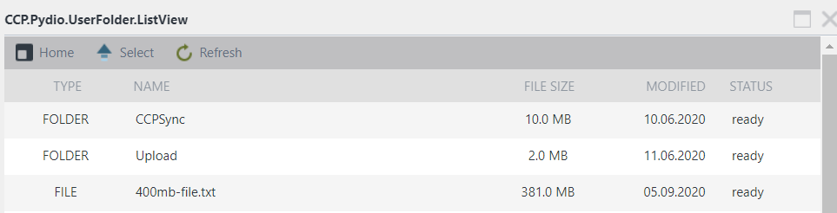

3. Click “Upload” to upload the file. If user do not do it yourself, it will be done automatically after selecting Task Action and clicking “Submit”.

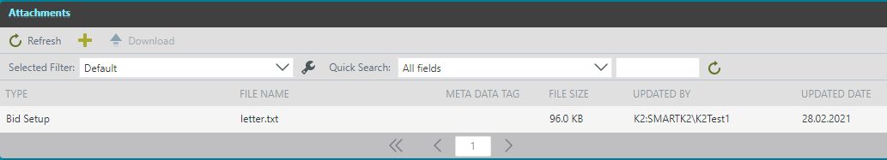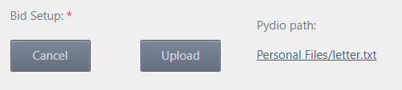

The location of the file on Pydio that was selected for download is indicated.

You may click Cancel button, if you select the wrong Document, and add another one.

After clicking the Upload button, the selected file will be displayed in the Attachments and Saved as Attachment in Process.

*Project Scope*

The current version of the project supports the 5th version templates of the Quotation files. If the user tries to load a Quotation file of a different version, the system will display a warning.

This part of the window displays the loaded scopes from the Quotation Files. Quotation Files are loaded in steps:

* 3-0 Review Bid Setup and Upload Q Proposal.
* 4-2 Prepare Quotation PDF.
* 6-0 Upload New or Revised L Proposal.
* 14-1 Upload C Proposal and SOV.
* 19-3 Upload CA Proposal.
* 23-2 RS Proposal.

After uploading these files, the corresponding data is updated. This area becomes visible in the 3-0 Review Bid Setup and Upload Q Proposal, provided that the Upload button was clicked when the Q File was loaded.

Column Status:

- "Added" Scope added, but not started yet.

- "Initiated" Scope is ready to start.

- "Started" Scope has started but has not finished yet.

- "Finish" Scope process is completed as soon as it passes or finished forcibly.

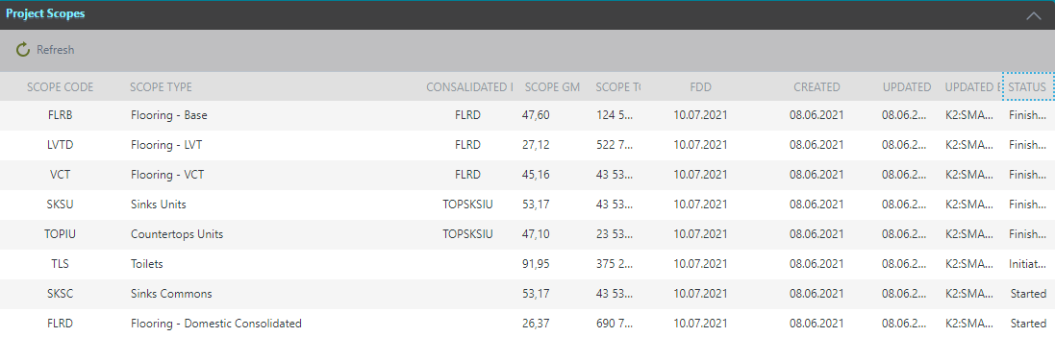

The Consolidated In column shows the Consolidated Scope Code, to which a particular Scope belongs.

After uploading the file, the Project Scope data is updated automatically. When you Upload a Quotation file with updated Scopes List data in which the Total Amount of any previously launched Scope is Null -this Scope Instance will be automatically finished.

*Action for Step*

This part gives a short description of the current step: its name; it describes the actions that need to be performed; lists the documents that need to Upload; and describes the Task Action.

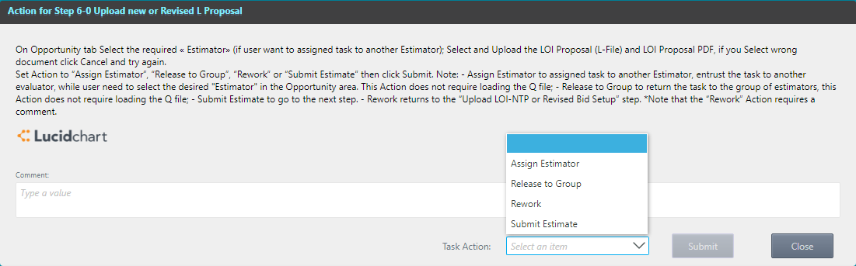

A brief description of the tasks at this stage. A description of a possible transition by Task Action

Area for entering comments, especially when the action in a step is performed Rework - a comment is required. If you want a specific user to see this comment, you need to specify the username after the @ (Example: @NameUser). This message will be shown in SalesForce chat.

To move the current step further, select "Task Action" from the drop-down list. After selecting "Action", click the "Submit" button. Or "Close" to close the current window.

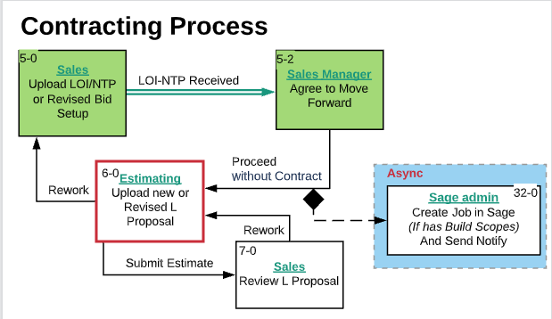

Full name of the Step

If user clicks Submit without completing all the required tasks for the current step, the user will see a warning window containing a message stating what else needs to be done.

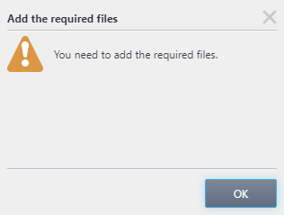

For example: You need to add the required files. Click OK and download the required files. Then repeat the Action to go to the next Step.

*Attachments*

This section shows all the documents that were uploaded in the previous steps. The command line provides additional options to Upload and Download the selected document.



After clicking the Upload button, the selected file will be displayed in the Attachments and Saved as Attachment in Process. In the Attachment view, the user may see added attachments and can download them or add a new one.

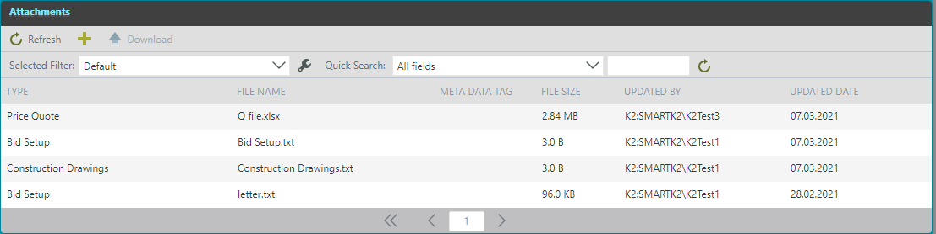

To quickly find the file you need, you can use the filter command line

The toolbar contains buttons for *Refresh* the list of uploaded documents; *Add a new document* to Attachments; button to *Download* the required document.

When adding a file using this method, an additional window opens.



To return from a folder, click the *Home* button on the toolbar. To load the selected document, click the *Add to sync list* button (or double-click the left mouse button on the required file). To update the File Status, use the *Refresh* button.

To remove the selected file from the synchronization sheet, click the *Remove* button on the toolbar. To completely clear the sync sheet, click the *Clear* button. To download the file as an attachment, *select an item* from the dropdown list and click the *Sync to Pydio* button.

To quickly find the file you need, you can use the filter command line.

***To add new attachment to Attachment’s view:***



1. Click the button in the toolbar and an auxiliary form will open.



1. Select the required file or folder from the personal directory and click on *Add to sync* list button.

3. Files will appear in the Files selected for synchronization view.

4. On the Files for synchronization view, select from drop-down list file type.

5. Click on *Sync to Pydio*.



6. After clicking Sync to Pydio, click the *OK* bottom in the message box and a new file will appear in the Attachments list.

*Action History*

This area is displayed at each step in the Opportunity tab. This area is informative and is not changed by anyone.

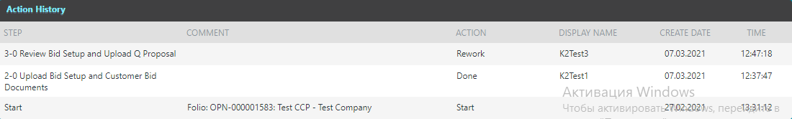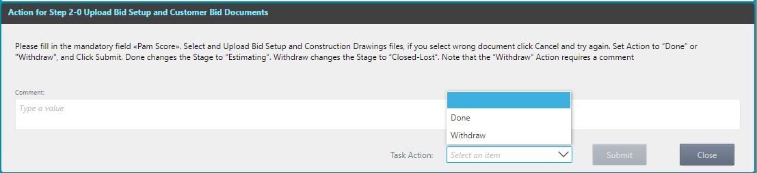

It shows a list of completed steps with their names, what comment was entered at the corresponding steps, what Action was selected for each Step, which user performed the action and on what day and time it was performed.

The bottom line in the Action History displays information about when the process started and with which Folio.

### Tab Include/Exclude

Tab Include / Exclude becomes available in the Step 3-0 Review Bid Setup and Upload Q Proposal Step. After Uploading the Quotation file to the Opportunity tabs, on the Include\Exclude tab, the user can see the specification items and special notes of the Quotation file.

*Screenshot - Sales – Step 4-1 Review and Approve Price Quotation – Contracting Process*

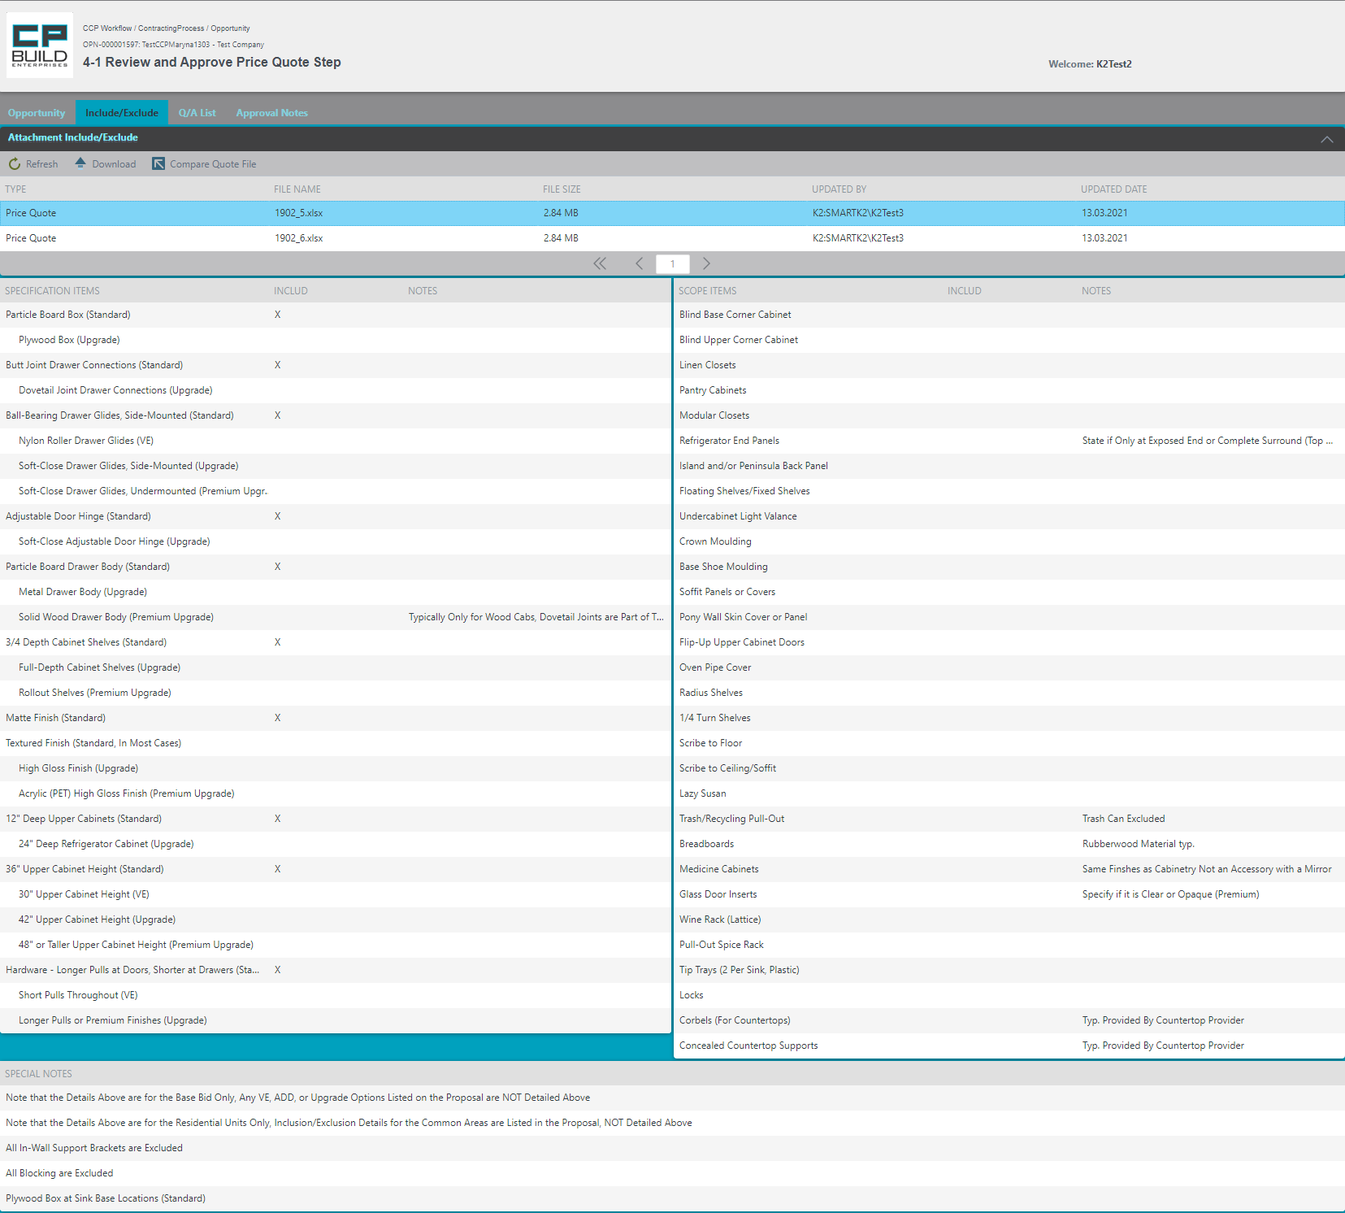

Header section, which displays current information about process name, project name and step number with its name and username.

On the Attachment view, you may see Quotation Files. Download them or Compare Quote File.

On the Include \ Exclude tab, you can see the Specification Items and Scope Items of the Quote file.

On the Include \ Exclude tab, you can see the Special Notes of the Quote file.

***To compare files:***

*Screenshot - Sales – Step 3-0 Review Bid Setup and Upload Q Proposal – Contracting Process*

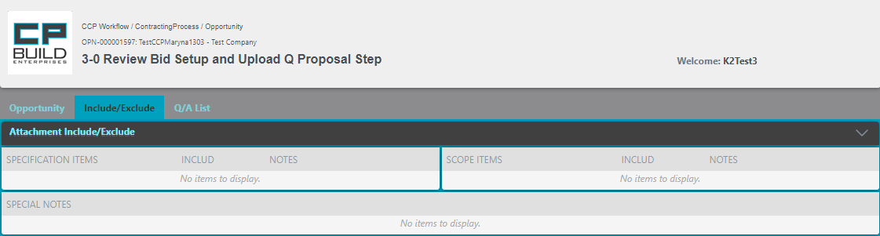

Expand the Attachment Include / Exclude

After expanding the Attachment Include/Exclude view, the user can use the Compare button to compare the Quotation file to previous information.

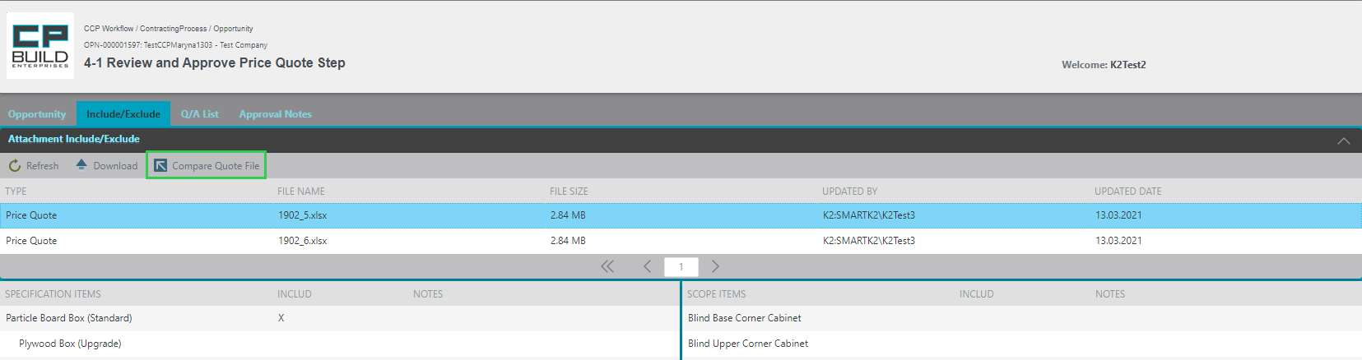

1. Select the Price Quote file you interested in and click on Compare Quote File button.
2. Sub form, where you can see the difference will open. If there is no difference with the Quote file, you will see the notification.

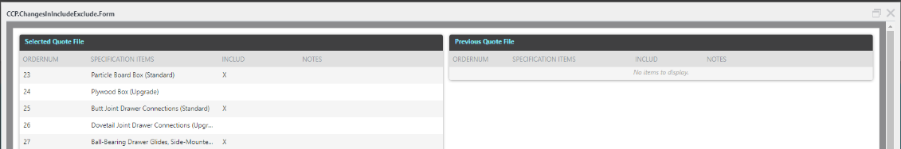

*\*Note: user can compare the Quotation file to the current one.*

This tab is for informational purposes only and is not editable.

### Tab Q/A List

This tab allows the user to correspond on issues related to this project with the Destination user. This tab is available from the first step of the project.

The Area Header section is displayed at each step. This area is informative and is not changed by anyone.

Area Attachments Q/A view user may see added attachments and download them. Attachment Q/A area works similarly to the Attachments area in the Opportunity tab.

*Screenshot - Sales – Step 2-0 Upload Bid Setup and Customer Bid Documents – Contracting Process*

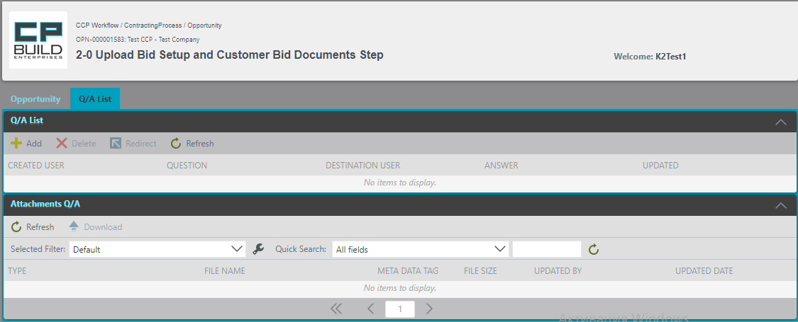

On the Attachments Q/A view, you may see added attachments and can download them.

In the Q/A List area, the entire correspondence history is available for viewing and working.

*Q/A List*

In the Q/A List part, a letter is created with a question or answer to the letter that came to the user. The user can see the history of the correspondence here.

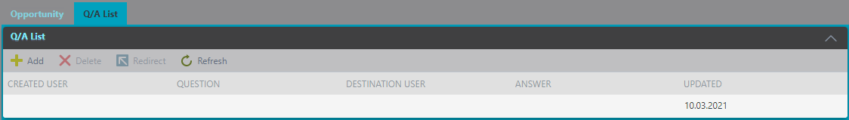

The toolbar contains buttons responsible for creating a new list of questions and answers, Click the "*Add*" button; deleting the correspondence with the "*Delete*" button; redirect to another target user with the "*Redirect*" button and Refresh windows button "*Refresh*".

This part will contain closed correspondence and awaiting answers. The list displays Created User, Question, Destination user, Answer and Updated.

***To add new Q/A List:***

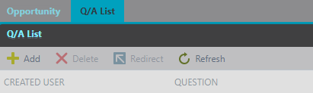

1. Click on the *Add* button to create a new question.

In the opened sub-form Project Q/A enter the Question, select the Destination User and, if needed, add an Attachment. You then click on the "Submit" button to submit the question, or on "Cancel" to exit the sub-form without saving. After you Submit, your question will immediately come to the recipient, the answer user will see iit n email and in the Q/A List at the ANSWER field.

If the user selects the wrong recipient, then select the question row, click on the Redirect button, and select another destination user.

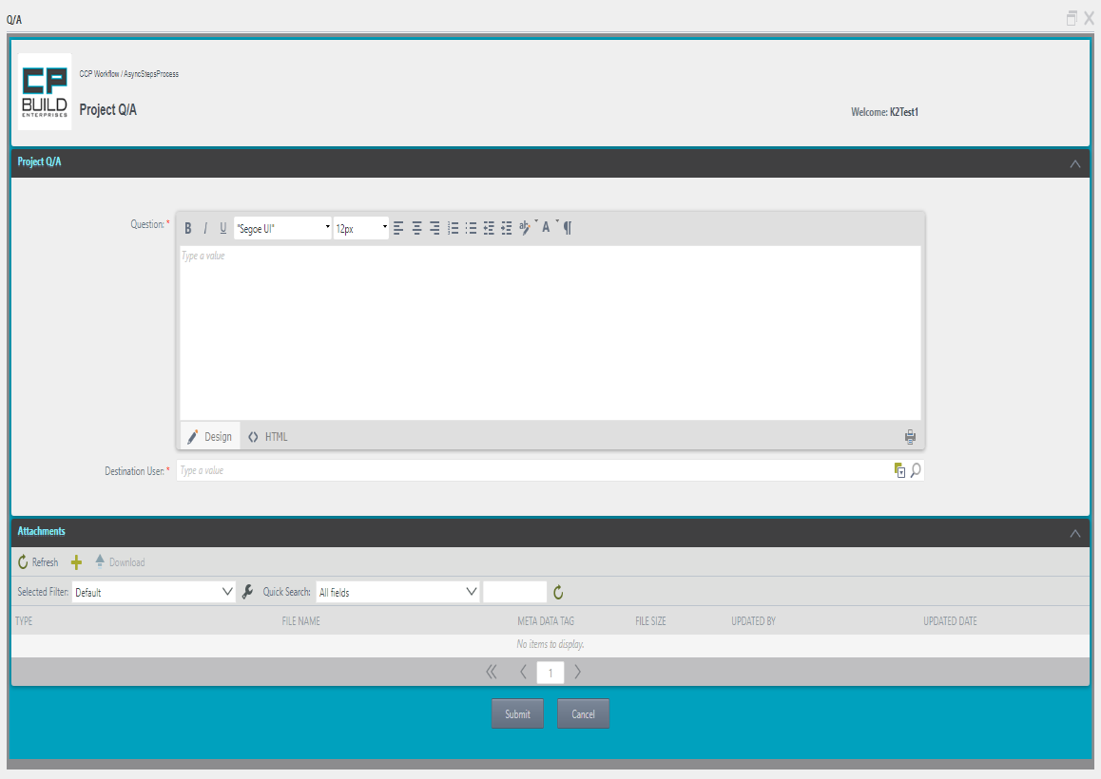

The toolbar contains buttons for editing text.

The text of the letter will be placed here. area.

Select Destination User to whom the letter is addressed.

In the Attachments view, you can see the attachments added to the letter, download them, or add new ones. This area works identically to the Tab Opportunity.

In the Project Q / A area, there is a field for the text of the letter. It is possible to edit it and select a Destination User.

The control buttons of the letter *Close* or *Submit* are located.

It is possible to unseal the text of the letter.

After the user sends the letter and in the next steps, this is what the Q / A List form will look like, if there is a need to redirect the letter to another recipient.

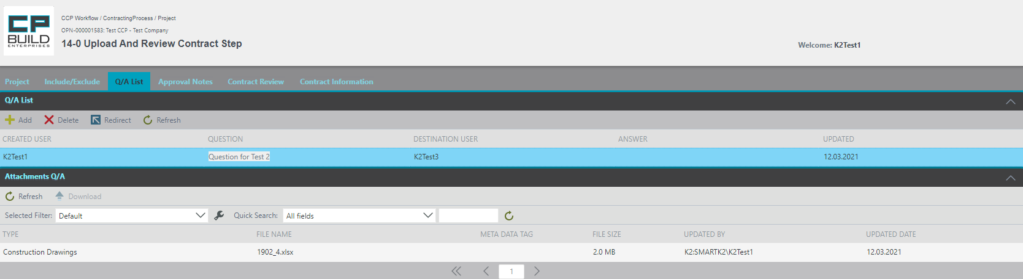

1.Highlight the required entry and click the Redirect. button.

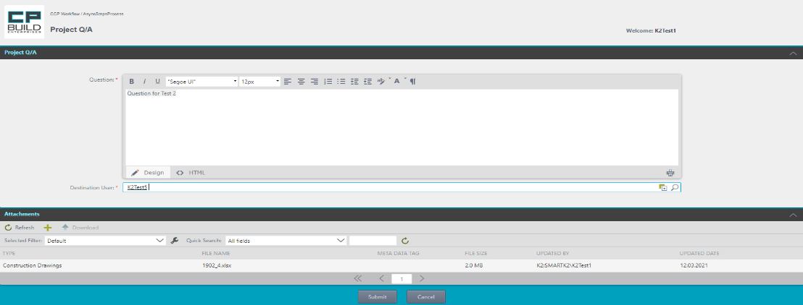

2.The text of the previous letter and attached files will be saved in the window that opens. The user needs to delete the previous target user and select the desired one. After that, click Submit at the bottom.

3. A confirmation message will then be displayed.

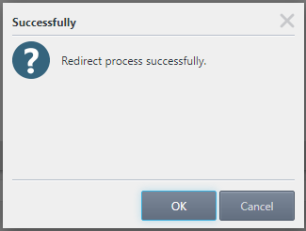

### Tab Approval Notes

Tab Approval Notes becomes available in Step 4-0 Sales Review and Approve Price Quotation. The Approval Notes tab works with the files with the type of Price Quotation. The Attachment List view user may see added attachments and download them. The Attachment List works similarly to the Attachment Q/A area in the Q/A List tab.

*Screenshot - Sales – Step 4-0 Sales Review and Approve Price Quotation – Contracting Process*

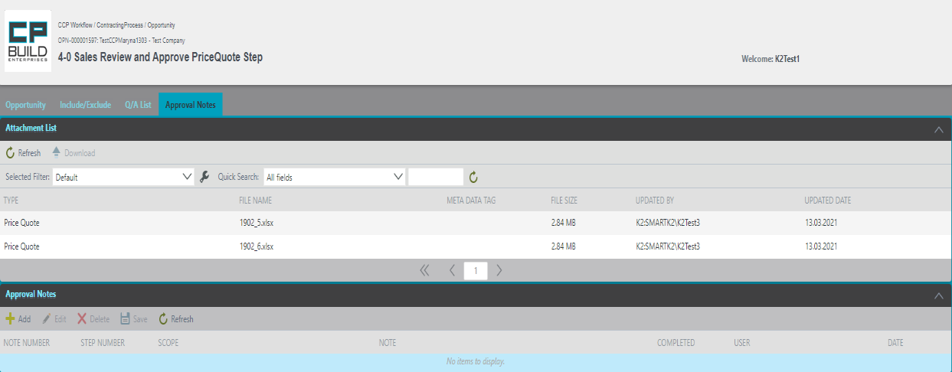

On the Attachment List view, you may see added attachments and you can download them.

In the "Approval Notes" area, you can add Notes to each Scope.



The toolbar contains buttons responsible for creating a new Notes click the "Add" button; deleting Notes with the "Delete" button; edit Notes using the "Edit" button and refresh the window with the "Refresh" button.

At this stage, you can change two fields: select Scope from the dropdown list and enter Note for these Scope.

***To add notes:***

1. On the Note column, enter the note text.

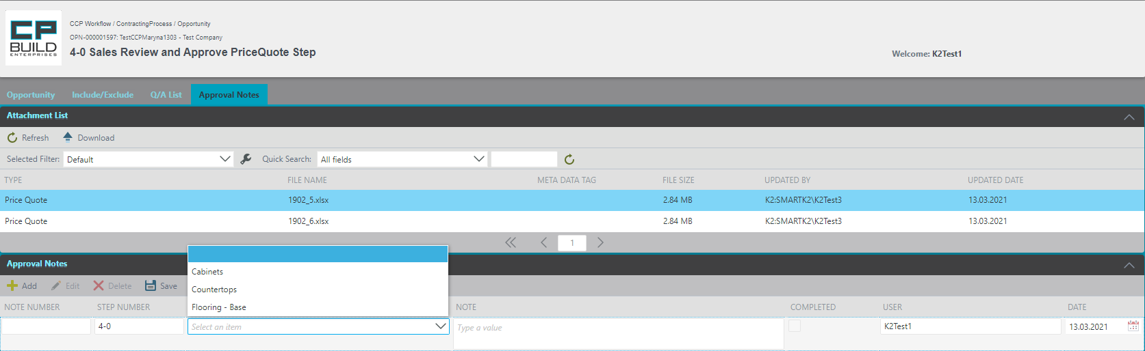

1. From the Attachments List, view select required Price Quotation file.
2. On the Approval Notes, click the Add button and a new row will appear
3. In the Scope column, select from drop-down list scope name that you need.
4. Click the Save button.

After saving, the status will be displayed with the inscription "Completed" - No.



In Step 4-2 Prepare Quotation PDF Step, On the Approval Notes tab, if approval notes were created in previous steps, the user needs to Complete approval notes.

***To Complete approval notes:***

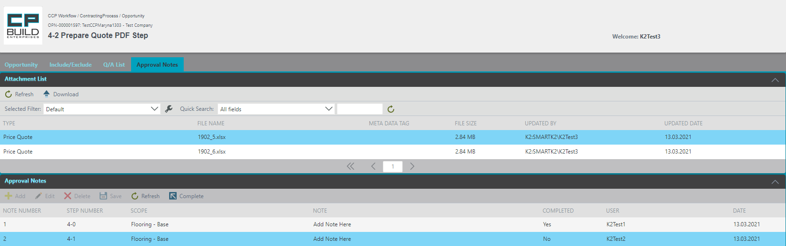

1. From the Attachments List, view select required Price Quote file
2. Select needed note on the Approval Notes
3. Click on the Complete button

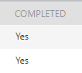

After pressing on the Complete button, the completed column will change from “No” to “Yes”.

After that, this tab works only for viewing.

### Tab Project

When moving to the Stage Contract Negotiations at Step 14 "Upload and Review Contract", the "Project" tab, replace the Opportunities tab. The data that is displayed according to the current draft contract works the same as with the Opportunities tab.

*Screenshot - Sales – Step 14-0 Upload and Review Contract – Contracting Process*

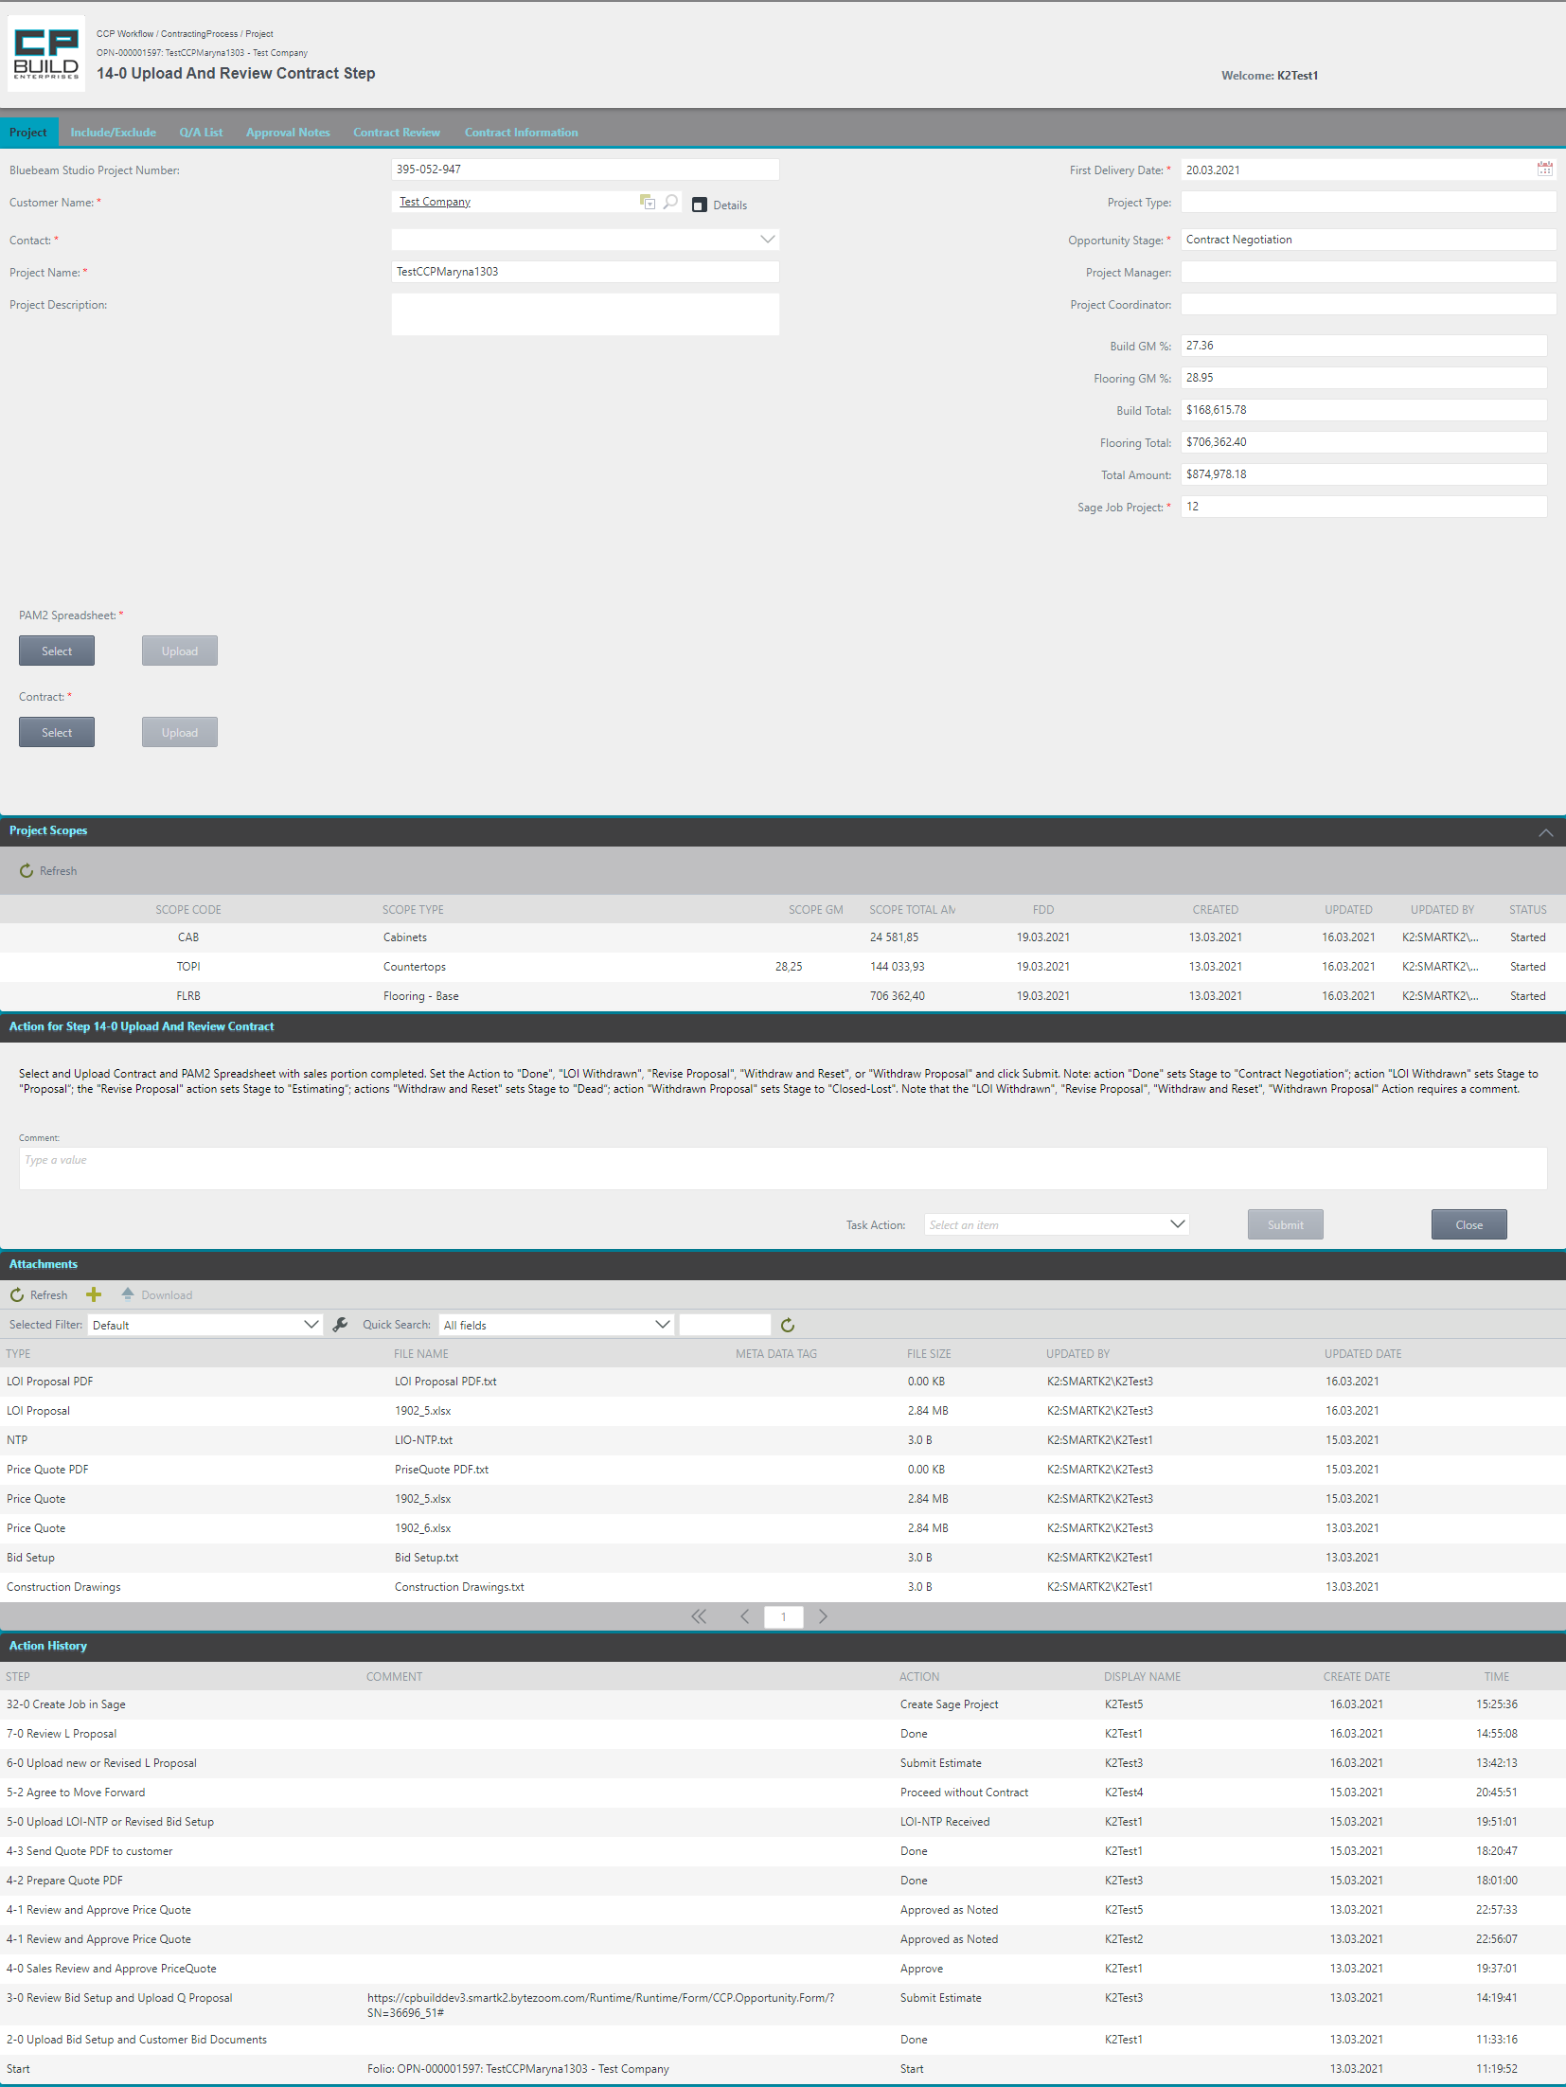

Header section, which displays current information about process name, project name and step number with its name and username.

This is the main user's work area in which tabs, fields with data information and a block for uploading the necessary documents for a specific step are available.

Action to represent a step. The user can enter a comment and select an action from the Task Action drop-down list. The user can also see a hint for the current step in the form of a description of the required actions and a link to a schematic representation of a step in the overall process.

In the Attachment view, you may see added attachments, download them, or add new ones.

Action History view shows step name, comment, action, display name, date, and time for activity in previous steps.

This part of the window displays the loaded Scopes from the Quotation Files.

On the Project tab, you can upload the necessary documents for the corresponding step and * indicate the required fields.

### Tab Contract Review

When going to the Contract Negotiation stage at 14 Upload and Review Contract step, the Contract Review tab becomes available.

*Screenshot - Sales – Step 14-0 Upload and Review Contract – Contracting Process*

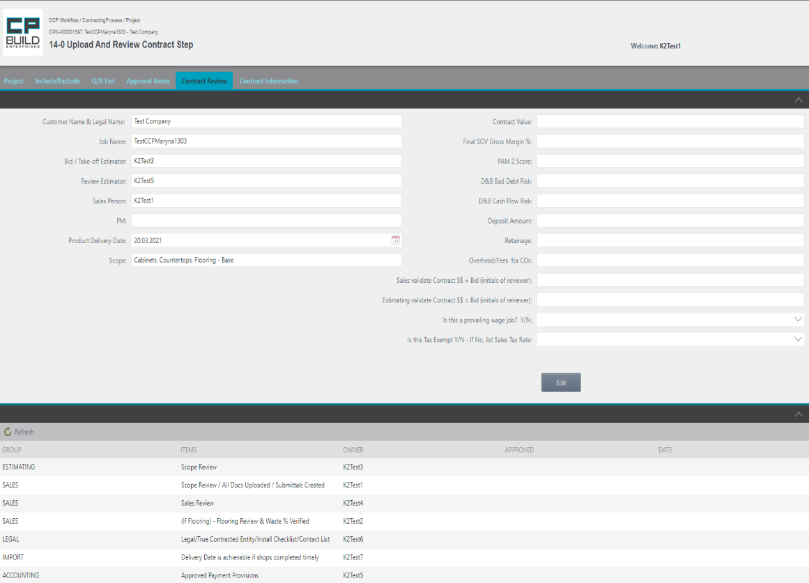

In this part of the Contract Review tab, we see the listed Checklist items for checking the contract.

In this part of the tab, we see the items of the checklist (group, items), and owner who specifies who should sign the above information in the "Contract Verification Checklist".

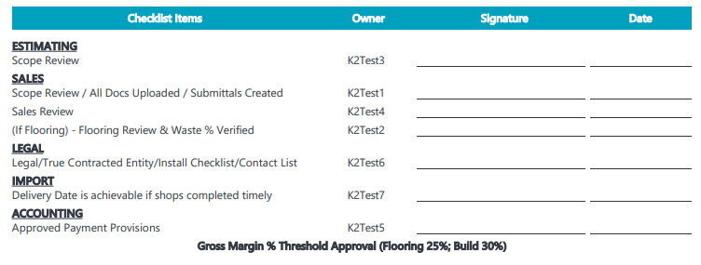

***To add information in Contract review checklist:***

On the Contract Review, the user can edit fields that would be shown in Contract Verification Checklist. Read the information in the left column and enter the details that you know in the right column. This requires:

*Screenshot - Sales – Step 14-0 Upload and Review Contract – Contracting Process*

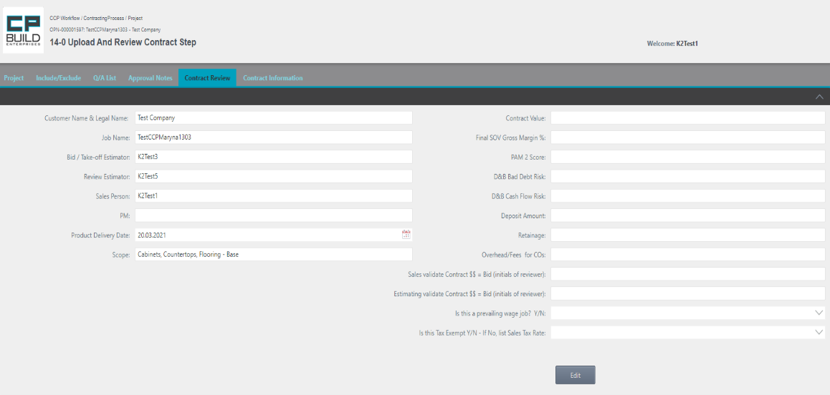

1. Click the button *Edit* and enter the details that you know in the right column.

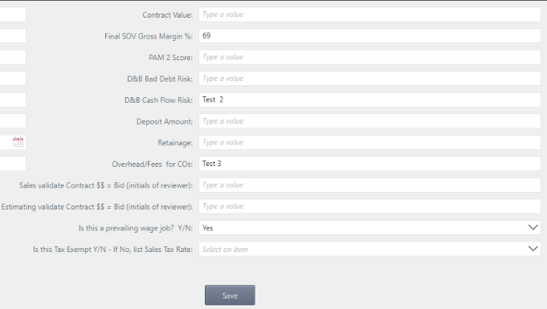

1. After entering the information you know, click the button *Save*.

At Step 16 of Prepare Contract Addendum, the formation of the "Contract review checklist" and loading becomes available.

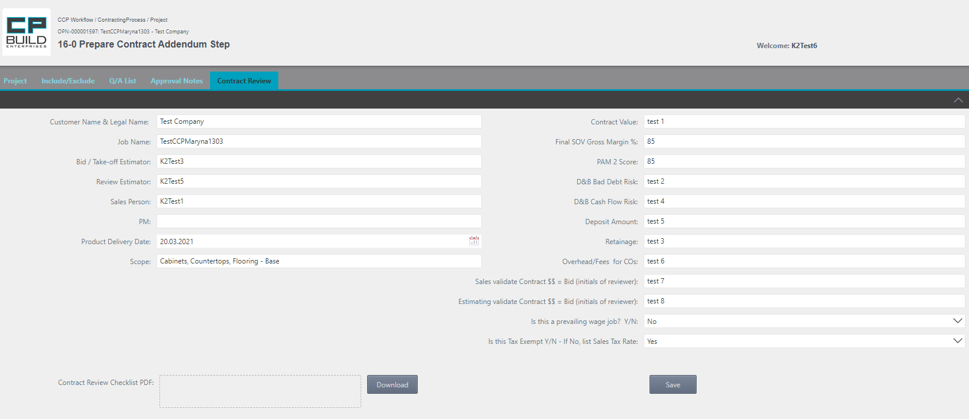

1. After entering all the information known to the user in the right column, click the *Save* button.

2. Then click the Download button. This will generate a "Contract Review Checklist PDF."

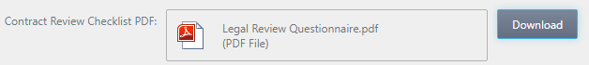

3. To download a document, you must click on it.

After loading, the document will look like

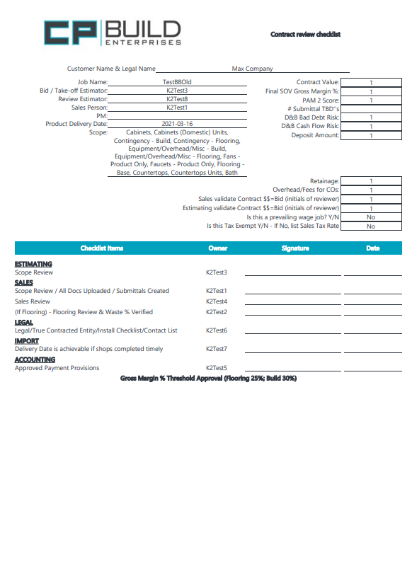

### Tab Contract Information

Going to the Contract Negotiation stage at 14 Upload and Review Contract step, the Contract Information tab becomes available.

*Screenshot - Sales – Step 14-0 Upload and Review Contract – Contracting Process*

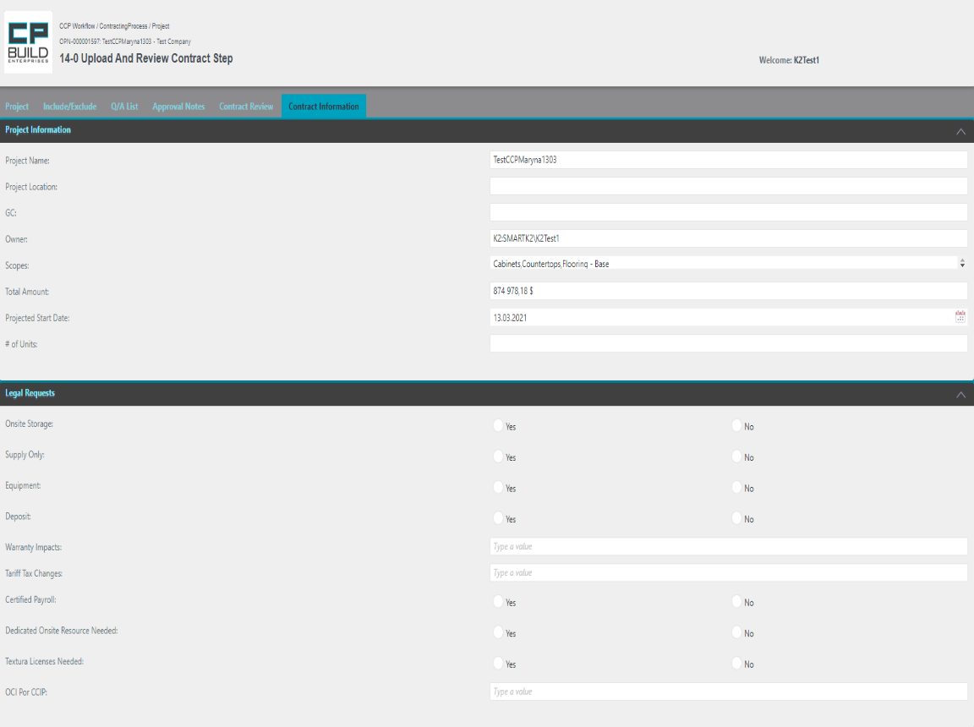

In this part, the user can see of the Contract Information.

Review the information in the Project Information area, and then complete the information in the Legal Requests area.

After clicking the submit button, information from this part will be sent by letter to all participants of this project.

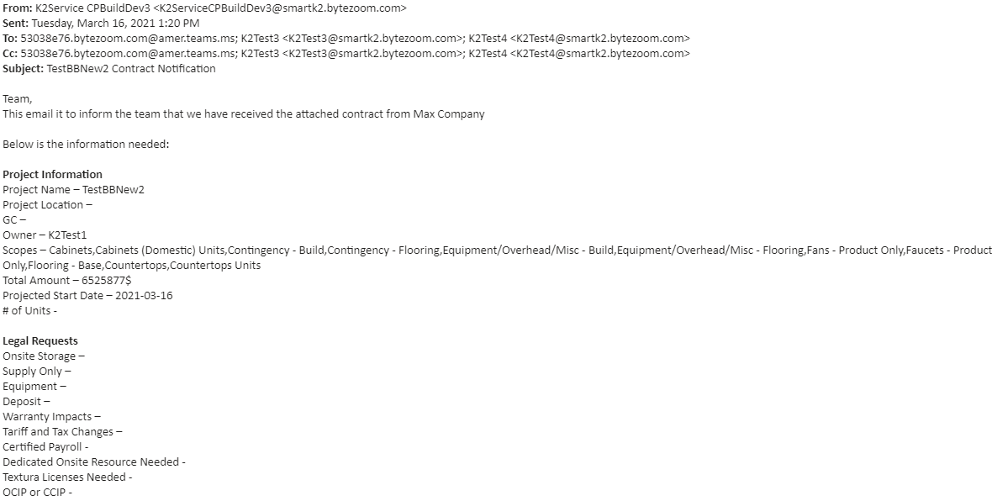

### Tab Procore Project

By going to Step 22-0 Procore Submittals Approved, the Tab Procore project is available. When you go to the Procore Project tab, you get acquainted with the message. We then go directly to the information on the tab.

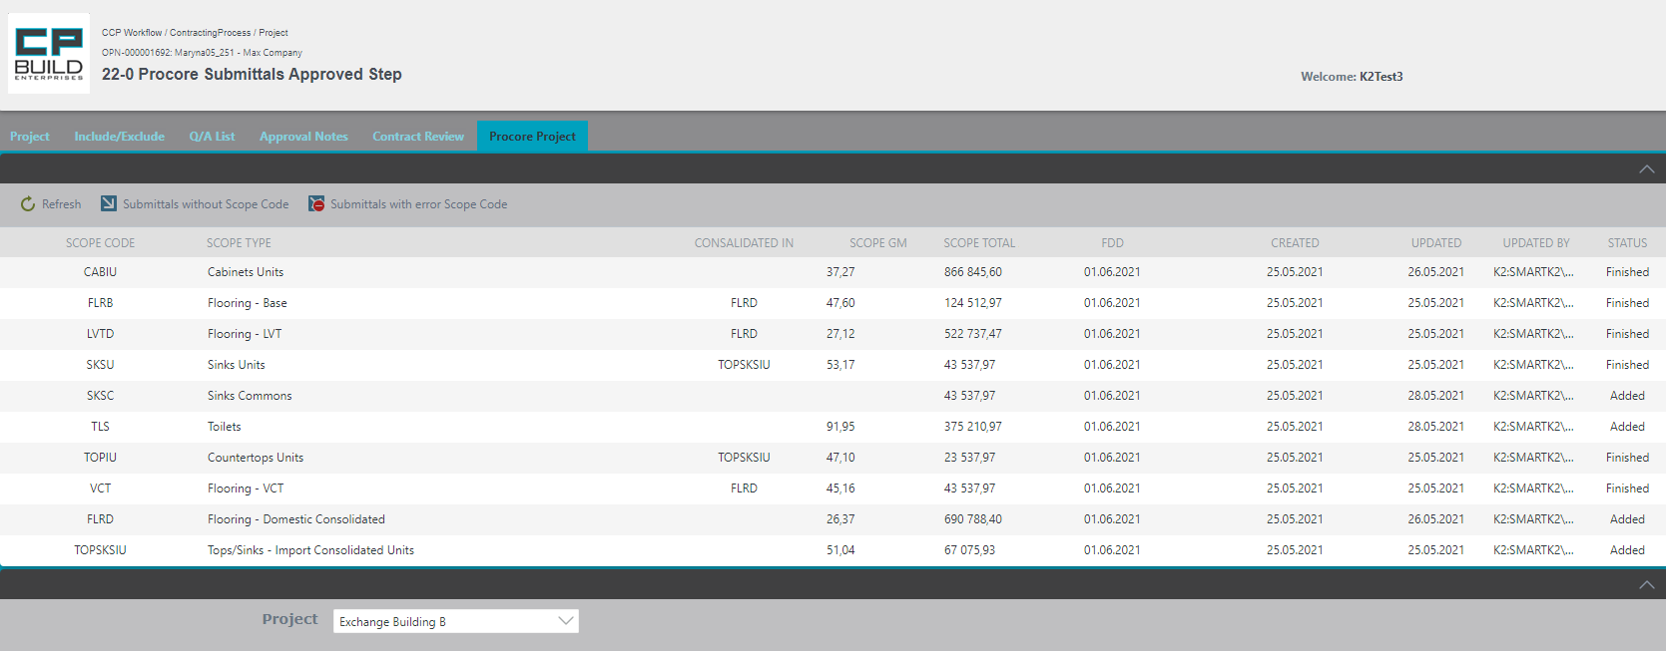



The project has Submittals without reference to Scope codes.

Click "Submittals without scope code" for details.

There are errors in the project Scope Codes in the project.

Click "Submittals with errors" for details.

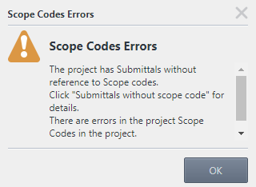

*Screenshot – Sales and PM – Step 22-0 Procore Submittals Approved – Contracting Process*

After clicking the "Submittals without scope code" button on the toolbar, the user can see.

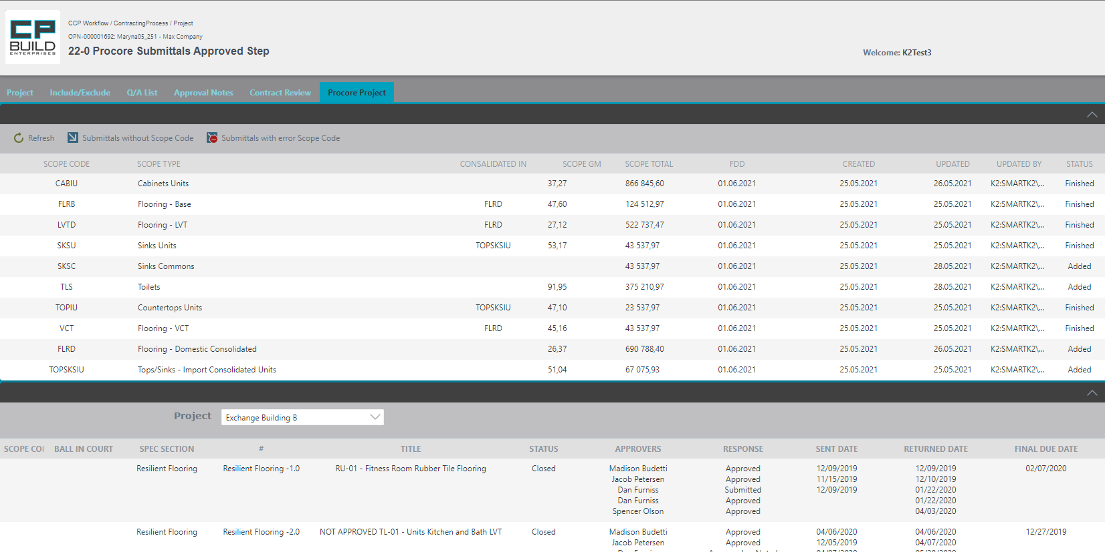

*Screenshot – Sales and PM – Step 22-0 Procore Submittals Approved – Contracting Process*

# Roles

# Task form images and instructions

### Sales

### **2-0 Upload Bid Setup and Customer Bid Documents**

In Step 2-0, look at the details on the Opportunity tab. Some fields are already filled in automatically with information from Sales Force. All other fields will be filled in automatically after uploading documents, which will contain this information, or manually by the user. If needed, ask a question on the Q/A List tab. The user can learn how to work with the corresponding tabs in the section "Form Images and descriptions," which is outlined above.

*Screenshot - Sales – Step 2-0 Upload Bid Setup and Customer Bid Documents – Contracting Process*

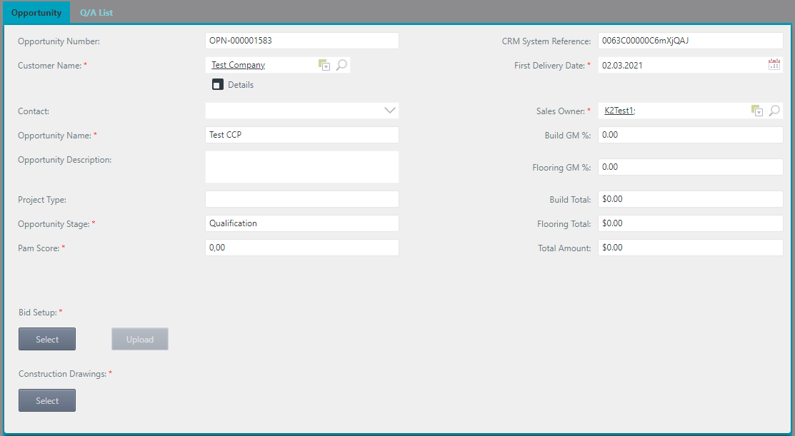

Please Select and Upload the mandatory Files, such as for the Bid Setup and Construction Drawings

At this step, we have two tabs available for work:

- Opportunity

- Q/A List

Please fill in the mandatory field «Pam Score».

In the Opportunities tab, there are required objects to be filled in.

The Q/A List tab is filled in. If there is any question.

**Action for Step 2-0 Upload Bid Setup and Customer Bid Documents**

At this step, the user needs to:

1. Fill in the mandatory field “Pam Score” (if the value needs to be changed).

2. Select and Upload the Bid Setup and Construction Drawings mandatory files, if the user selects the wrong document, click Cancel and try again.

*The User can find a step-by-step description of uploading a file in the description of the Opportunity tab.

3.Then Set Action to “Done” or "Withdraw" and Click Submit.

- The Action **"Done"** changes the Stage to “Estimating”. It then moves on to the next step.

-The Action **"Withdraw"** changes the Stage to “Closed-Lost”.

*Note: that the “Withdraw” Action requires a comment.

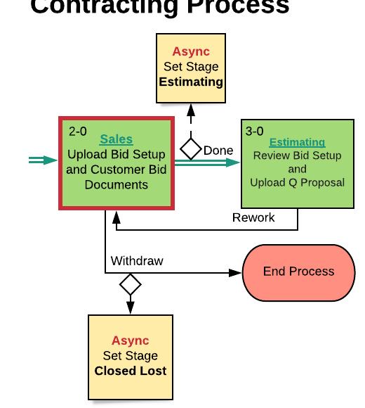

*Screenshot –* *Lucid Chart – Step 2-0 Upload Bid Setup and Customer Bid Documents – Contracting Process*

### **4-0** **Sales Review and Approve Price Quotation**

In Step 4-0, the Approval Notes tab becomes available. Look at the details on the Opportunity tab. If needed, compare the current Quotation file to the previous version on the Include/Exclude tab. Ask a question on the Q/A List tab or Add Notes to Scopes on the Approval Notes tab. The user can learn how to work with the corresponding tabs in the section "Form Images and descriptions," which is outlined above.

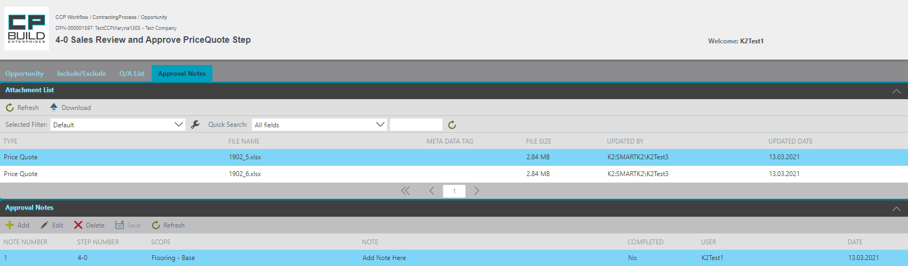

*Screenshot - Sales – Step 4-0 Sales Review and Approve Price Quotation – Contracting Process*

**Action for Step** **4-0 Sales Review and Approve Price Quotation**

At this step, the user needs to:

1. Complete and Save the Approval Conditions for Scope in the Approval Notes tab. They must then go to the "Opportunity" tab.

* The user can find a step-by-step description of how to work with the Approval Notes tab in "Form images and descriptions."

2. Set Action to “Approve” or " Rework " and Click Submit.

- The Action **"Approve"** moves on to the next step.

- The Action **"Rework"** returns to the “Review Bid Setup and Upload Quotation” step.

*Note that the “Rework” Action requires a comment.

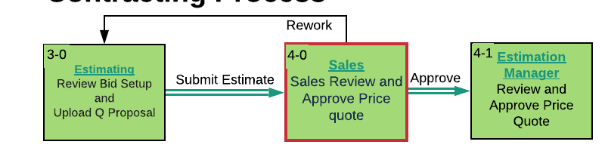

*Screenshot -* *Lucid Chart* *– Step 4-0 Sales Review and Approve Price Quotation – Contracting Process*

### **4-3 Send Quotation PDF to customer**

Step 4-3 requires Sales to Send a Quotation PDF to the customer. Look at the details on the Opportunity tab. If needed, compare the current Quotation file to the previous version on the Include/Exclude tab. Ask a question on the Q/A List tab. The user can learn how to work with the corresponding tabs in the section "Form Images and descriptions," which is outlined above.

*Screenshot - Sales –* *Step 4-3 Send Quotation PDF to customer – Contracting Process*

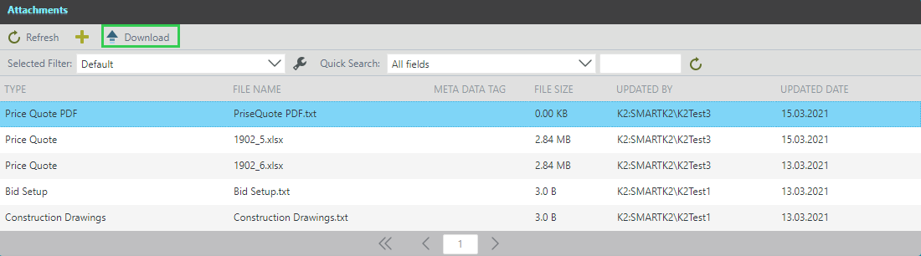

Select the required Price Quote PDF file and click the Download button on the toolbar.

**Action for Step 4-3 Send Quotation PDF to customer**

At this step, user needs to:

1. On the Opportunity tab, go down to the Attachments list. Download the Price Quotation PDF from the Attachments List and Send to Customer.

2. Then Set the Action "Done" and click Submit.

- The Action **"Done"** changes the Stage to “Proposal”. It then moves on to the next step.

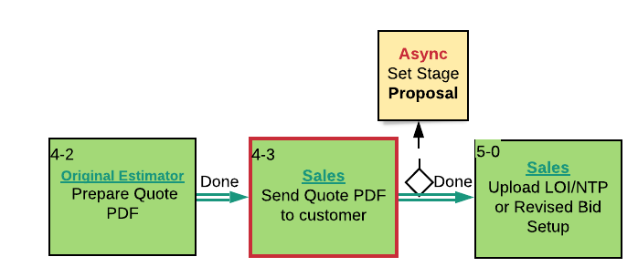

*Screenshot -* *Lucid Chart – Step 4-3 Send Quotation PDF to customer – Contracting Process*

### **5-0** **Upload LOI/NTP or Revised Bid Setup**

Step 5-0 is the select and upload LOI / NTP or Revised Bid Setup file. Look at the details on the Opportunity tab. If needed, compare the current Quotation file to the previous version on the Include/Exclude tab. Ask a question on Q/A List tab. The user can learn how to work with the corresponding tabs in the section "Form Images and descriptions," which is outlined above.

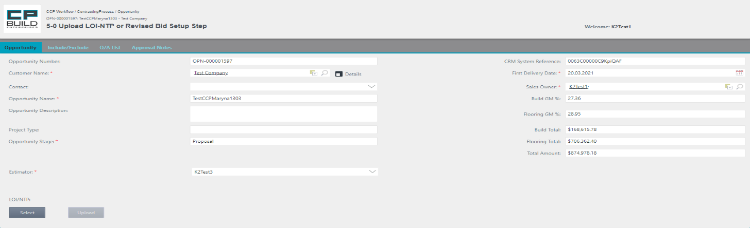

Select and upload LOI / NTP or Revised Bid Setup file

*Screenshot - Sales – Step 5-0* *Upload LOI/NTP or Revised Bid Setup – Contracting Process*

**Action for Step** **5-0** **Upload LOI/NTP** **or Revised Bid Setup**

In this step, user needs to:

1. User can Select and Upload the LOI/NTP or Revised Bid Setup document. If they select the wrong document, they click Cancel and try again.

*The User can find a step-by-step description of uploading a file in the description of the Opportunity tab.

2. They then Set Action to "Contract Received", "Dead-New", "Estimating Rework", "LOI-NTP Received" or "Reject," then click Submit.

- The Action **"Contract Received"** sets the Stage to "Contract Negotiation". It then moves on to the next step.

- The Action **"Dead-New"** sets the Stage to "Dead" and creates a New instance of the task.

- The Action **"Estimating Rework"** returns to the “Review Bid Setup and Upload Q Proposal” step.

- The Action **"LOI-NTP Received"** sets the Stage to "LOI". It then moves on to the next step.

- The Action **"Reject"** sets the Stage to "Closed-Lost".

*Note that the "Dead-New", "Estimating Rework" and "Reject" Actions require a comment.

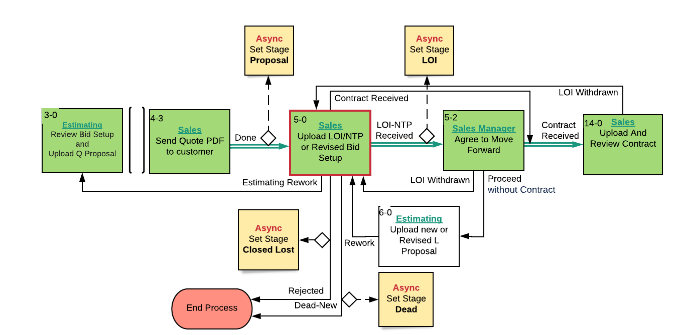

*Screenshot -* *Lucid Chart – Step 5-0 Upload LOI/NTP or Revised Bid Setup – Contracting Process*

### **5-2** **Agree to Move Forward Step**

The process is awaiting the receipt of the contract. When the contract is received, agree to move to a forward step. Look for details on the Opportunity tab. If needed, compare the current Quotation file to the previous version on Include/Exclude tab. Ask a question on the Q/A List tab. The user can learn how to work with the corresponding tabs in the section "Form Images and descriptions," which is outlined above.

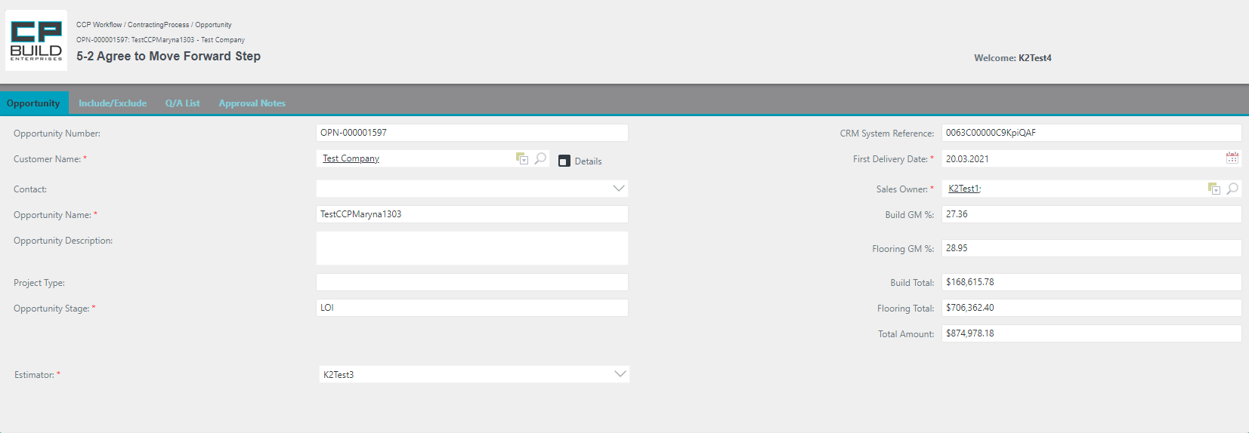*Screenshot - Sales – Step 5-2 Agree to Move Forward Step – Contracting Process*

**Action for Step** **5-2 Agree to Move Forward Step**

In this step, the user must:

1. Set Action to "Proceed without Contract", "Contract Received" or " LOI Withdrawn, " then click Submit.

- The Action **"Contract Received"** sets the Stage to "Contract Negotiation" and bypasses the creation of L Proposal and to go directly to Step "Upload and Review Contract";

- The Action **"Proceed without Contract"** moves on to the "Upload new or Revised L Proposal" step;

- The Action **"****LOI Withdrawn"** returns to the “Upload LOI/NTP or Revised Bid Setup” step.

*Note that the "LOI Withdrawn" Action requires a comment.

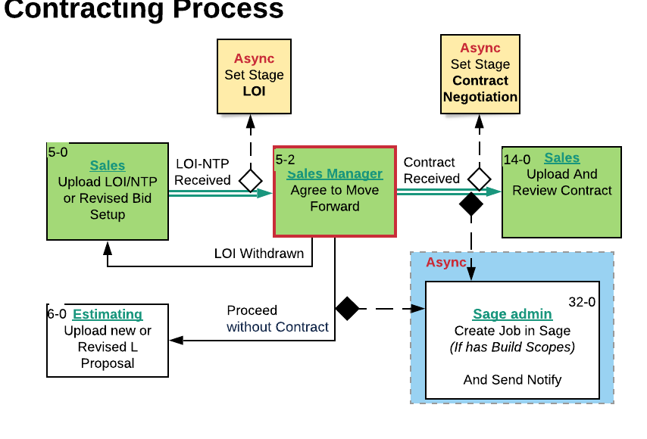

*Screenshot -* *Lucid Chart – Step 5-2 Agree to Move Forward Step – Contracting Process*

### **7-0 Review L Proposal**

Step 7-0 - Download and review the LOI Proposal file from the Attachments section. Look for details on the Opportunity tab. If needed, compare the current Quotation file to the previous version on Include/Exclude tab. Ask a question on the Q/A List tab. The user can learn how to work with the corresponding tabs in the section "Form Images and descriptions," which is outlined above.

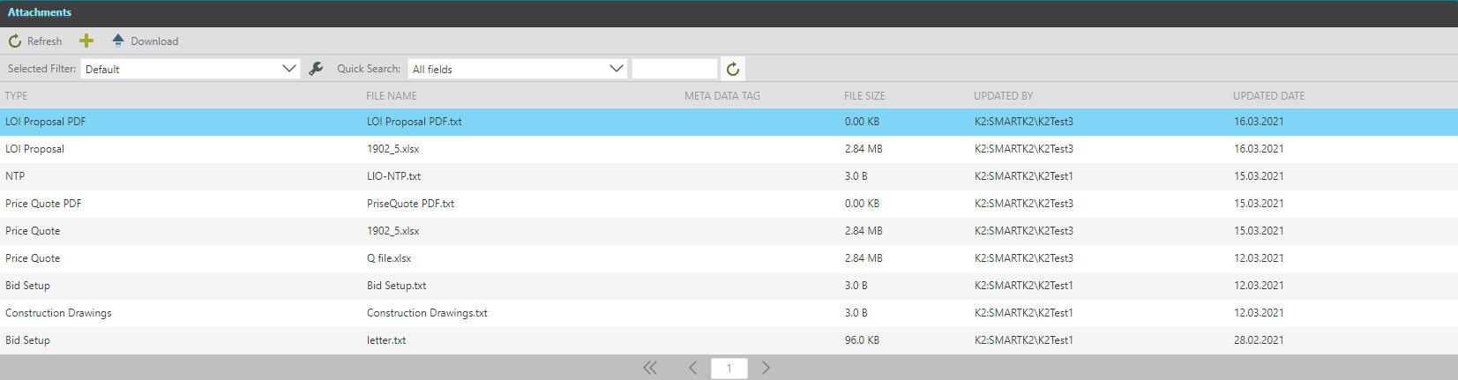

Select the required LOI Proposal PDF file and click the Download button on the toolbar.

*Screenshot - Sales – Step 7-0 Review L Proposal– Contracting Process*

**Action for Step** **7-0 Review L Proposal**

In this step, user need:

1. On the Opportunity tab, go down to the Attachments List. Download and review the LOI Proposal file from the Attachments List.

2. Set Action to “Done” or “Rework” and click Submit.

- The Action **"Done"** moves on to the next step.

- The Action **"Rework"** returns to the “Upload new or Revised L Proposal” step.

*Note that the “Rework” Action requires a comment.

After the Click button is done with the Step 7-0 Review L Proposal Step, the Project Scope Process is launched in parallel.

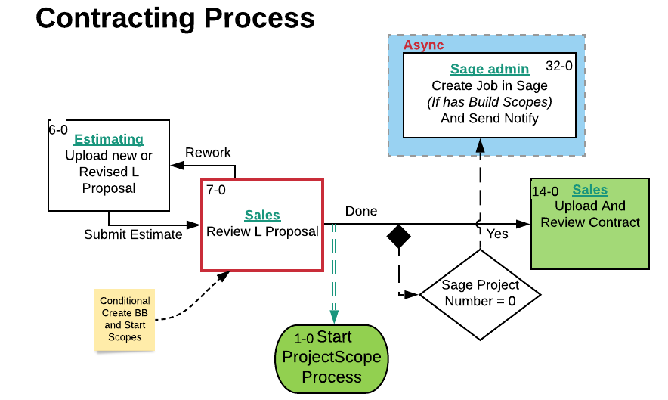

*Screenshot -* *Lucid Chart* *– Step 7-0 Review L Proposal– Contracting Process*

### **14-0 Upload and Review Contract**

In Step 14-0, it is necessary to enter information that the user knows in the tabs "Contract Review", "Contract Information" and "Project". If needed, compare the current Quotation file to the previous version on the Include/Exclude tab. Ask a question on the Q/A List tab. The user can learn how to work with the corresponding tabs in the section "Form Images and descriptions," which is outlined above.

*Screenshot - Sales – Step 14-0 Upload and Review Contract – Contracting Process*

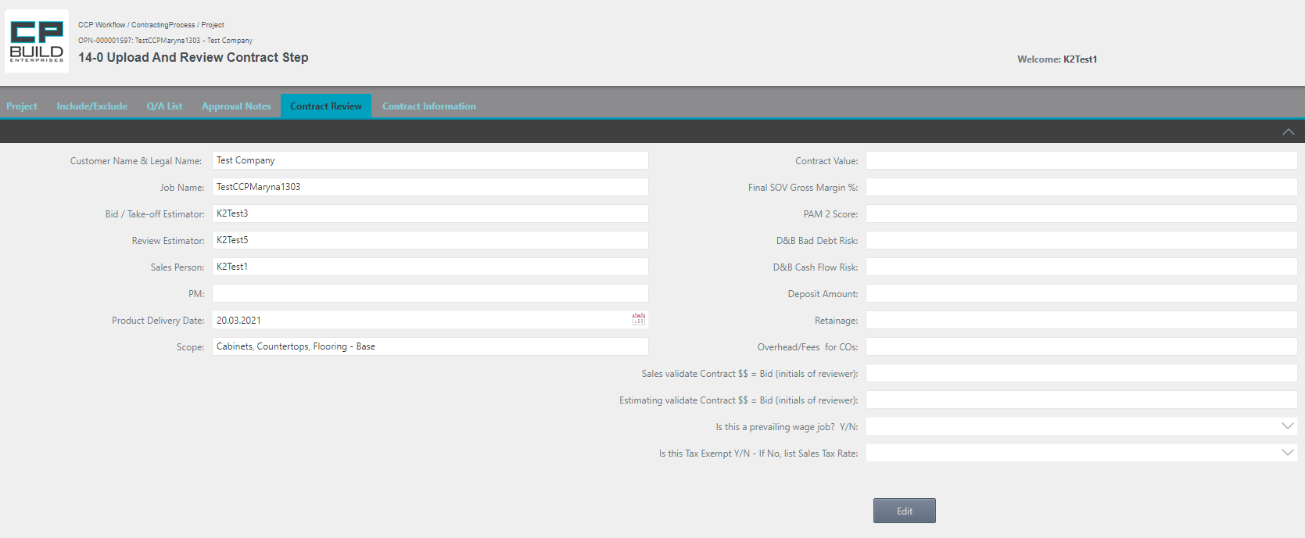

Read the information in the left column, click the Edit button, and enter the details you know in the right column.

*Screenshot - Sales – Step 14-0 Upload and Review Contract – Contracting Process*

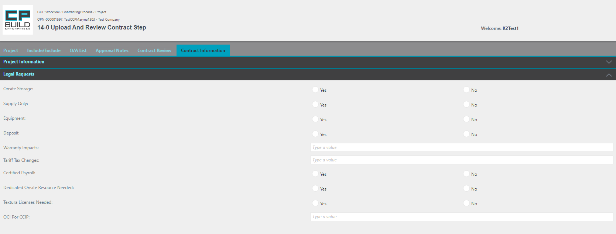

Read the information in the Project Information area, and then enter the information you know in the Legal Requests area.

*Screenshot - Sales – Step 14-0 Upload and Review Contract – Contracting Process*

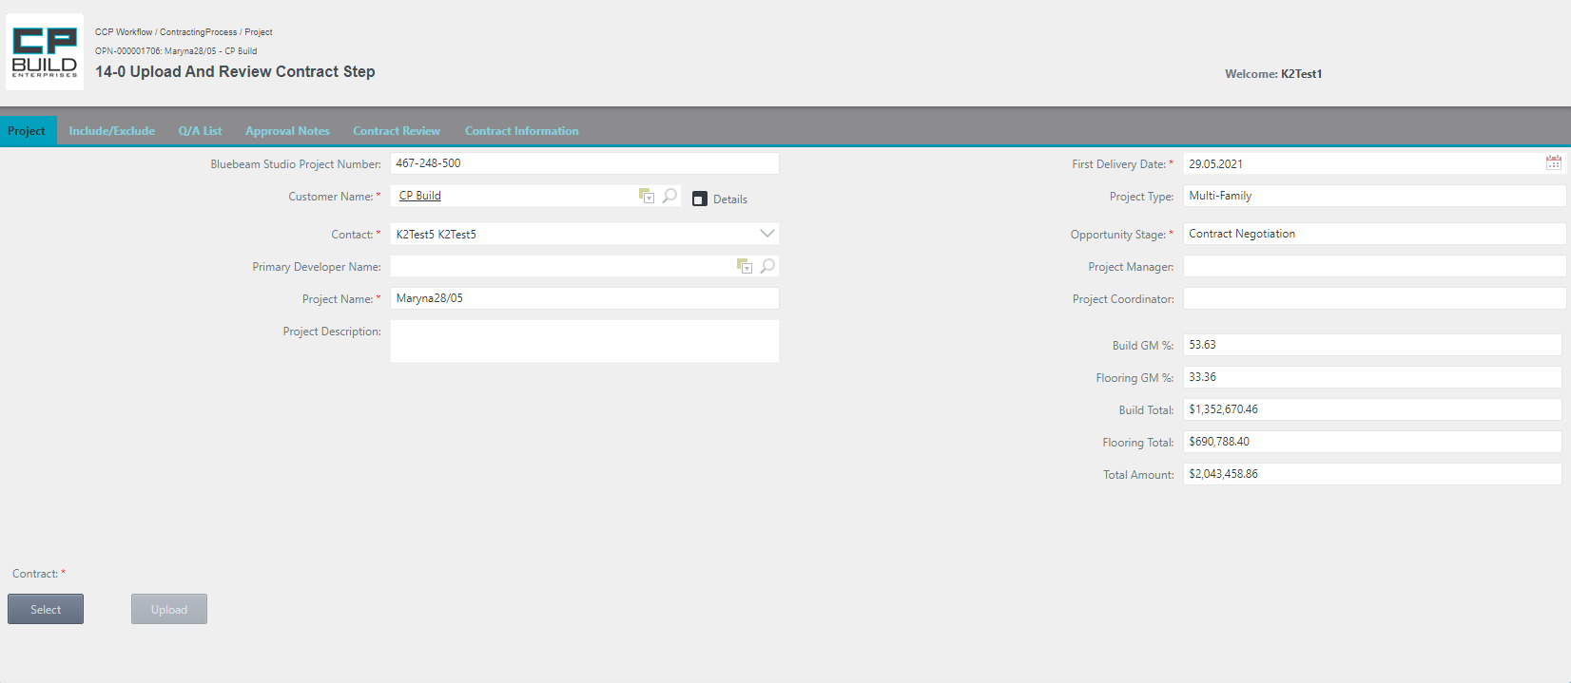

Please Select and Upload the mandatory Files for the Contract.

**Action for Step** **14-0** **Upload and Review Contract**

In this step, user must:

1. On the “Contract Review” Tab, click the Edit button and fill in the fields with the data that is available. The user can learn how to work with the corresponding tabs in the section "Form Images and Descriptions," which is outlined above.

2. Go to the “Contract Information” Tab in the Legal Request area and fill in the fields. After clicking the Submit button, information from the “Contract Information” Tab will be sent by e-mail "Preliminary Contract Notification" to all project participants. The user can learn how to work with the corresponding tabs in the section "Form Images and descriptions," which is outlined above.

3. Go to the “Project” tab, Select and Upload Contract with the sales portion completed. If user selects the wrong document, click Cancel and try again.

4. Set the Action to "Done", "LOI Withdrawn", "Revise Proposal", "Withdraw and Reset", or "Withdraw Proposal" and click Submit.

- The Action **"Done"** sets the Stage to "Contract Negotiation". It moves on to the next step.

- The Action **"LOI Withdrawn"** returns to the “Upload LOI/NTP or Revised Bid Setup” step.

- The Action **"Revise Proposal"** returns to the “Review Bid Setup and Upload Q Proposal” step.

- The Action **"Withdraw** **and Reset"** sets Stage to "Dead".

- The Action **"Withdrawn Proposal"** sets Stage to "Closed-Lost".

*Note that the "LOI Withdrawn", "Revise Proposal", "Withdraw and Reset", "Withdrawn Proposal" Action require a comment.

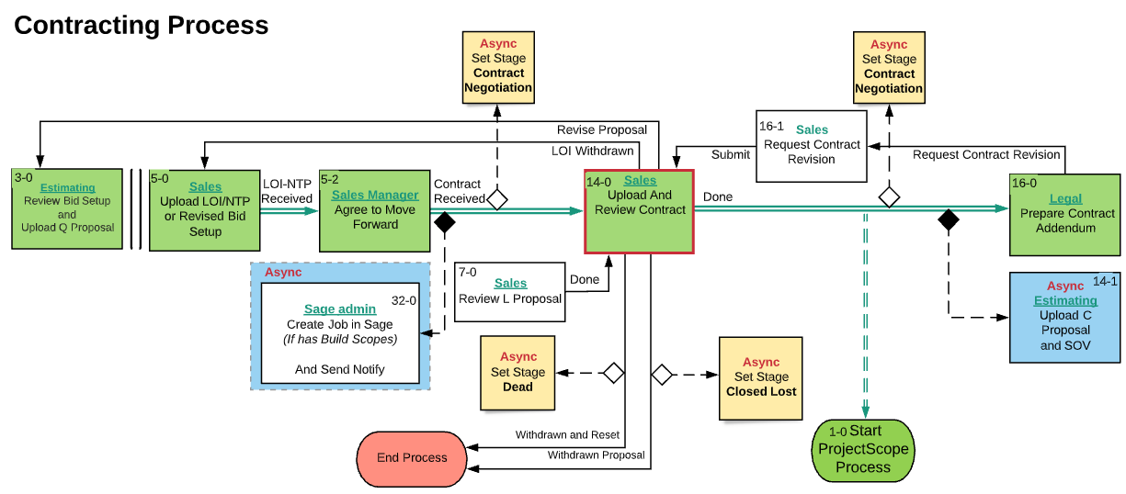

*Screenshot -* *Lucid Chart* *– Step 14-0 Upload and Review Contract – Contracting Process*

If the project went along the path Stage to "Contract Negotiation" and bypasses the creation of L Proposal, it goes directly to Step "Upload and Review Contract". After the Click button Done on Step 14-0 Upload and Review Contract, the Project Scope Process is launched in parallel.

### **16-1 Request Contract Revision**

Step 16-1 Request Contract Revision. Enter a description of the customer interaction. Look for details on the Opportunity tab. If needed, compare the current Quotation file to the previous version on Include/Exclude tab. Ask a question on the Q/A List tab. The user can learn how to work with the corresponding tabs in the section "Form Images and descriptions," which is outlined above.

*Screenshot - Sales – Step 16-1 Request Contract Revision – Contracting Process*

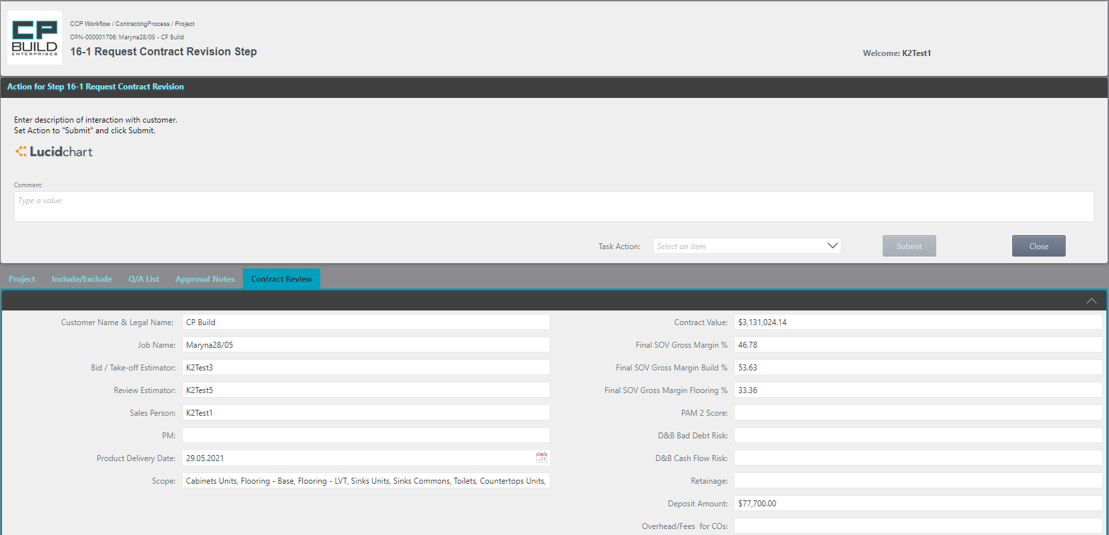

Enter description of interaction with customer.

**Action for Step** **16-1 Request Contract Revision**

In this step, the user needs to:

1. Enter a description of the interaction with the customer.

2. Set Action to "Submit" and click Submit.

- The Action **"Submit"** moves on to the step 14-0 Upload and Review Contract.

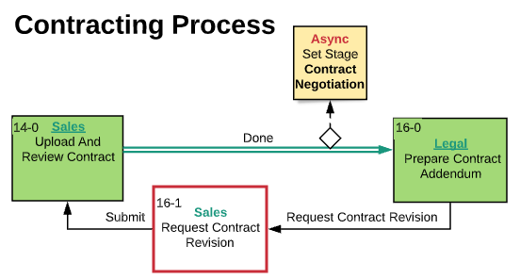

*Screen shot -* *Lucid Chart* *–* *Step 16-1 Request Contract Revision – Contracting Process*

### **19-0 Send Signed Contract to Customer Step**

Step 19-0 Send Signed Contract to Customer. Look for details on the Opportunity tab. If needed, compare the current Quotation file to the previous version on the Include/Exclude tab. Ask a question on the Q/A List tab. The user can learn how to work with the corresponding tabs in the section "Form Images and descriptions," which is outlined above.

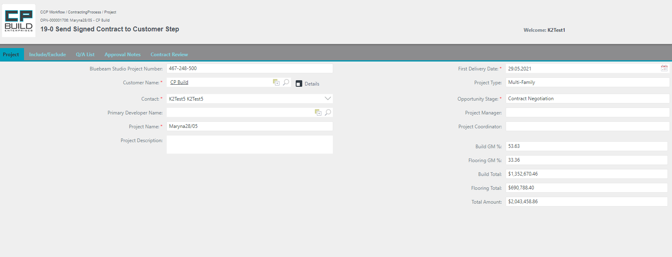

*Screen shot - Sales – Step 19-0 Send Signed Contract to Customer – Contracting Process*

**Action for Step** **19-0 Send Signed Contract to Customer**

In this step, the user needs to:

1. Send the Signed Contract to Customer.

2. Set Action to **"Done"** and click Submit.

- The Action **"Done"** moves on to the next step.

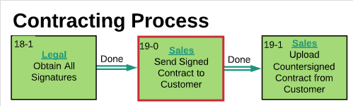

*Screenshot -* *Lucid Chart* *– Step 19-0 Send Signed Contract to Customer – Contracting Process*

### **19-1 Upload Countersigned Contract from Customer Step**

Step 19-1 Upload Countersigned Contract from Customer. Look for details on the Opportunity tab. If needed, compare the current Quotation file to the previous version on the Include/Exclude tab. Ask a question on the Q/A List tab. The user can learn how to work with the corresponding tabs in the section "Form Images and descriptions," which is outlined above.

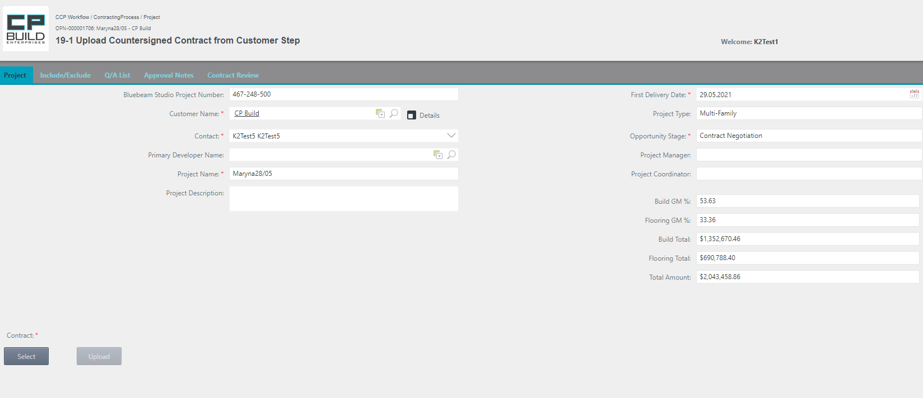

Please Select and Upload the mandatory Files for the Contract.

*Screenshot - Sales –* *Step 19-1 Upload Countersigned Contract from Customer – Contracting Process*

**Action for Step 19-1** **Upload Countersigned Contract from Customer**

In this step, the user needs to:

1. On the Project tab, Select and upload the Countersigned Contract from the Customer. If the user Selects the wrong document, click Cancel and try again.
2. Set Action to **"Legal Review"** or **"Legal Review or Rework"** and click Submit.

- The Action **"Legal Review"** moves on to the next step.

- The Action **"Legal Review or Rework"** returns to the "Prepare Contract Addendum" step.

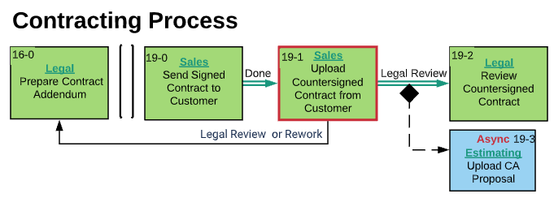

*Screenshot -* *Lucid Chart* *– Step 19-1 Upload Countersigned Contract from Customer – Contracting Process*

### **22-0 Procore Submittals Approved Step**

Step 22-0 Procore Submittals Approved the Procore Project tab is available. If needed, compare the current Quotation file to the previous version on the Include/Exclude tab. Ask a question on the Q/A List tab. The user can learn how to work with the corresponding tabs in the section "Form Images and descriptions," which is outlined above.





The project has Submittals without reference to Scope codes.

Click "Submittals without scope code" for details.

There are errors in the project Scope Codes in the project.

Click "Submittals with errors" for details.



*Screenshot - Sales – Step 22-0 Procore Submittals Approved – Contracting Process*

**Action for Step 22-0 Procore Submittals Approved**

In this step, the user needs to:

1. On the Procore Project tab, investigate Scope Code Errors, if any. Click "Submittals without scope code" for details. If the project has Submittals without reference to Scope codes, click "Submittals with errors" for details.

2. On the Project tab, set Action to “Approve” and click Submit.

- The Action **"Approve"** moves on to the next step.

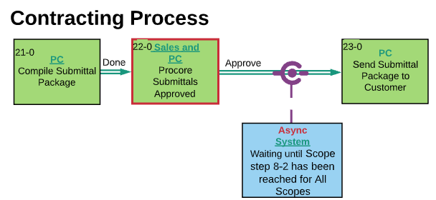

*Screenshot -* *Lucid Chart* *– Step 22-0 Procore Submittals Approved – Contracting Process*

### **56-0 Start Transition meeting Step**

Step 56-0 - Start Transition meeting. Look for details on the Opportunity tab. If needed, compare the current Quotation file to the previous version on the Include/Exclude tab. Ask a question on the Q/A List tab. The user can learn how to work with the corresponding tabs in the section "Form Images and descriptions," which is outlined above.

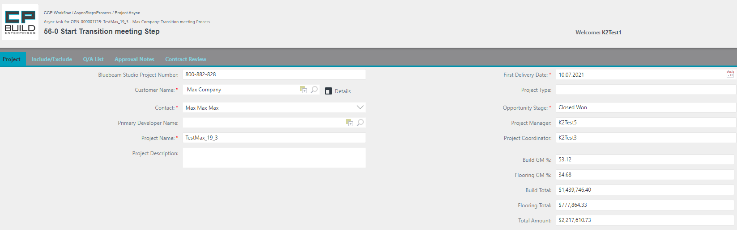

*Screenshot - Sales – Step 56-0 Start Transition meeting – Contracting Process*

**Action for Step 56-0 Start Transition meeting**

In this step, the user needs to:

1. After this step, Sales holds a transition meeting with PM and PC.
2. Set Action to **"Done"** and click Submit.

- The Action **"Done"** moves on to the next step.

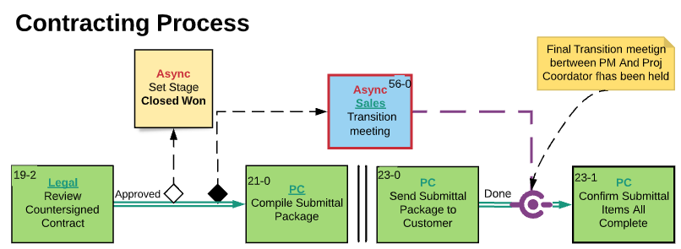

*Screenshot -* *Lucid Chart – Step 56-0 Start Transition meeting – Contracting Process*

If after Step "23-0 Send Submittal Package to Customer," the asynchronous step "56-0 Transition meeting" is not yet closed, the process will be blocked and will not be able to get to "23-1 Confirm Submittal Item All Complete".

### Estimating

### **3-0** **Review Bid Setup and Upload Q Proposal**

In Step 3-0, some fields are already filled in automatically with information from the Sales Force. All other fields will be filled in automatically after uploading the Q file at this step, or manually by the user. Look for details on the Opportunity tab. If needed, compare the current Quotation file to previous version on Include/Exclude tab. Ask a question on the Q/A List tab or Add Notes to Scopes on the Approval Notes tab. The user can learn how to work with the corresponding tabs in the section "Form Images and descriptions," which is outlined above.

*Screenshot - Estimating – Step 3-0 Review Bid Setup and Upload Q Proposal – Contracting Process*

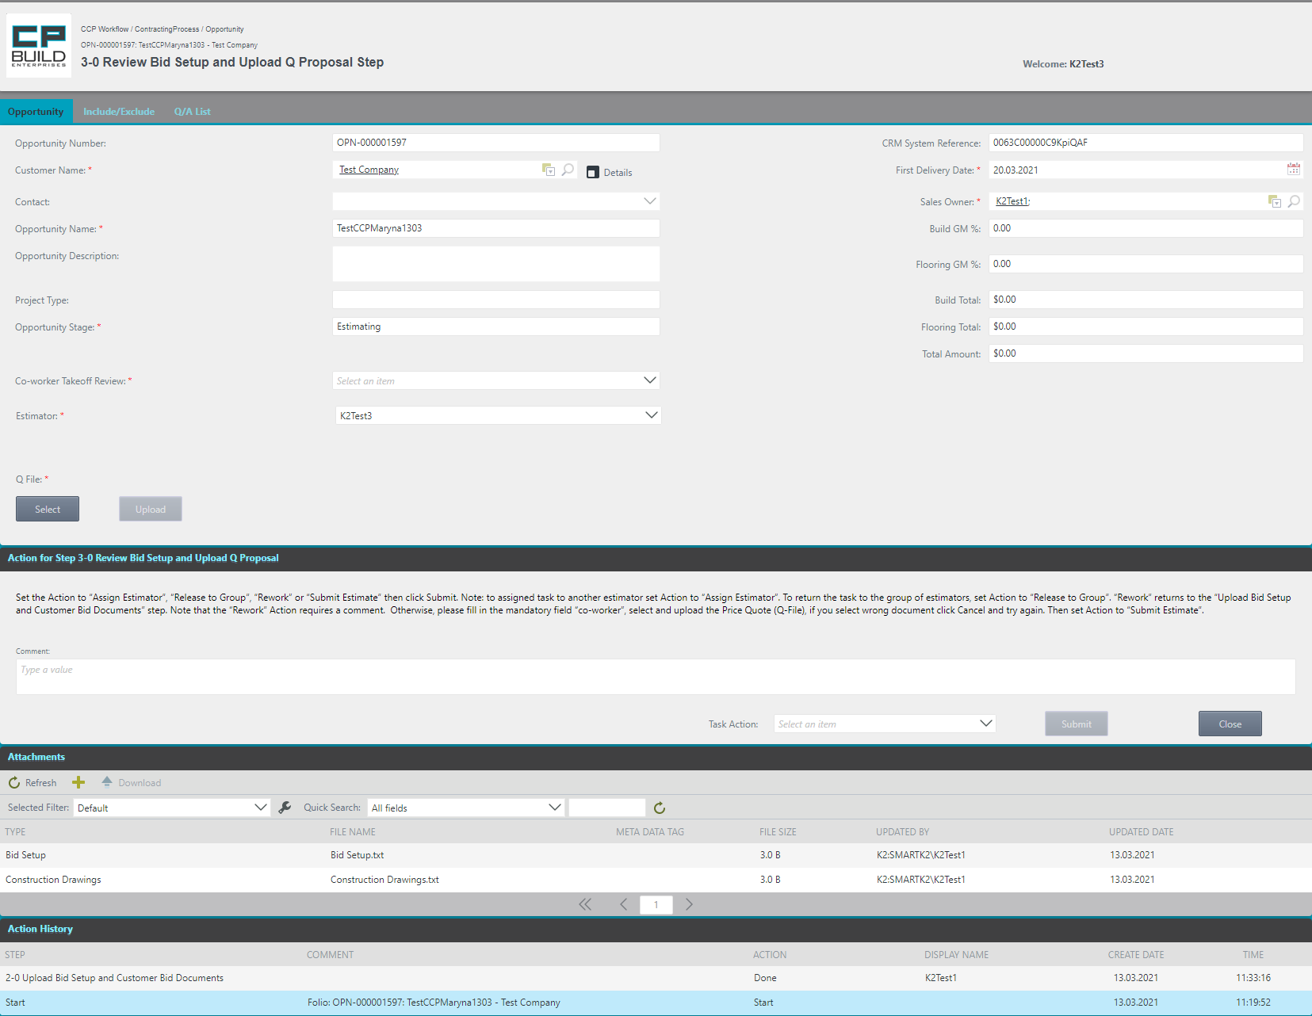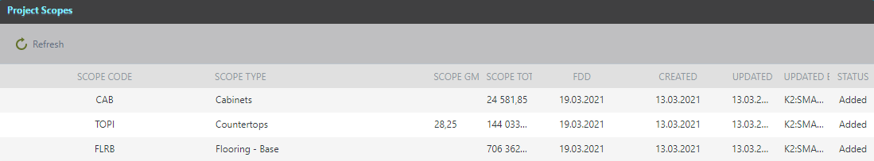

In this step, it is imperative to fill out the Co-worker Take off Review and, if necessary, you can change the Estimator.

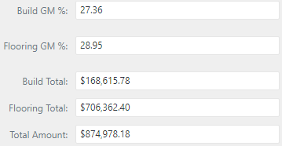

After Upload of the required Q-file, the Project Scope will appear in the Attachment List and the data in certain fields will be updated.

There are three tabs available for this step: Opportunity, Include / Exclude and Q / A. List.

**Action for Step 3-0** **Review Bid Setup and Upload Q Proposal**

In this this step, the user needs to:

1. Select the required Co-Worker from the drop-down list “Co-worker Take off Review “. This field is required.
2. Select the required “Estimator” from the drop-down list (if user wants to assign task to another Estimator)

3. Select and Upload mandatory files, Price Quotation (Q-File). If the user selects the wrong document, click Cancel and try again.

* User can find a step-by-step description of uploading a file in the description of the "Form Images and descriptions".

4. Then Set the Action to “Assign Estimator”, “Release to Group”, “Rework” or “Submit Estimate,” then click Submit.

- The action **"Assign Estimator"** entrusts the task to another Estimator. For this to occur, the current Estimator must select the desired "Estimator" in the drop-down list. This action does not require uploading the Q file.

- The Action **"Release to Group"** returns the task to the group of estimators. This Action does not require uploading the Q-file.

- The **"Rework"** action returns to the “Upload Bid Setup and Customer Bid Documents” step.

*Note that the “Rework” Action requires a comment.

- The **"Submit Estimate"** action proceeds to the next step.

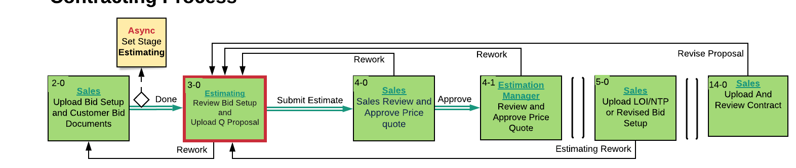

*Screenshot -* *Lucid Chart – Step 3-0 Review Bid Setup and Upload Q Proposal – Contracting Process*

### **4-1** **Review and Approve Price Quotation**

In order to proceed to the next step in the process, it is necessary that all Estimating Managers have completed the current step. When someone from the "Estimating Manager" selects the "Rework" action, the whole process will return to Step "3-0 Review Bid Setup and Upload Q Proposal". Look at the details on the Opportunity tab. If needed, compare the current Quotation file to the previous version on the Include/Exclude tab. Ask a question on the Q/A List tab or Add Notes to Scopes on the Approval Notes tab. The user can learn how to work with the corresponding tabs in the section "Form Images and descriptions," which is outlined above.

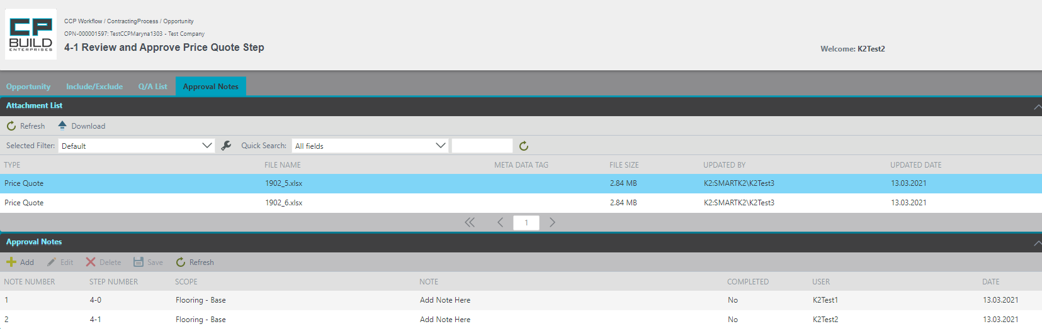

*Screenshot - Estimating – Step 4-1 Review and Approve Price Quotation – Contracting Process*

**Action for Step** **4-1 Review and Approve Price Quotation**

In this step, the user needs to:

1. Complete and Save the Approval Conditions for the Scope in the Approval Notes tab. Then go to the "Opportunity" tab.

* The user can find a step-by-step description of how to work with the Approval Notes tab in "Form images and descriptions."

2. Set the Action “Approve as Noted” or “Rework” and click Submit.

- The **"Approve as Noted"** action proceeds to the next step.

- The Action **"Rework"** returns to the “Review Bid Setup and Upload Quotation” step.

*Note that the “Rework” Action requires a comment.

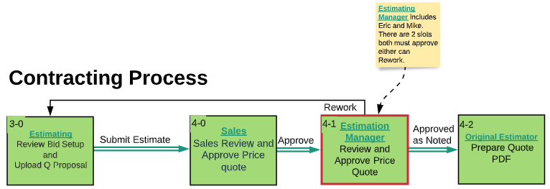

*Screenshot -* *Lucid Chart* *– Step 4-1 Review and Approve Price Quotation – Contracting Process*

### **4-2 Prepare Quotation PDF**

This Step 4-2 Prepare Quotation PDF loads the Quotation file. The current version of the project supports the 5th version of the Quotation file templates. If the user tries to upload a different version of the proposal file, the system will issue a warning. Look at the details on the Opportunity tab. If needed, compare the current Quotation file to the previous version the on Include/Exclude tab. Ask a question on the Q/A List tab or Add Notes to Scopes on the Approval Notes tab. The user can learn how to work with the corresponding tabs in the section "Form Images and descriptions," which is outlined above.

*Screenshot - Estimating – Step 4-2 Prepare Quotation PDF – Contracting Process*

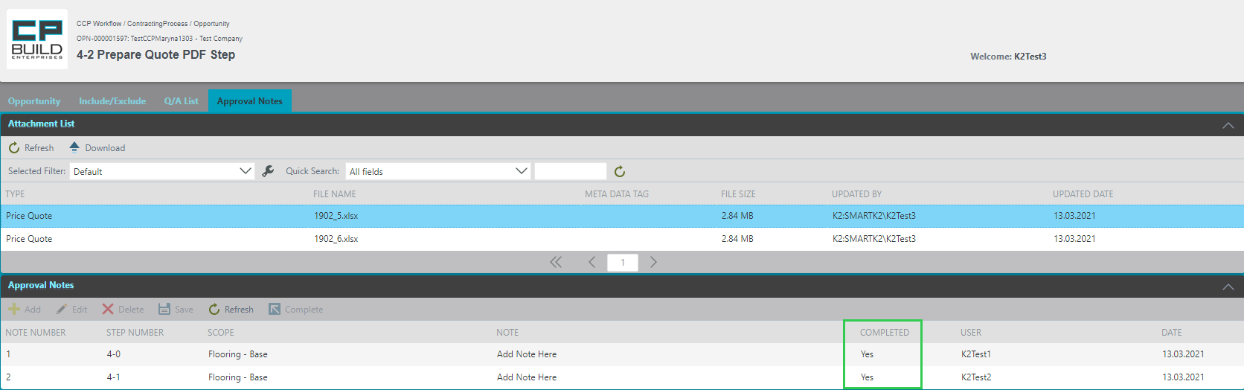

If Approval Notes were created on previous steps, user needs to Complete Approval Notes.

*Screenshot - Estimating – Step 4-2 Prepare Quotation PDF – Contracting Process*

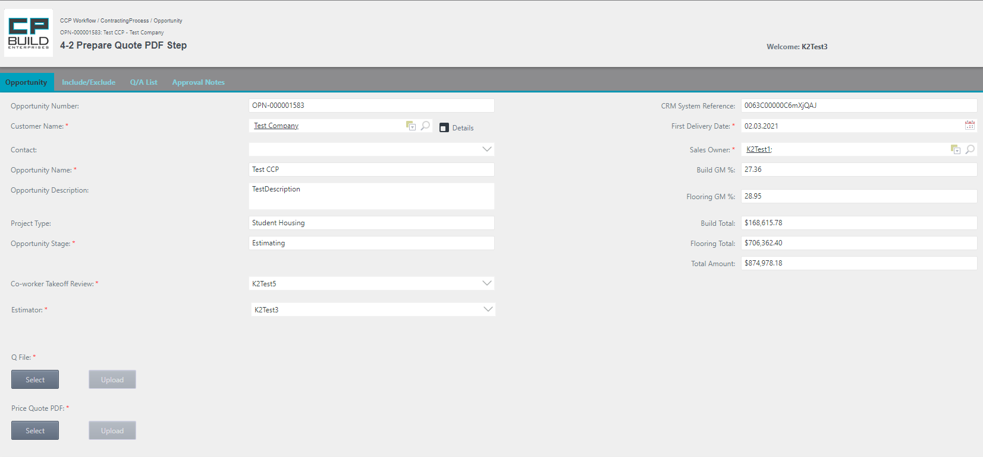

After Upload, the required Q-file and Price Quote PDF appear in Attachment List and the data in certain fields will be updated.



**Action for Step** **4-2** **Prepare Quotation PDF**

For this step, the user needs to:

1. On the Approval Notes tab, check Notes Completed. (to the method for performing this action is described in detail in the section "Form Images and descriptions.")

2. Then go to the Opportunity tab. Select and Upload the Quotation (Q-File) and Quotation PDFs. If the user selected the wrong document, click Cancel and try again.

3. Set the Action “Done” and click Submit.

- The Action **"Done"** moves on to the next step.

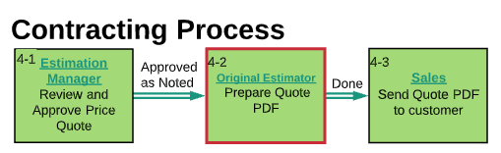

*Screenshot -* *Lucid Chart – Step 4-2 Prepare Quotation PDF – Contracting Process*

### **6-0 Upload new or Revised L Proposal**

This Step 6-0 Upload new or Revised L Proposal loads the Quotation file. The current version of the project supports the 5th version of the Quotations file templates. If the user tries to download a different version of the proposal file, the system will issue a warning. Look at the details on the Opportunity tab. If needed, compare the current Quotation file to the previous version on the Include/Exclude tab. Ask a question on the Q/A List tab or Add Notes to Scopes on the Approval Notes tab. The user can learn how to work with the corresponding tabs in the section "Form Images and descriptions," which is outlined above.

c*Screenshot - Estimating – Step 6-0 Upload new or Revised L Proposal – Contracting Process*

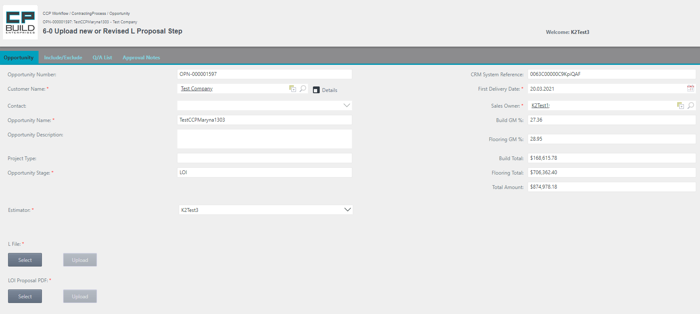

Upload L-file and LOI Proposal PDF, will appear in the Attachment List and the data in certain fields will be updated.



**Action for** **Step 6-0** **Upload new or Revised L Proposal**

In this step, the user needs to:

1. In the Opportunity tab, Select and Upload the LOI Proposal (L-File) and LOI Proposal PDF. If you select the wrong document, click Cancel and try again.

2. Set Action to “Assign Estimator”, “Release to Group”, “Rework” or “Submit Estimates” then click Submit.

- The action **"Assign Estimator"** entrust the task to another Estimator. The current Estimator must select the desired "Estimator" in the drop-down list. This action does not require the uploading of the Q file.

- The Action **"Release to Group"** returns the task to the group of estimators. This Action does not require uploading the Q-file.

- The **"Rework"** action returns to the “Upload LOI-NTP or Revised Bid Setup” step;

*Note that the “Rework” Action requires a comment.

- The **"Submit Estimate"** action proceeds to the next step.

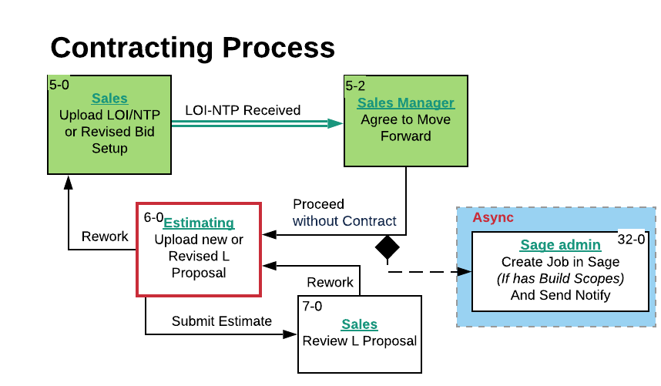

*Screenshot -* *Lucid Chart – Step 6-0 Upload new or Revised L Proposal – Contracting Process*

### **14-1 Upload** **C Proposal and SOV**

This Step 14-1 Upload C Proposal and SOV loads the Quotation file. The current version of the project supports the 5th version of the Quotations file templates. If the user tries to upload a different version of the proposal file, the system will issue a warning. Step 14-1 is Upload C Proposal and SOV. Look on for the details on the Opportunity tab. If needed, compare the current Quotation file to the previous version on the Include/Exclude tab. Ask a question on the Q/A List tab or Add Notes to Scopes on the Approval Notes tab. The user can learn how to work with the corresponding tabs in the section "Form Images and descriptions," which is outlined above.

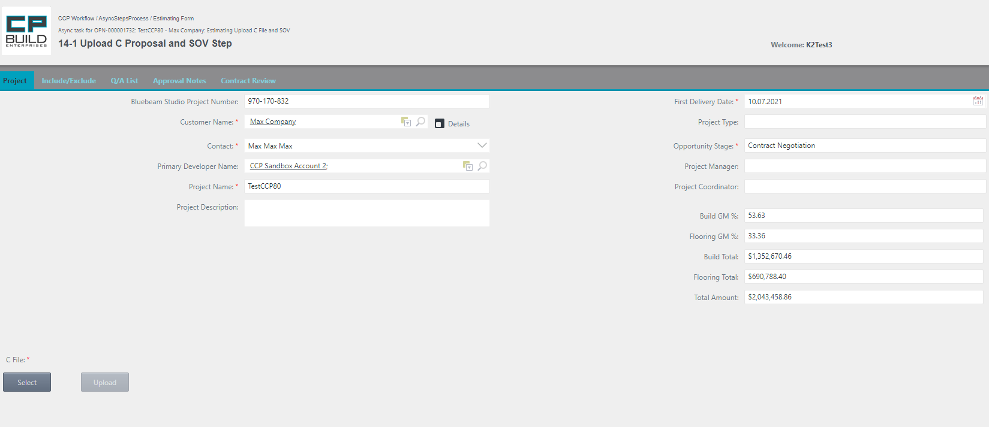

Upload C-file will appear in Attachment List and the data in certain fields will be updated.

*Screenshot - Estimating – Step 14-1 Upload C Proposal and SOV – Contracting Process*

**Action for Step 14-1 Upload C Proposal and SOV**

In this this step, user needs to:

1. In the Opportunity tab, Select and Upload Clean Proposal (C File) document. If you Select the wrong document, click Cancel and try again.

* After uploading the file, the Project Scope data is updated automatically. When you Upload a Quotation file with updated Scopes List data, in which the Total Amount of any previously launched Scope is Null, this Scope Instance will be automatically finished.

2. Set the Action as "Done" and click Submit.

- The Action **"Done"** moves on to the next step.

* After clicking the Submit button, complete contract information will be sent by e-mail "Contract Notification Notice" to all project participants.

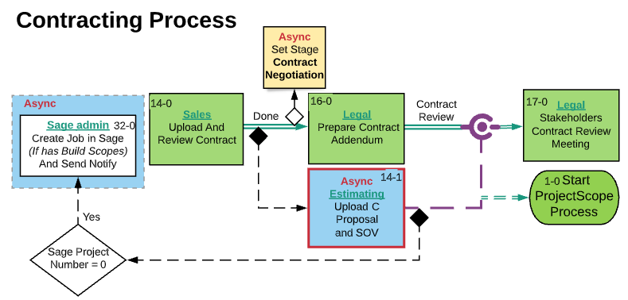

*Screenshot -* *Lucid Chart* *– Step 14-1 Upload C Proposal and SOV – Contracting Process*

If after Step "16-0 Prepare Contract Addendum," the asynchronous step "14-1 Upload C Proposal and SOV" is not yet closed, the process will be blocked and will not be able to get to "17-0 Stakeholders Contract Review Meeting Step ".

### 19-3 Upload CA Proposal Step

This Step 19-3 Upload CA Proposal loads the Quotation file. The current version of the project supports the 5th version of the Quotations file templates. If the user tries to upload a different version of the proposal file, the system will issue a warning. Look for the details on the Opportunity tab. If needed, compare the current Quotation file to the previous version on the Include/Exclude tab. Ask a question on the Q/A List tab or Add Notes to Scopes on the Approval Notes tab. The user can learn how to work with the corresponding tabs in the section "Form Images and descriptions," which is outlined above.

*Screenshot - Estimating – Step 19-3 Upload CA Proposal – Contracting Process*

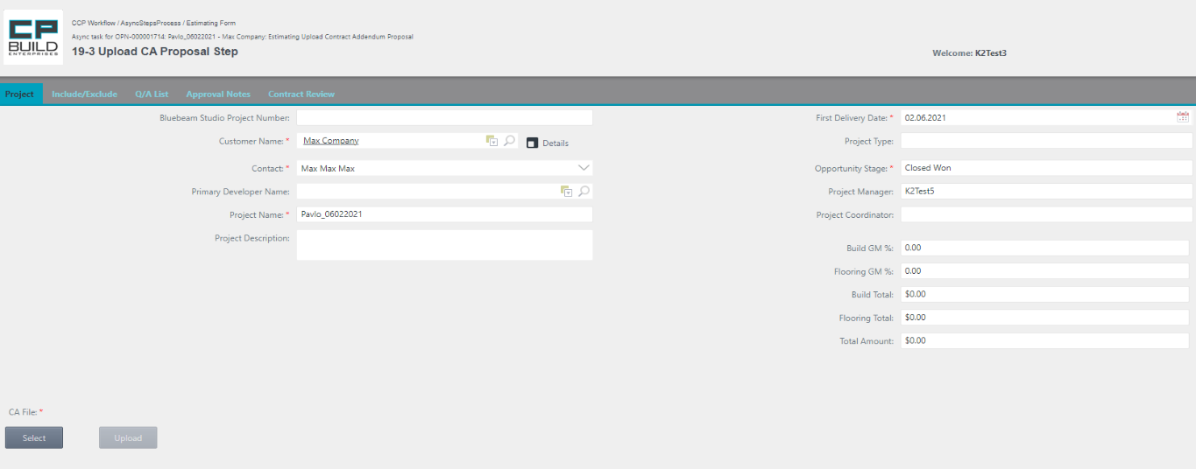

Upload CA-file will appear in Attachment List and the data in certain fields will be updated.



**Action for Step** **19-3 Upload CA Proposal**

In this step, the user needs to:

1. In the Opportunity tab, Select and Upload CA Proposal (CA File) document. If you Select the wrong document, click Cancel and try again.

* After uploading the file, the Project Scope data is updated automatically. When you Upload a Quotation file with updated Scopes List data, in which the Total Amount of any previously launched Scope is Null, this Scope Instance will be automatically finished.

2. Set the Action as "Done" and click Submit.

- The Action **"Done"** moves on to the next step.

Note* After clicking Submit, information about the CA SOV Upload will be sent by email to Project Coordination Manager.

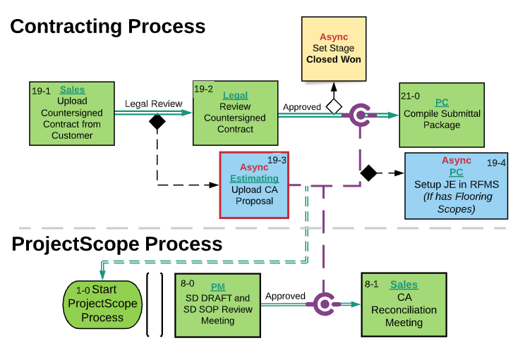

*Screenshot - -* *Lucid Chart* *– Step 19-3 Upload CA Proposal– Contracting Process*

If after Step "19-2 Review Countersigned Contract Step, " the asynchronous step "19-3 Upload CA Proposal Step " is not yet closed, the process will be blocked and will not be able to get to "21-0 Compile Submittal Package Step ".

### **58-0 Upload OPS Proposal Step**

Step 58-0 Upload OPS Proposal meeting. Look for the details on the Opportunity tab. If needed, compare the current Quotation file to the previous version on the Include/Exclude tab. Ask a question on the Q/A List tab. The user can learn how to work with the corresponding tabs in the section "Form Images and descriptions," which is outlined above.

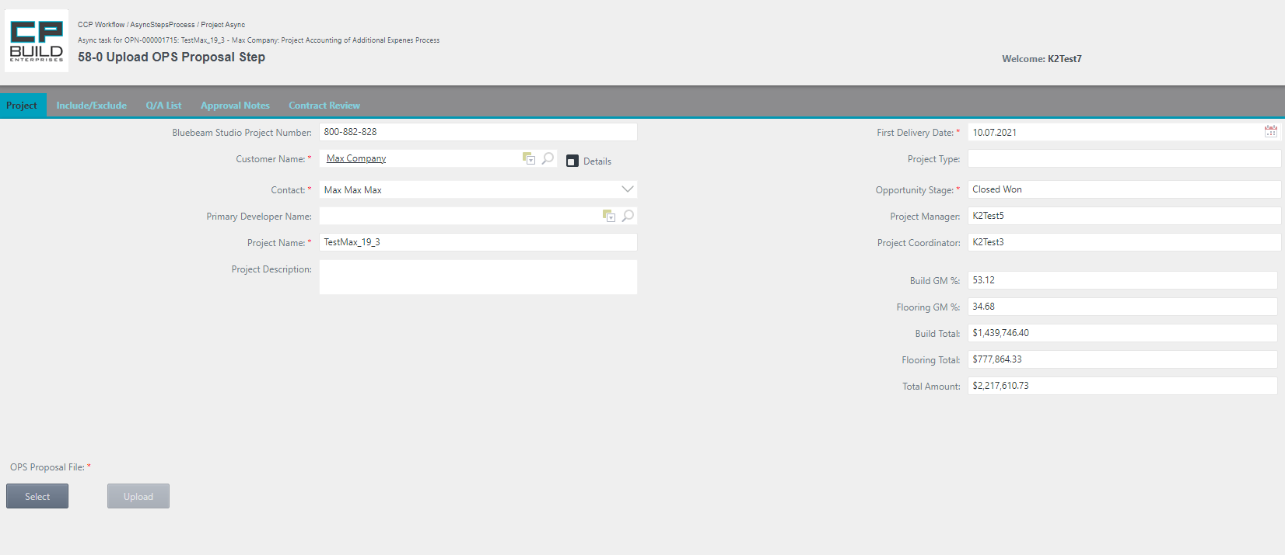

Please Select and Upload the mandatory Files for the OPS Proposal File.

*Screenshot - Estimating – Step 58-0 Upload OPS Proposal – Contracting Process*

**Action for Step** **58-0 Upload OPS Proposal**

In this step, the user needs to:

1. In Opportunity tab, Select and Upload the “OPS Proposal File”. If you Select the wrong document, click Cancel and try again.
2. Set Action to **"Done"** and click Submit.

- The Action **"Done"** moves on to the next step.

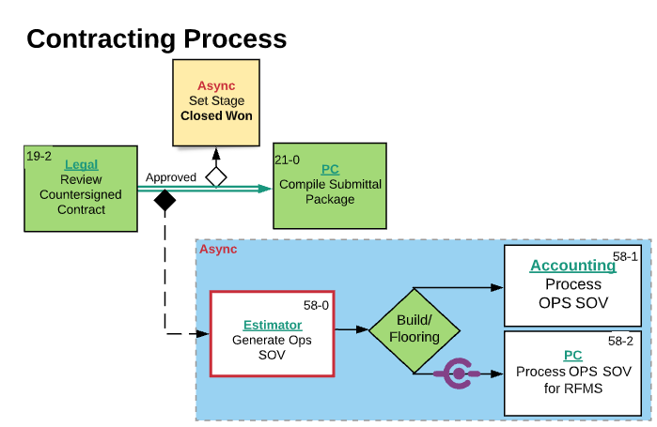

*Screenshot -* *Lucid Chart* *– Step 58-0 Upload OPS Proposal – Contracting Process*

### **23-2** **RS Proposal Step**

This Step 23-2 RS Proposal loads the Quotation file. The current version of the project supports the 5th version of the Quotations file templates. If the user tries to download a different version of the proposal file, the system will issue a warning. Look for the details on the Opportunity tab. If needed, compare the current Quotation file to the previous version on the Include/Exclude tab. Ask a question on the Q/A List tab or Add Notes to Scopes on the Approval Notes tab. The user can learn how to work with the corresponding tabs in the section "Form Images and descriptions," which is outlined above.

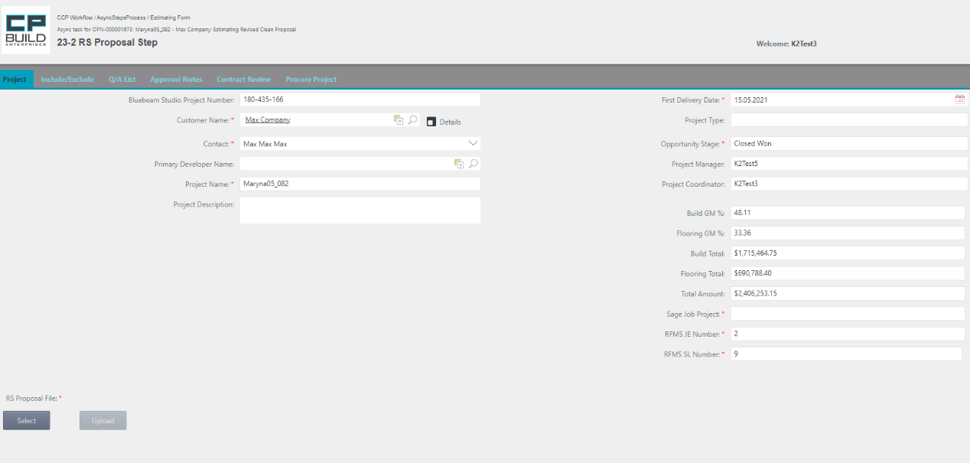

Upload CA-file will appear in the Attachment List and the data in certain fields will be updated.



*Screenshot - Estimating –* *Step 23-2 RS Proposal – Contracting Process*

**Action for Step** **23-2 RS Proposal**

In this this step, the user needs to:

1. In the opportunity tab, Select and Upload the RS Proposal File document. If you Select the wrong document, click Cancel and try again.

* After uploading the file, the Project Scope data is updated automatically. When you Upload a Quotation file with updated Scopes List data, in which the Total Amount of any previously launched Scope is Null, this Scope Instance will be automatically finished.

2. On the Approval Notes tab, check Notes Completed. (The explanation of how to perform this action is described in detail in the section "Form images and descriptions.")

3. Set the Action as "Done" and click Submit.

- The Action **"Done"** moves on to the next step.

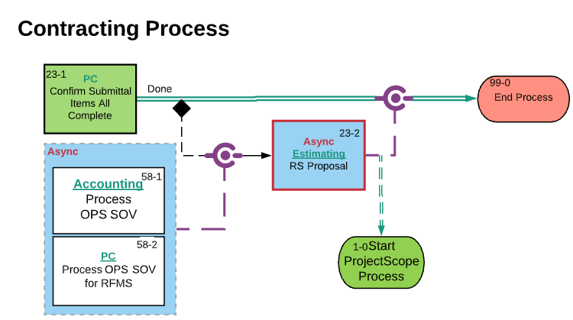

*Screenshot - -* *Lucid Chart* *– Step 23-2 RS Proposal – Contracting Process*

If after Step "23-1 Confirm Submittal Items All Complete Step " the asynchronous step "23-2 RS Proposal Step " is not yet closed, the process will be blocked and will not be able to get to "End Process."

### Sage admin

### **32-0 Create Job in Sage**

Step 32-0 fill in mandatory "Sage Job Project" field. Look at the details on the Opportunity tab. If needed, compare the current Quotation file to the previous version on the Include/Exclude tab. Ask a question on the Q/A List tab or Add Notes to Scopes on the Approval Notes tab. The user can learn how to work with the corresponding tabs in the section "Form Images and descriptions," which is outlined above.

*Screenshot – Sage admin – Step 32-0 Create Job in Sage – Contracting Process*

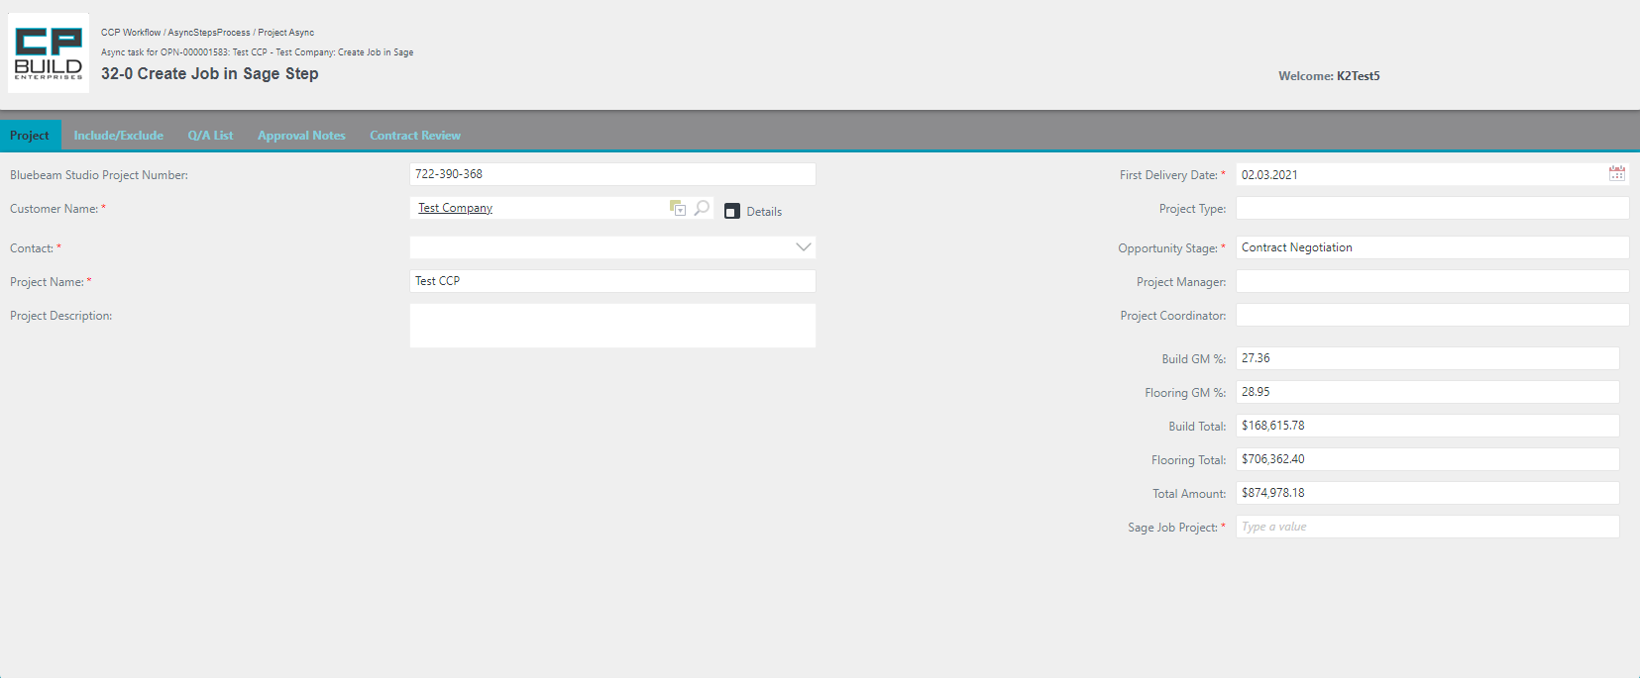

Fill in the mandatory "Sage Job Project" field

**Action for Step** **32-0 Create Job in Sage**

In this step, the user needs to:

1. On the Opportunity tab, fill in the mandatory "Sage Job Project" field.

2. Set Action to “Create Sage Project” and click Submit.

- **Create Sage Project** moves on to the next step.

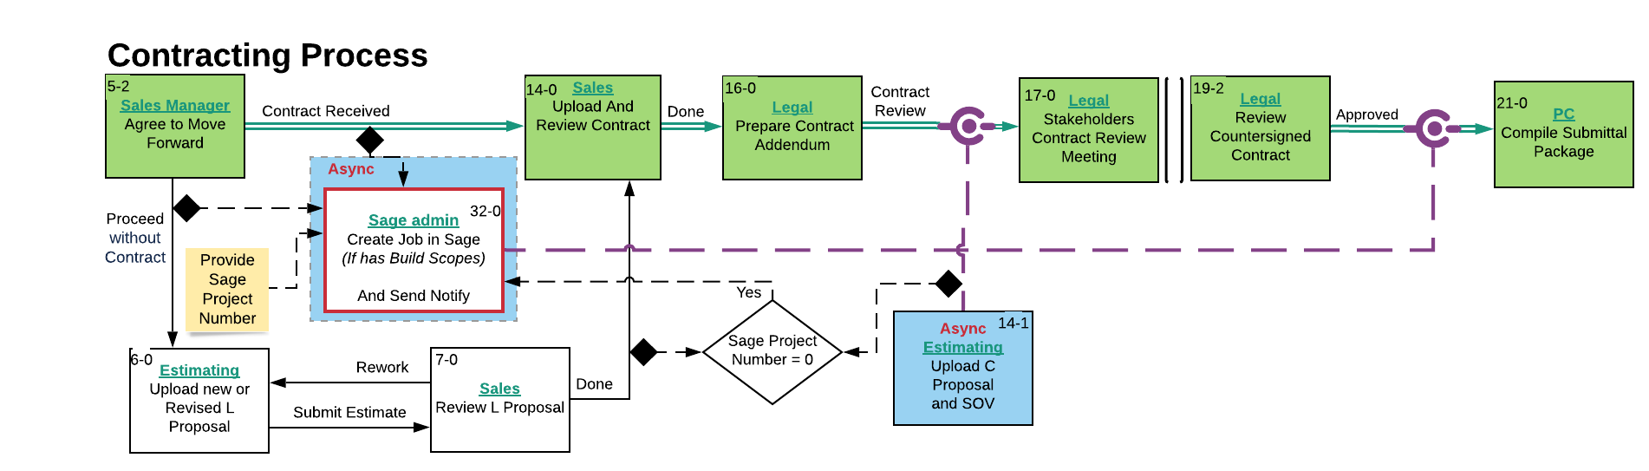

*Screenshot - -* *Lucid Chart* *– Step 32-0 Create Job in Sage – Contracting Process*

If after Step "16-0 Prepare Contract Addendum " the asynchronous step "32-0 Create Job in Sage " is not yet closed, the process will be blocked and will not be able to get to "17-0 Stakeholders Contract Review Meeting"

### Legal

### **16-0 Prepare Contract Addendum**

Step 16-0 is necessary to generate "Contract Review Checklist PDF" on the Contract Review tab. If needed, compare the current Quotation file to the previous version on the Include/Exclude tab. Ask a question on the Q/A List tab. The user can learn how to work with the corresponding tabs in the section "Form Images and descriptions," which is outlined above.

*Screenshot – Legal – Step* *16-0 Prepare Contract Addendum – Contracting Process*

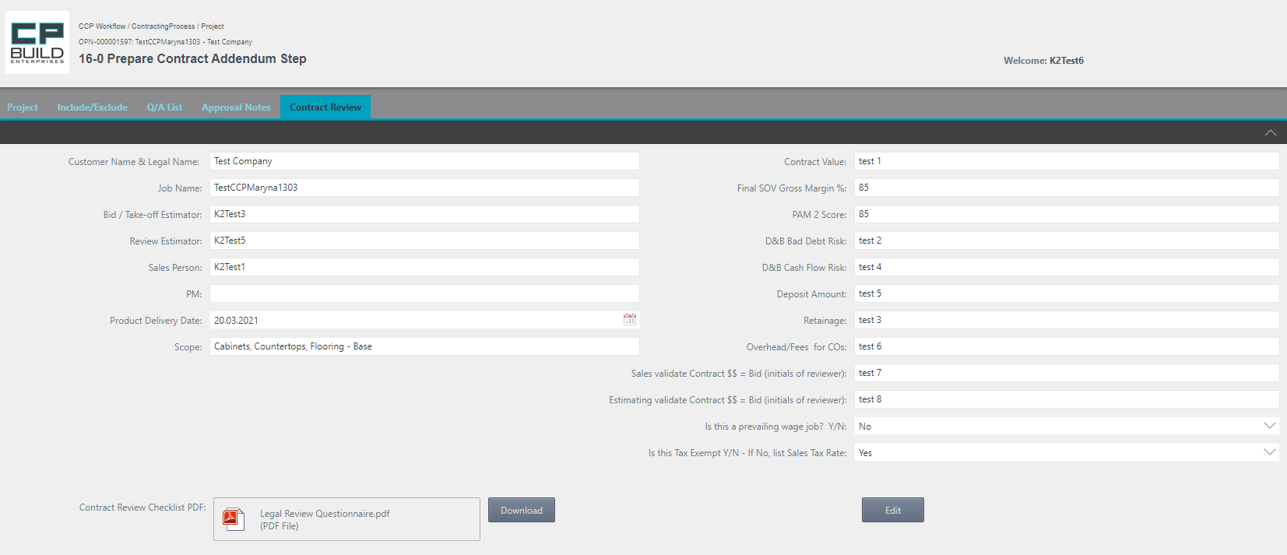

1.After loading the information, click the Save button.

2.Download the generated file by clicking on it with the left mouse. button

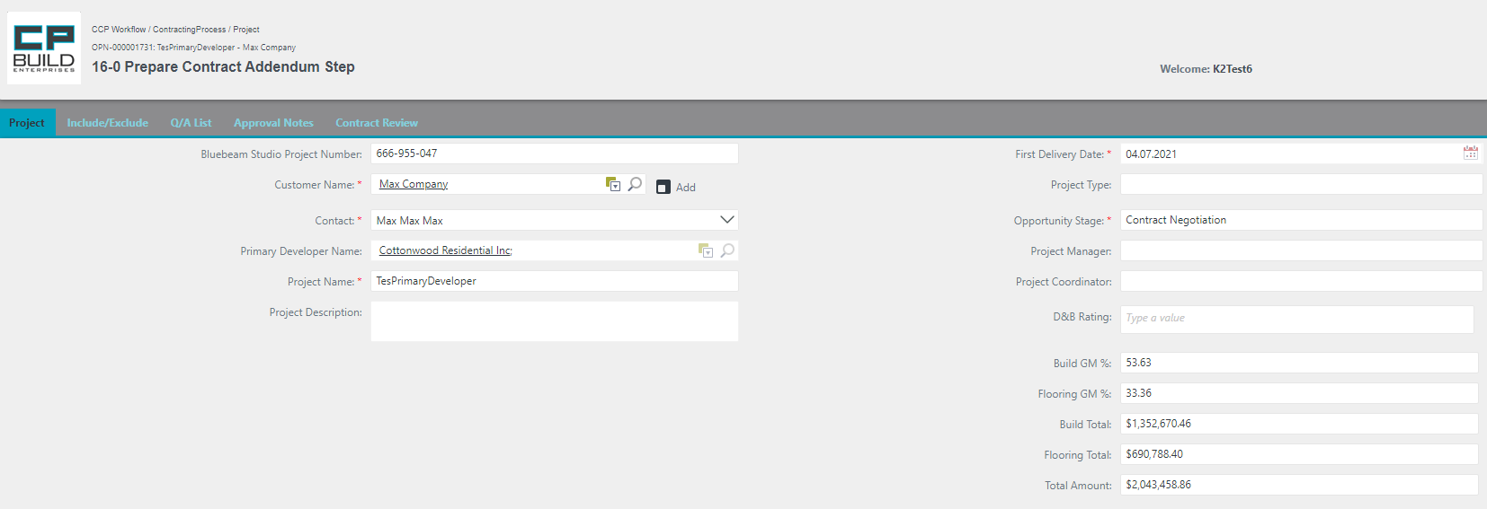

1. Change the value of the D&B rating, if necessary.

*Screenshot – Legal – Step 16-0 Prepare Contract Addendum – Contracting Process*

**Action for Step** **16-0** **Prepare Contract Addendum**

In this step, the user needs to:

1. On the Contract Review tab, Click the Edit button after entering all the information known to the user in the right column, click the Save button, then Download the PDF with the checklist. The user can learn how to work with the corresponding tabs in the section "Form Images and descriptions," which is outlined above.
2. Go to the Project tab. The User can also change the D&B Rating value.
3. Set Action to "Request Contract Revision" or "Contract Review" and click Submit.

- The Action **"Contract Review"** moves on to the "Stakeholders Contract Review Meeting" step.

- The Action **"Request Contract Revision"** moves on to the "Request Contract Revision" step.

*Note: "Request Contract Revision" Action requires a comment.

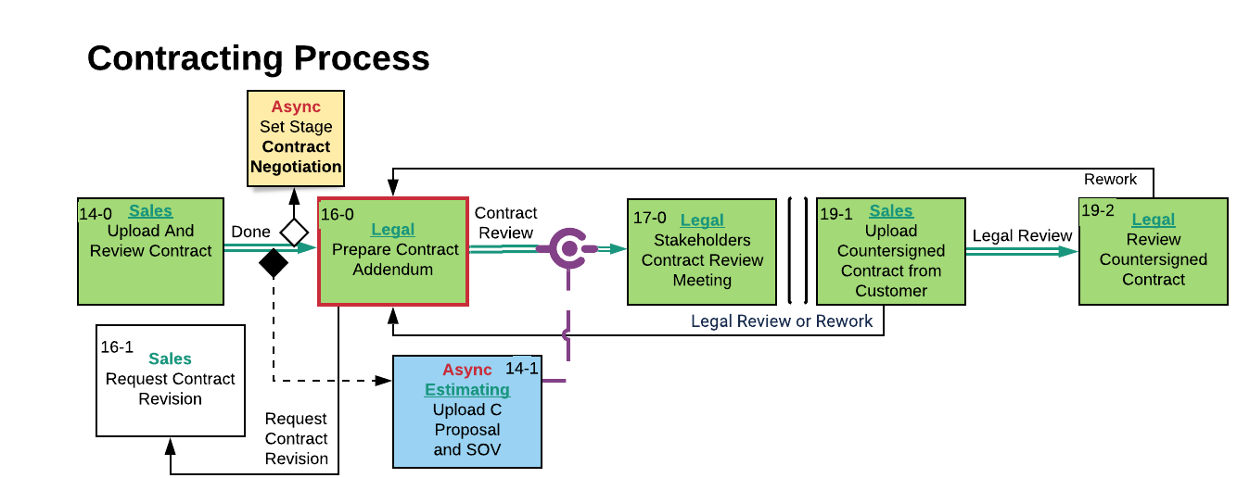

*Screenshot - -* *Lucid Chart* *– Step 16-0 Prepare Contract Addendum – Contracting Process*

### **17-0 Stakeholders Contract Review Meeting**

Step 17-0 Stakeholders Contract Review Meeting. If needed, compare the current Quotation file to the previous version on the Include/Exclude tab. Ask a question on the Q/A List tab. The user can learn how to work with the corresponding tabs in the section "Form Images and descriptions," which is outlined above.

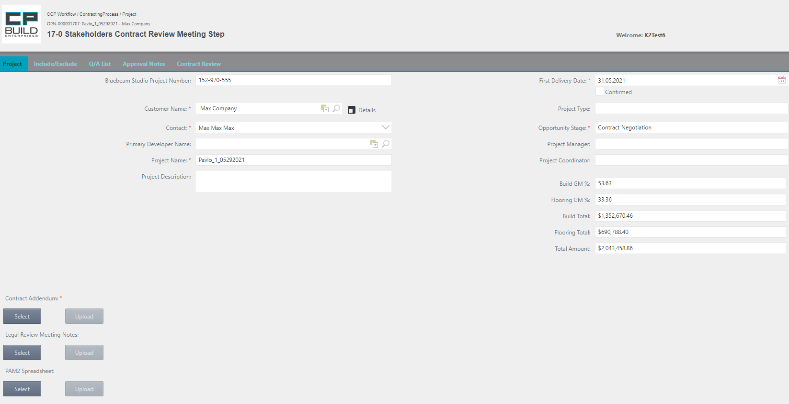

Confirm the "First Delivery Date," by checking the box.

Select and upload the required Contract Addendum file. There is also the option to upload "Legal Review Meeting Notes", "PAM2 Spreadsheet."

*Screenshot – Legal – Step 17-0 Stakeholders Contract Review Meeting – Contracting Process*

**Action for Step 17-0 Stakeholders Contract Review Meeting**

In this step, the user needs to:

1. On the Project tab, Select and Upload the required Contract Addendum file. There is also the option of uploading "Legal Review Meeting Notes", "PAM2 Spreadsheet.". If you selected the wrong document, click Cancel and try again.
2. Confirm the "First Delivery Date," by checking the box.
3. Set the Action as "Done" and click Submit.

- The Action **"Done"** changes the Stage to “Proposal”. It moves on to the next step.

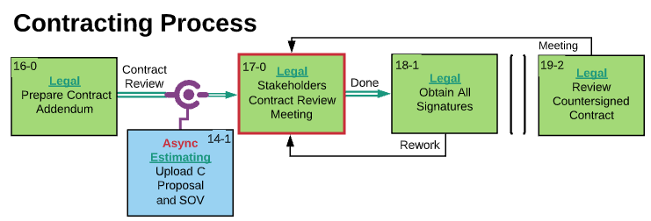

*Screenshot - -* *Lucid Chart* *– Step 17-0 Stakeholders Contract Review Meeting – Contracting Process*

### **18-1 Obtain All Signatures Step**

Step 18-1 Obtain All Signatures. If needed, compare the current Quotation file to the previous version on the Include/Exclude tab. Ask a question on the Q/A List tab. The user can learn how to work with the corresponding tabs in the section "Form Images and descriptions," which is outlined above.

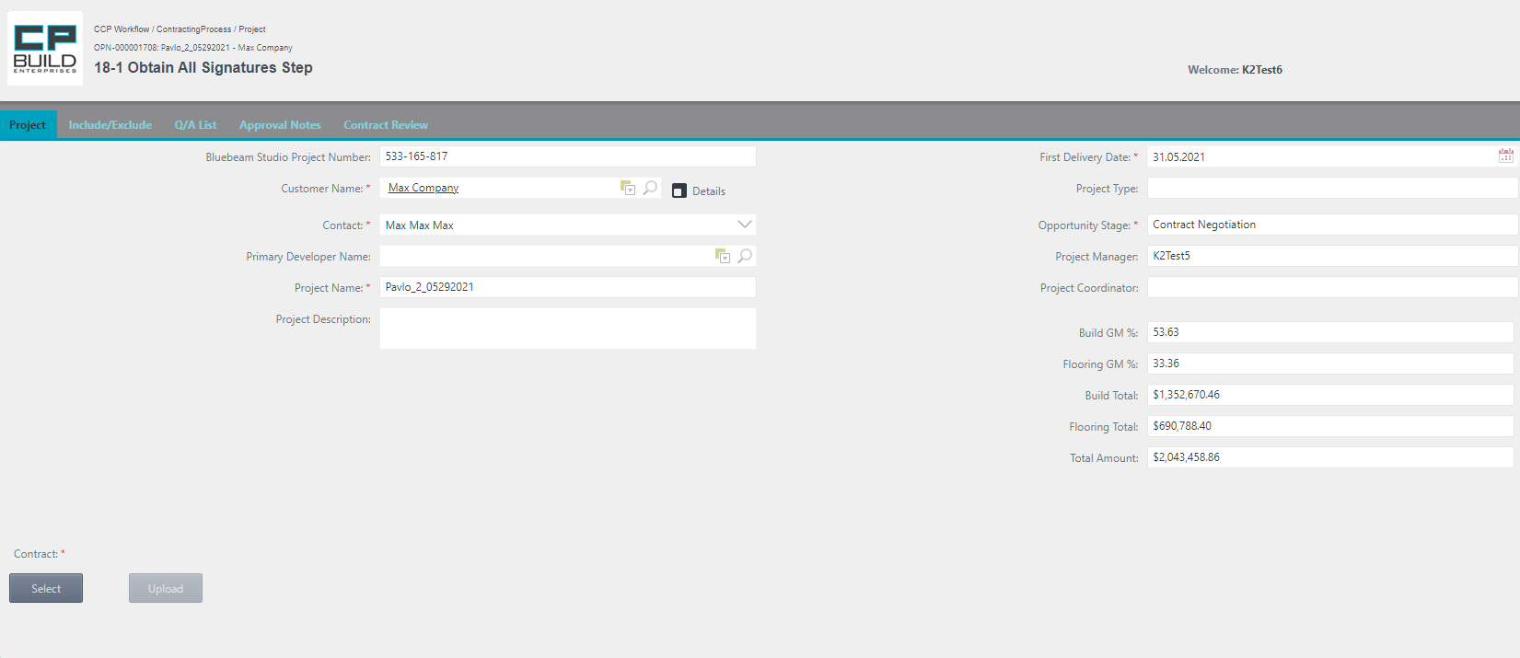

Select and upload the required Contract file.

*Screenshot - Legal – Step 18-1 Obtain All Signatures – Contracting Process*

**Action for Step 18-1 Obtain All Signatures**

In this step, the user needs to:

1. On the Project tab, Select and Upload the Signed Scanned “Contract” PDF document. If you selected the wrong document, click Cancel and try again.

2. Set the Action to “Done” or “Rework” and click Submit.

- The Action **"Done"** moves on to the next step.

- The Action **"Rework****"** returns to the “Stakeholders Contract Review Meeting “step.

*Note that the “Rework” Action requires a comment.

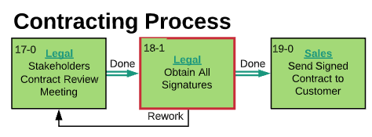

*Screenshot -* *Lucid Chart* *– Step 18-1 Obtain All Signatures – Contracting Process*

### **19-2 Review Countersigned Contract Step**

Step 19-2 Review Countersigned Contract. If needed, compare the current Quotation file to the previous version on the Include/Exclude tab. Ask a question on the Q/A List tab. The user can learn how to work with the corresponding tabs in the section "Form Images and descriptions," which is outlined above.

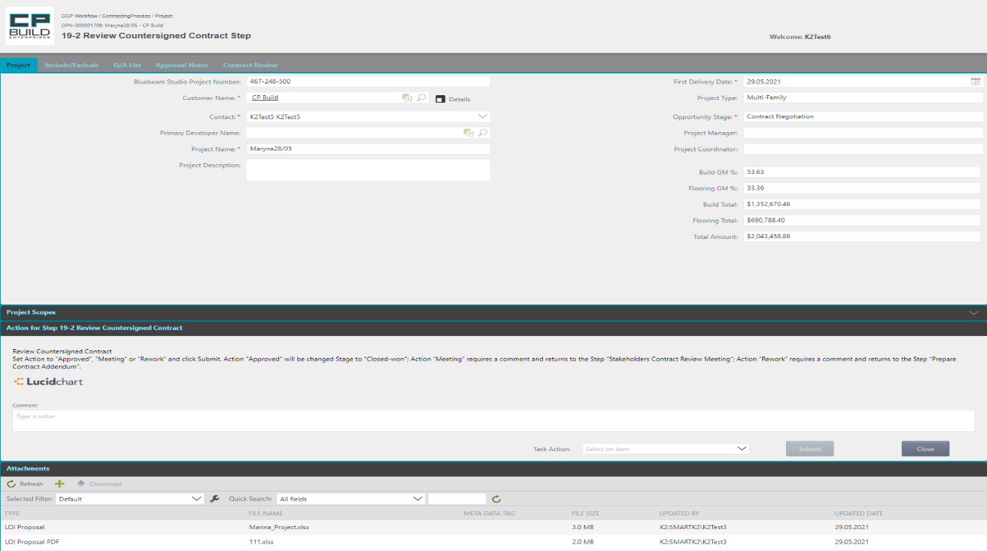

In the Attachments List, you can Download and Review Countersigned Contract.

*Screenshot - Legal – Step 19-2 Review Countersigned Contract – Contracting Process*

**Action for Step 19-2 Review Countersigned Contract**

In this step, the user needs to:

1. On the Project tab, go down to the Attachments List. You can Download and Review the Countersigned Contract.

2. Set Action to “Approved”, “Meeting” or “Rework” and click Submit.

- The Action **" Approved "** changes the Stage to "Closed-won". It then moves on to the next step.

- The Action **"** **Meeting "** returns to the “ Stakeholder’s Contract Review Meeting “ step.

- The Action **"Rework"** returns to the “Prepare Contract Addendum“ step.

*Note that the “Rework”," Meeting " Action requires a comment.

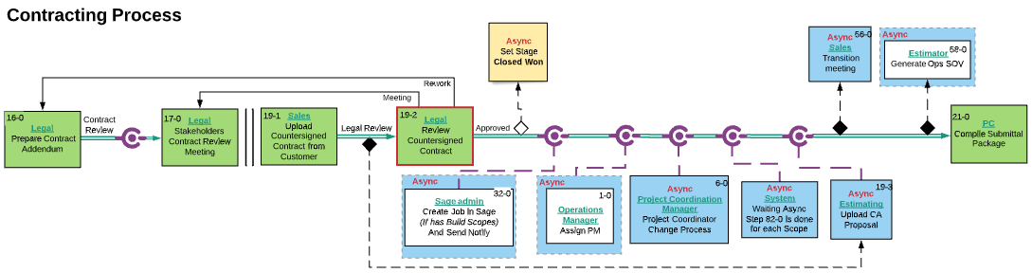

*Screen shot -* *Lucid Chart* *– Step 19-2 Review Countersigned Contract – Contracting Process*

### Operations Manager

### **1-0 Start PM Change Process Step**

Step 1-0 Start PM Change Process. The “Operations Manager” can initiate the process of assignment a “New project manager” before this step occurs using the “New Project Manager” button in the “My Project” menu. The user can learn how to work with the corresponding tabs in the section "Form Images and descriptions," which is outlined above.

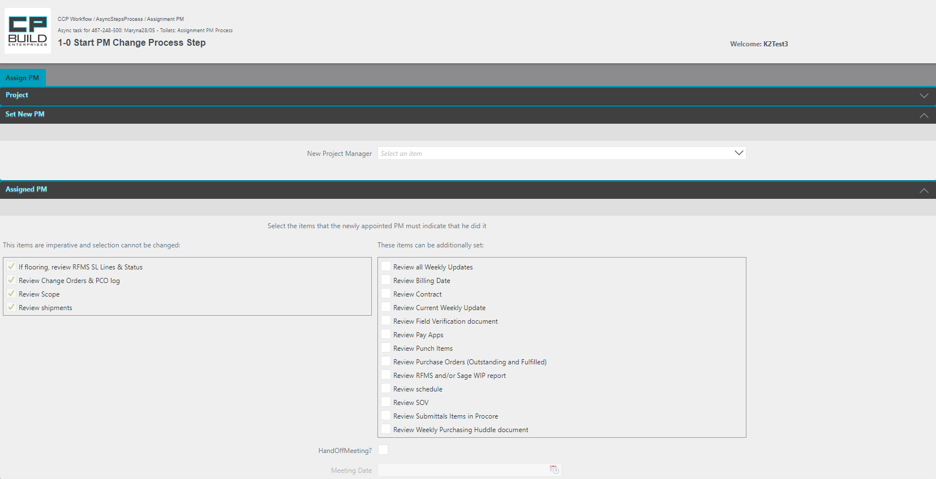

Select New Project Manager

These items can also be set:

It is also possible to set a Hand Off Meeting Date.

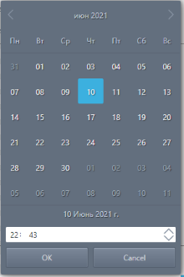

Information on the Project is located in the minimized Project tab.

*Screenshot – Operation Manager – Step 1-0 Start PM Change Process – Contracting Process*

**Action for** **Step** **1-0 Start PM Change Process**

In this step, the user needs to:

1. On the Assign PM tab, go down to the Set New PM List. In the drop-down, Select New Project Manager.
2. Optionally, select the items that the newly appointed PM should specify, by checking the additional "These items can be optionally checked" checkboxes.
3. If necessary, you can chec-box "Hand Off Meeting Date," while selecting the required date from the calendar and specifying the time of the meeting.
4. Set Action to “Start” and click Submit.

- The "**Start**" Action proceeds to the next asynchronous step.

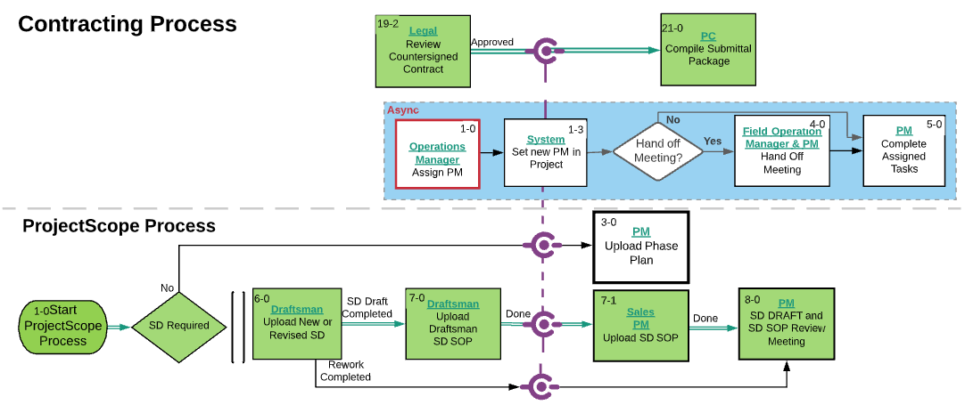

*Screenshot -* *Lucid Chart* *– Step 1-0 Start PM Change Process – Contracting Process*

If after Step "19-2 Review Countersigned Contract Step " the asynchronous step "1-0 Start PM Change Process " is not yet closed, the process will be blocked and will not be able to get to "21-0 Compile Submittal Package Step ".

### **4-0 Hand off Meeting Step**

Step 4-0 Hand off Meeting. This step appears, if in “Step 1-0 Start PM Change Process” the “Hand Off Meeting Date” checkbox was selected, the required date was selected in the calendar and the time of the meeting was specified. If necessary, you can get acquainted with the information about the project using the collapsed “Project” tab. The user can learn how to work with the corresponding tabs in the section "Form Images and descriptions," which is outlined above.

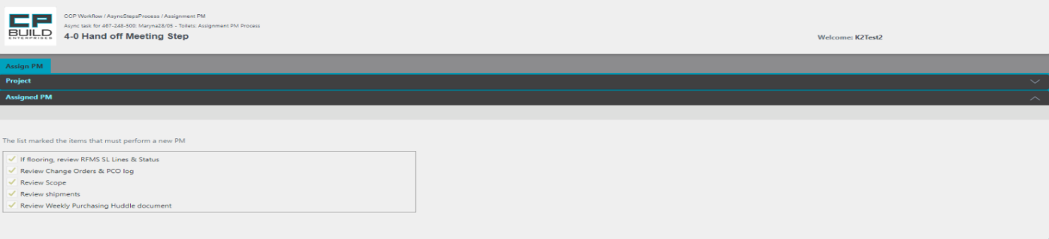

If necessary, you can get acquainted with the information about the project using the collapsed “Project” tab.

*Screenshot – Operation Manager – Step 4-0 Hand off Meeting – Contracting Process*

**Action for Step 4-0 Hand-off Meeting**

In this step, the user needs to:

1. On the Assign PM tab, go down to the Assigned PM List. The list marked the items that must be performed by a new PM.
2. After the Hand off Meeting is done, set Action to “**Done**” and click Submit.

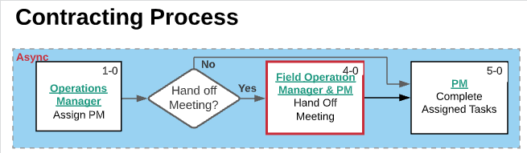

*Screen shot -* *Lucid Chart* *– Step 4-0 Hand off Meeting – Contracting Process*

### PM

### **5-0** **Complete Assigned PM Task Step**

Step 5-0 Complete Assigned PM Task. If necessary, you can get acquainted with the information about the project using the collapsed “Project” tab. The user can learn how to work with the corresponding tabs in the section "Form Images and descriptions," which is outlined above.

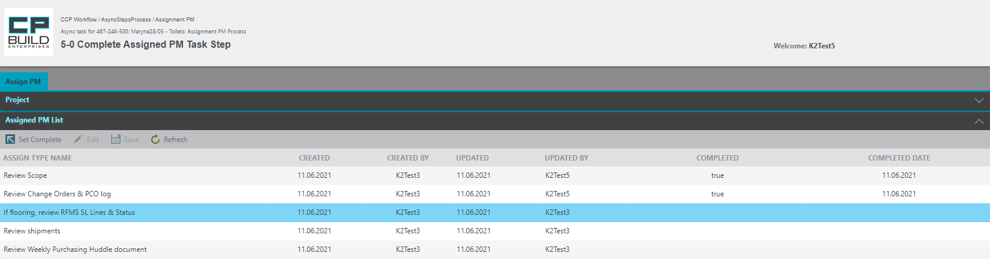

Check Completed to give the Type a Name.

For this:

- Select the line you want

- Click the button on the *Set Complete* toolbar.

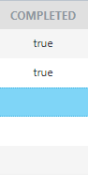

*Screenshot – PM – 5-0 Complete Assigned PM Task – Contracting Process*

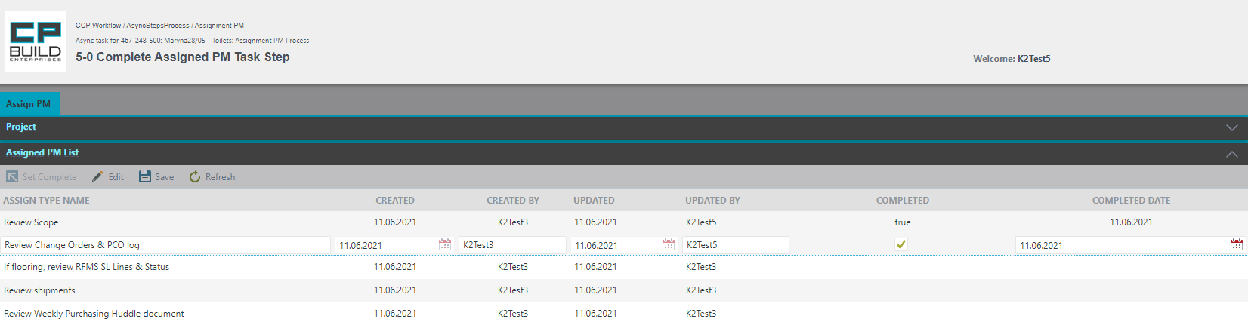

To edit the record of Complete or Complete Date, you must:

- Select the line you want

- Click the button on the *Edit* toolbar

- After making changes, click the button on the *Save* toolbar

*Screenshot – PM – 5-0 Complete Assigned PM Task – Contracting Process*

**Action for Step 5-0 Complete Assigned PM Tas**

In this step, the user needs to:

1. In the List Assigned PM, Set Complete for all Assign Type Names.
2. Set Action to “**Complete**” and click Submit.

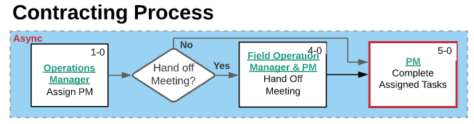

*Screenshot -* *Lucid Chart* *– 5-0 Complete Assigned PM Task – Contracting Process*

### Project Coordination Manager

### **6-0 Start Project Coordinator Change Process Step**

Step 6-0 Start Project Coordinator Change Process. The Project Coordinator Manager can initiate the “New Project Coordinator assignment process” using the “New Project Coordinator” button on the My Project menu. The user can learn how to work with the corresponding tabs in the section "Form Images and descriptions," which is outlined above.

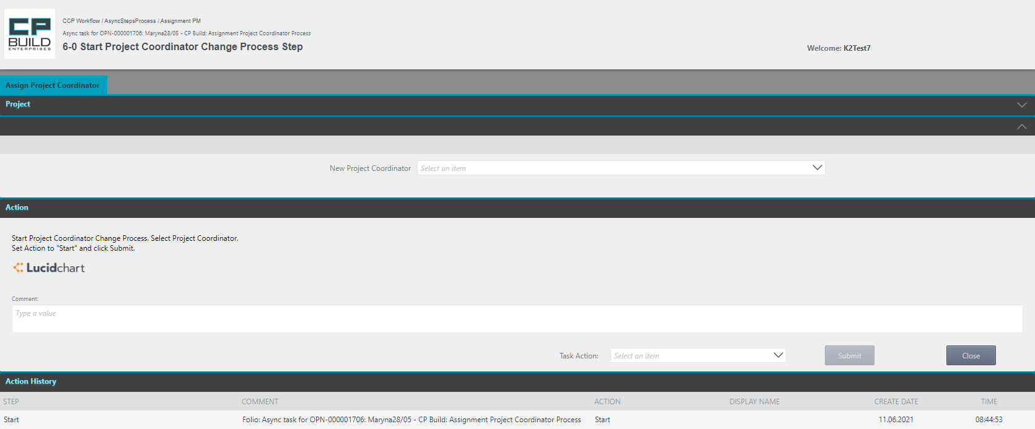

If necessary, you can get acquainted with the information about the project using the collapsed “Project” tab.

Select New Project Coordinator

*Screenshot – Project Coordinator Manager – Step 6-0 Start Project Coordinator Change Process – Contracting Process*

**Action for Step 6-0 Start Project Coordinator Change Process**

In this step, the user needs to:

1. On the Assign Project Coordinator Tab in Drop-down, Select New Project Coordinator.
2. Set Action to “Start” and click Submit.

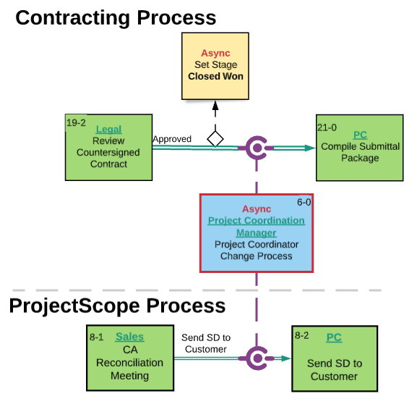

*Screenshot -* *Lucid Chart* *– Step* *6-0 Start Project Coordinator Change Process – Contracting Process*

If after Step "19-2 Review Countersigned Contract Step" the asynchronous step "6-0 Start Project Coordinator Change Process" is not yet closed, the process will be blocked and will not be able to get to "21-0 Compile Submittal Package Step".

### PC

### **21-0 Compile Submittal Package Step**

Step 21-0 Compile Submittal Package. If after Step "19-2 Review Countersigned Contract Step, Steps 82-0 have not yet been completed for each individual Scope in the project, the process will be blocked and will not be able to get to "21-0 Compile Submittal Package Step ". If needed, compare the current Quotation file to the previous version on the Include/Exclude tab. Ask a question on the Q/A List tab. The user can learn how to work with the corresponding tabs in the section "Form Images and descriptions," which is outlined above.

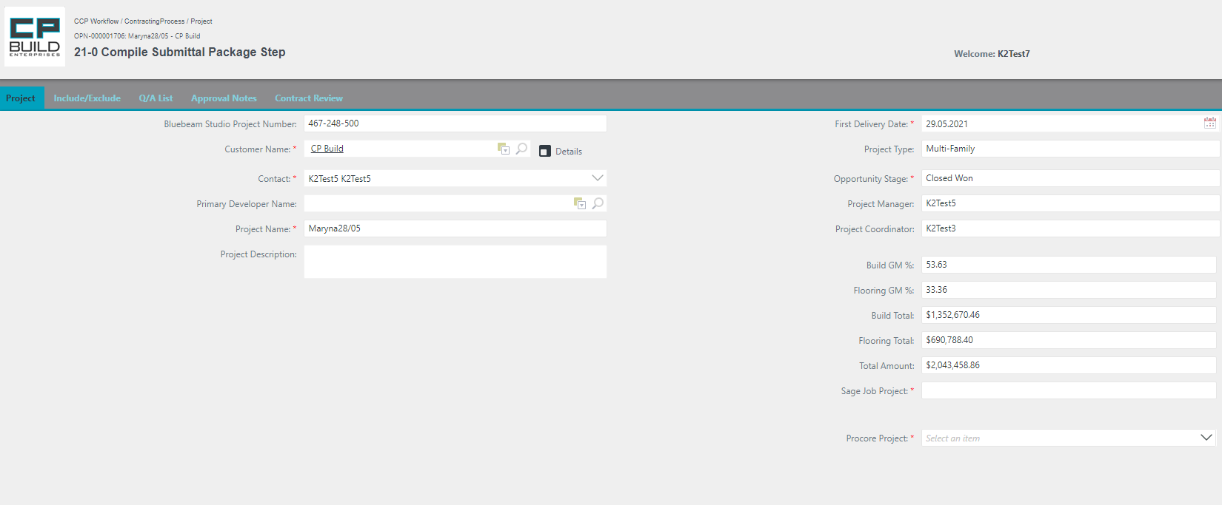

Select a Procore project from the dropdown list.

*Screenshot - PC – Step 21-0 Compile Submittal Package – Contracting Process*

**Action for Step 21-0 Compile Submittal Package**

In this step, the user needs to:

1. On the Project tab Select Procore Project and Compile Submittal Package.

2. Set Action to “Done” and click Submit.

- The Action **"Done"** moves on to the next step.

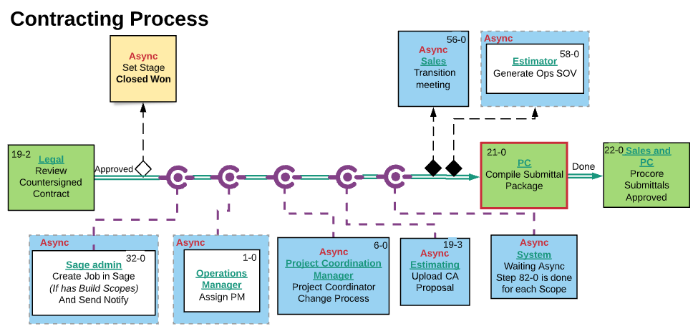

*Screenshot -* *Lucid Chart* *– Step 21-0 Compile Submittal Package – Contracting Process*

### **19-4 Setup JE in RFMS Step**

Step 19-4 Setup JE in RFMS. This step appears if Flooring Scopes has been loaded in the Project (at Step "19-3 Load CA Proposition"). If needed, compare the current Quotation file to the previous version on the Include/Exclude tab. Ask a question on the Q/A List tab. The user can learn how to work with the corresponding tabs in the section "Form Images and descriptions," which is outlined above.

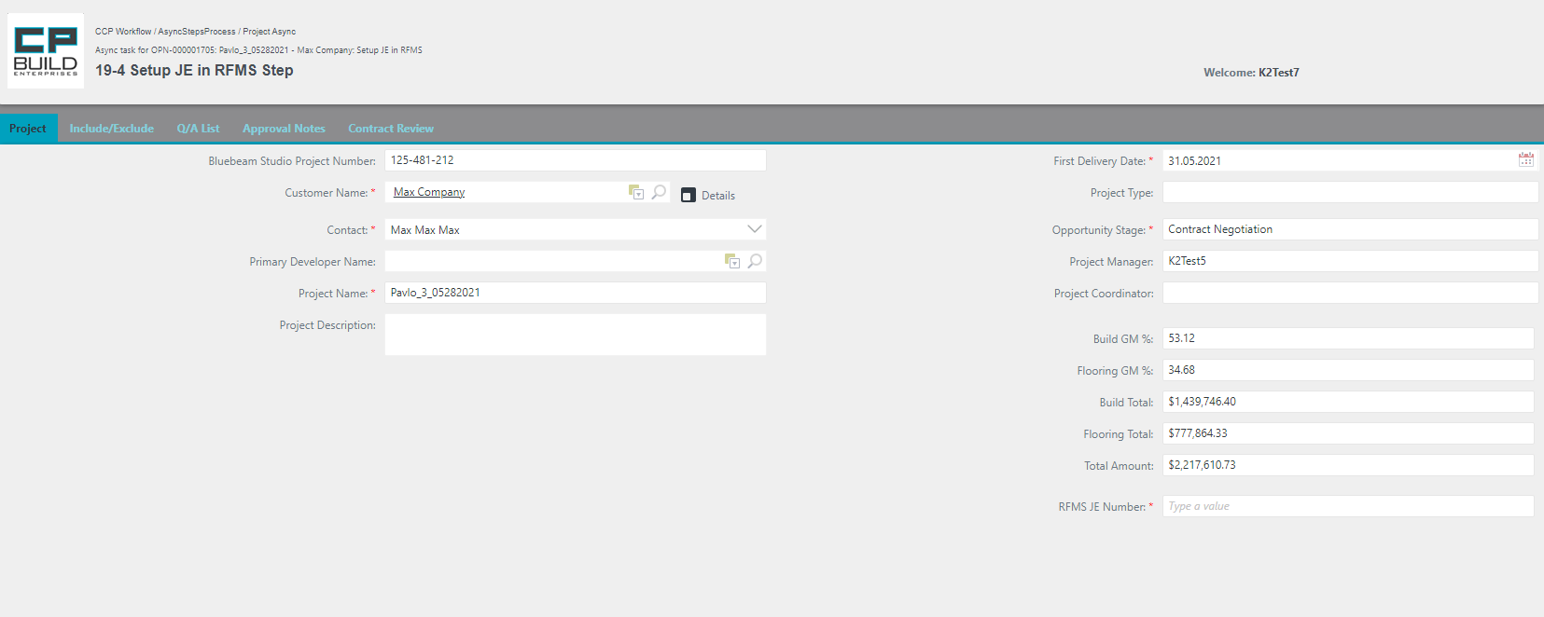

Fill in the required field RFMS JE Number

*Screenshot - PC – Step 19-4 Setup JE in RFMS – Contracting Process*

**Action for Step** **19-4 Setup JE in RFMS**

In this step, the user needs to:

1. On the Project tab, fill in the required field RFMS JE Number.

2. Set Action to “Done” and click Submit.

- The Action **"Done"** moves on to the next step.

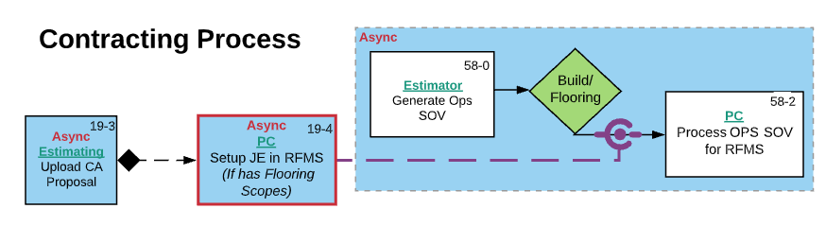

*Screenshot -* *Lucid Chart* *– Step 19-4 Setup JE in RFMS – Contracting Process*

If after Step "19-3 Upload CA Proposal " the asynchronous step " 19-4 Setup JE in RFMS " is not yet closed, the process will be blocked and will not be able to get to "58-2 Process OPS SOV for RFMS ".

### **22-0 Procore Submittals Approved Step**

Step 22-0 Procore Submittals Approved the Procore Project tab is available. If needed, compare the current Quotation file to the previous version on the Include/Exclude tab. Ask a question on the Q/A List tab. The user can learn how to work with the corresponding tabs in the section "Form Images and descriptions," which is outlined above.





The project has Submittals without reference to Scope codes.

Click "Submittals without scope code" for details.

There are errors in the project Scope Codes in the project.

Click "Submittals with errors" for details.



*Screenshot - PC – Step 22-0 Procore Submittals Approved – Contracting Process*

**Action for Step 22-0 Procore Submittals Approved**

In this step, the user needs to:

1. On the Procore Project tab, investigate Scope Code Errors, if any. Click "Submittals without scope code" for details. If the project has Submittals without reference to Scope codes, click "Submittals with errors" for details.

2. On the Project tab, set Action to “Approve” and click Submit.

- The Action **"Approve"** moves on to the next step.



*Screenshot -* *Lucid Chart* *– Step 22-0 Procore Submittals Approved – Contracting Process*

### **23-0 Send Submittal Package to Customer Step**

Step 23-0 Send Submittal Package to Customer. If after Step "22-0 Procore Submittals Approved," Steps 8-2 have not yet been reached for each individual Scope in the project, the process will be blocked and will not be able to get to "23-0 Send Submittal Package to Customer Step". If needed, compare the current Quotation file to the previous version on Include/Exclude tab. Ask a question on the Q/A List tab. The user can learn how to work with the corresponding tabs in the section "Form Images and descriptions," which is outlined above.

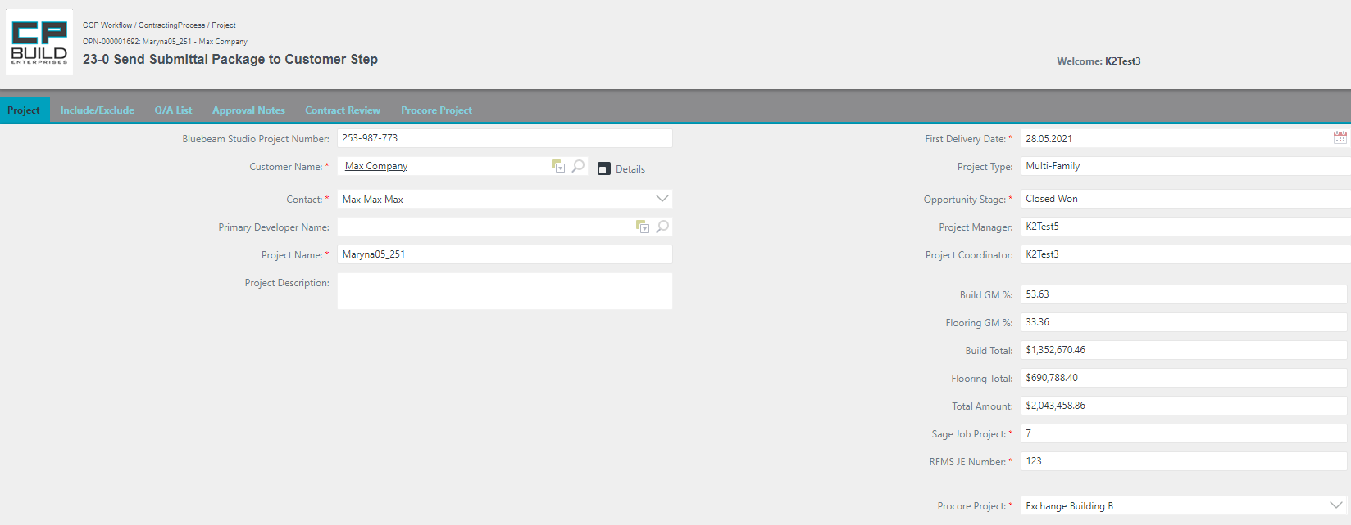

*Screen shot - PC – Step 23-0 Send Submittal Package to Customer – Contracting Process*

**Action for Step** **23-0 Send Submittal Package to Customer**

In this step, the user needs to:

1. Send Submittal Package to Customer

2. On the Project tab, Set Action to “Done” and click Submit.

- The Action **"Done"** moves on to the next step.

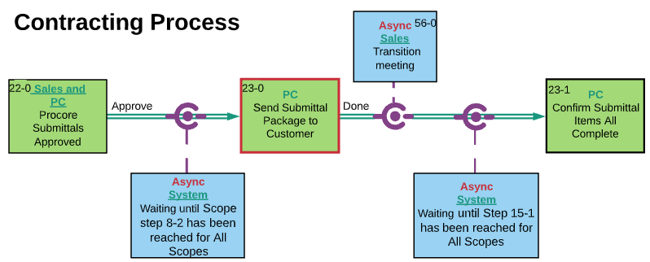

*Screenshot -* *Lucid Chart* *– Step 23-0 Send Submittal Package to Customer – Contracting Process*

### **23-1 Confirm Submittal Items All Complete Step**

Step 23-1 Confirm Submittal Items All complete. If after Step "23-0 Send Submittal Package to Customer Step," Steps 15-1 have not yet been reached for each individual Scope in the project, the process will be blocked and will not be able to get to "23-1 Confirm Submittal Items All Complete Step". If needed, compare the current Quotation file to the previous version on the Include/Exclude tab; Ask a question on the Q/A List tab. The user can learn how to work with the corresponding tabs in the section "Form Images and descriptions," which is outlined above.

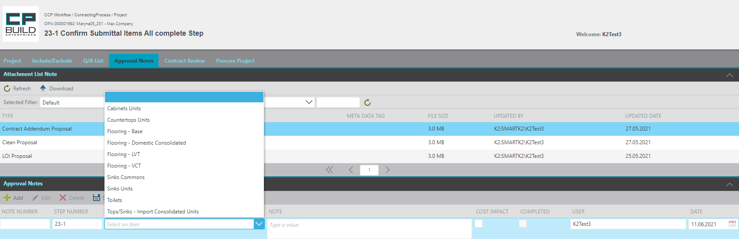

4.On the Note column, enter the note text

1. From Attachments List, view and select required Price Quote file

2. On the Approval Notes, click the Add button and new row will appear.

3.In the Scope column, select from the drop-down list scope name that you need.

5.Click the Save button

*Screenshot - PC – Step 23-1 Confirm Submittal Items All complete – Contracting Process*

**Action for Step 23-1 Confirm Submittal Items All complete**

In this step, the user needs to:

1. Confirm that Submittal Items are All complete
2. On the Approval Notes tab add notes, if needed (Screens shot - PC – Step 23-1 Confirm Submittal Items All complete – Contracting Process)
3. On the Project tab, set Action to “Done” and click Submit.

- The Action **"Done"** moves on to the next step.

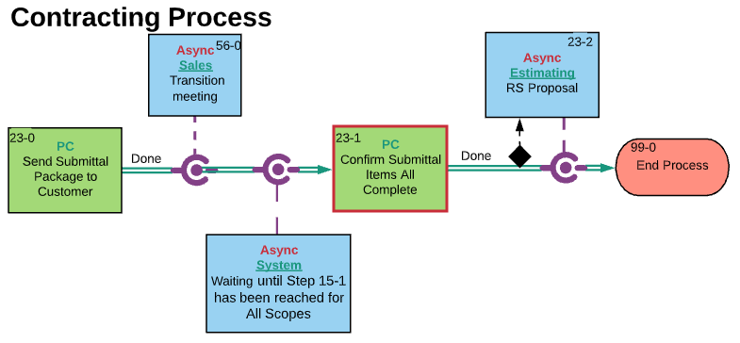

*Screenshot -* *Lucid Chart* *– Step 23-1 Confirm Submittal Items All complete – Contracting Process*

### **58-2 Process OPS SOV for RFMS Step**

Step 58-2 Process OPS SOV for RFMS. This step appears, if Flooring Scopes have been loaded in the Project (at Step "19-3 Load CA Proposition"). The user can learn how to work with the corresponding tabs in the section "Form Images and descriptions," which is outlined above.

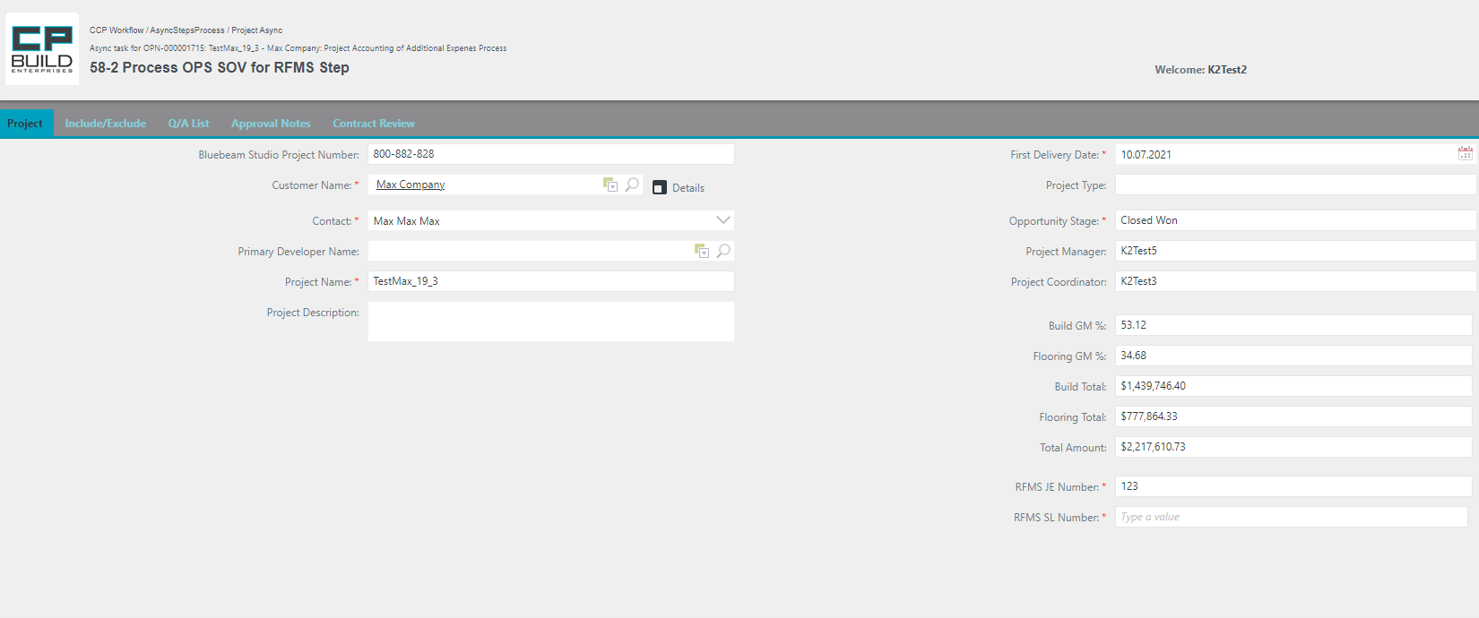

Fill in the required field RFMS SL Number

*Screenshot – PC – 58-2 Process OPS SOV for RFMS – Contracting Process*

**Action for Step 58-2 Process OPS SOV for RFMS**

In this step, the user needs to:

1. On the Project tab, fill in the required field RFMS SL Number.
2. Set Action to “**Done**” and click Submit.

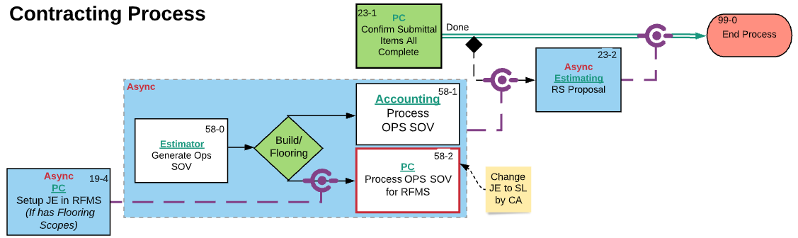

*Screenshot -* *Lucid Chart* *–* *58-2 Process OPS SOV for RFMS – Contracting Process*

If after Step "58-0 Upload OPS Proposal " the asynchronous step "58-2 Process OPS SOV for RFMS " is not yet closed, the process will be blocked and will not be able to get to "23-2 RS Proposal. "

### Accounting

### **58-1 Process OPS SOV Step**

Step 58-1 Process OPS SOV. This step appears if Build Scopes has been loaded in the Project (at Step "19-3 Load CA Proposition"). The user can learn how to work with the corresponding tabs in the section "Form Images and descriptions," which is outlined above.

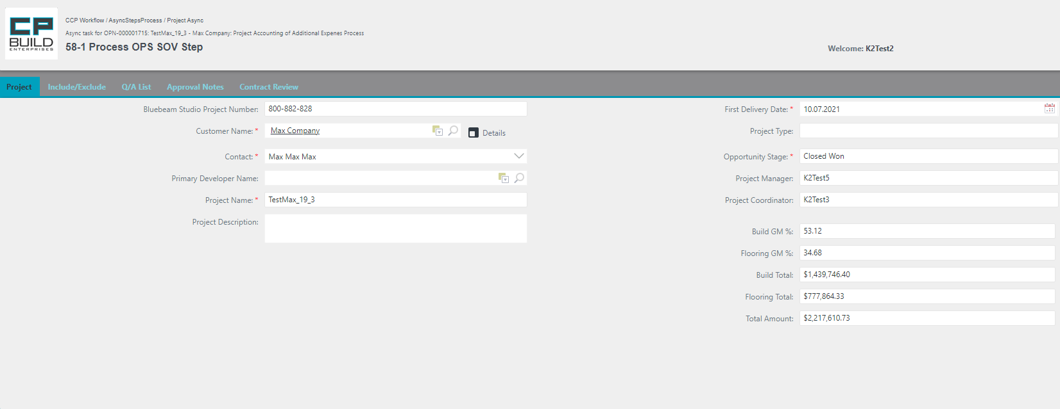

*Screenshot – Accounting – 58-1 Process OPS SOV – Contracting Process*

**Action for Step 58-1 Process OPS SOV**

In this step, the user needs to:

1. Update the job cost with values from OPS SOV and finalize “Original Budget” in Sage.
2. Set Action to “**Done**” and click Submit.

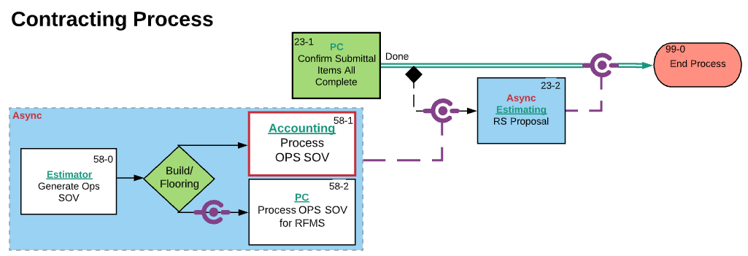

*Screenshot -* *Lucid Chart* *– 58-1 Process OPS SOV – Contracting Process*

If after Step "58-0 Upload OPS Proposal " the asynchronous step "58-1 Process OPS SOV " is not yet closed, the process will be blocked and will not be able to get to "23-2 RS Proposal ".

# Contracting Process General Schema

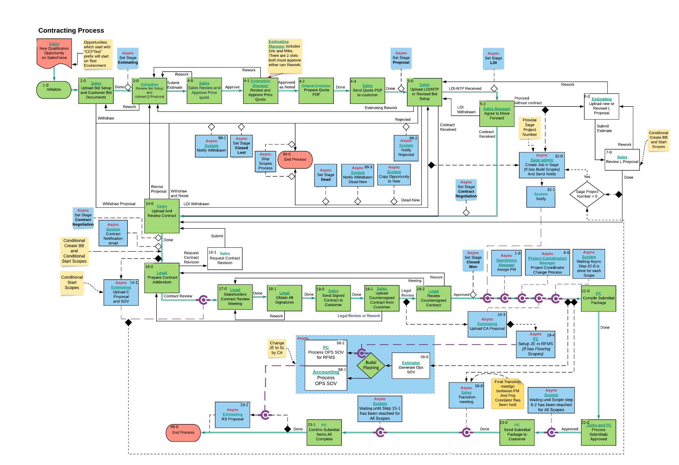

### Designations on the diagram

 The project will not proceed to the next step, until the asynchronous step is closed.

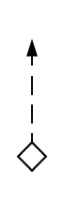

Indicates the transition of the project to the next stage.



Means that after the step, an asynchronous step will be launched, which will block the further progress of the project.

Asynchronous steps section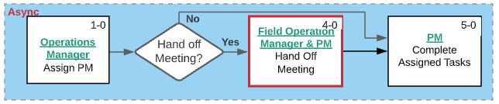

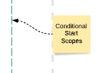

Note

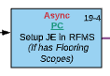 Shows the asynchronous step of the main process, where the recipient's role and step name are spelled out

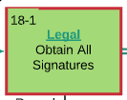 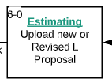Shows the step of the main process, where the role of the recipient and the name of the step are registered. The red frame shows which step you are in.

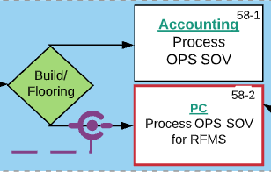

Decision under which the task can follow one of the paths.

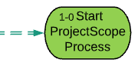

Start Process

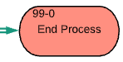

End Process